FarmStat User Guide
Version 1.0
February XXXXXXXXXXX, 2020

Nebraska Extension Digital Agriculture
Nebraska On-Farm Research
University of Nebraska - Lincoln

FarmStat – User Guide
Contents
FarmStat Overview 1
Organizing Data 2
Entering Data 2
“Enter New Dataset” 3
“Paste From Excel” 4
“Upload Existing Dataset (.json)” 5
Analyzing Data 6
Statistically Significant Differences 8
Saving Input Data 9
Saving Results 9
Using FarmStat Results 11

FarmStat Overview
FarmStat is a web-based program designed to simplify statistical analysis of data collected from agricultural experiments, and facilitate interpretation of the statistical output. The goal of FarmStat is to empower data-driven decisions from on-farm experimentation. FarmStat is provided free of charge to registered users. Use of FarmStat after registering to use the program implies acceptance of the terms and conditions for using FarmStat and its generated analyses.
Data analyzed in FarmStat should be collected through experiments with a randomized complete block design (RCBD) or a completely randomized design (CRD). Information regarding RCBD and CRD designs is provided in the information bubble signified by the blue “i” bubble next to the experimental design selection option. If you would like more information about RCBD and CRD designs, the Nebraska Extension Digital Ag Online Course discusses these designs in detail. Data that is not collected through an experiment with either a RCBD or CRD design can be entered into FarmStat, but the statistical analysis will not accurately indicate differences between treatments. FarmStat implements the Analysis of Variance (ANOVA) procedure to analyze data, reports treatment and block means, and offers either Tukey’s HSD (honest significant difference) or Fisher’s LSD (least significant difference) for determining specific differences between treatments in an experiment. This user guide will provide details and instructions for enabling users to effectively use the FarmStat program. For more details about components of the program, information bubbles are provided that can be accessed by hovering over blue “i” symbols.

Organizing Data
Data must be organized in a particular format for FarmStat to perform its statistical analysis. When data is entered manually, FarmStat prompts user input in the proper data format. Data pasted from excel, however, must be properly formatted in excel first for FarmStat to properly interpret the data. Data should be formatted in columns with attribute headers. Each row should contain the proper value for each attribute column. An example of properly formatted data in a table format is provided below.

Treatment | Block/Replication | Variable 1 (e.g Yield) | Variable 2 (e.g. Moisture)
Treatment 1 | 1 | 211 | 14.7
Treatment 2 | 1 | 215 | 14.6
Treatment 1 | 2 | 204 | 15.1
Treatment 2 | 2 | 205 | 15.3
Table 1 - Example of proper data formatting.
Requirements for Data Formatting:
- One column header (or attribute) must be titled “Treatment.”
- One column header must be titled “Block” or “Replication”
  - Use “Block” if data is from a RCBD.
  - Use “Replication” if data is from a CRD.
- At least three replications or blocks should be included.
- At least one variable must be included.
- Data should be entered as whole or decimal numbers without units.
Entries are not case sensitive (enter in any case) and units can be included in headers for variables.

Templates for data formatting are available for both types of experimental designs supported by FarmStat. Links to these templates may be found next to the “Paste from Excel” option in the FarmStat program or you may click on the following links to download the templates.
RCBD Template CRD Template

Entering Data
Three Options:
- “Enter New Dataset” – allows users to manually input data directly to the program.
- “Paste From Excel” – allows users to paste data from an excel spreadsheet containing data.
- “Upload Existing Dataset (.json)” – allows users to upload a JSON file saved from a previous FarmStat session for further analysis.
Each data entry method has particular advantages depending on the user’s desired workflow. Data entered into FarmStat should have been collected from a RCBD or CRD. Once data has been entered to the program and an analysis has been run, the input data may be saved for future use in FarmStat or other programs.

“Enter New Dataset”
This option should be selected if the data to be analyzed has not already been organized in a spreadsheet or saved using the FarmStat program.
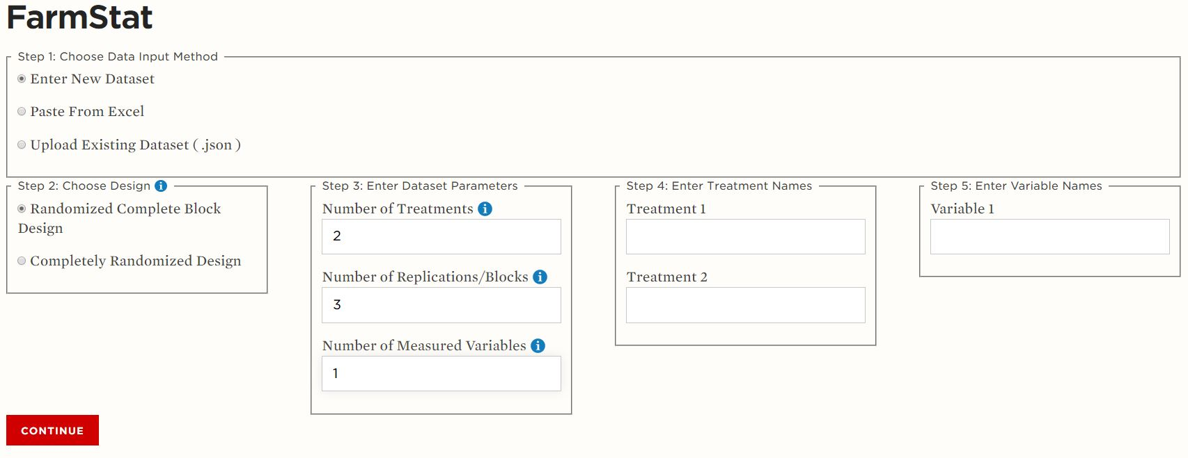
Figure 1 - Getting started with "Enter New Dataset" option.
To manually enter a new dataset:
- Select the experimental design used when collecting the data.
- Enter the dataset parameters:
  - Number of treatments (e.g. planting rates of 27,000 seeds/ac and 32,000 seeds/ac)
  - Number of blocks or replications
    - If the number of replications for a completely randomized design is different between treatments, enter the maximum number of replications observed.
  - Number of measured variables (e.g. yield, moisture)
- Enter treatment and variable names.
- Press the “Continue” button to proceed to the analysis portion of the program.
- Enter a title for the analysis to be used for the title of saved input data files and analysis output files.
- Enter data in appropriate columns and rows according to variable name, treatment name, and replication or block.
- Once data is satisfactorily entered, proceed to analyzing the data.
If the wrong number of treatments, datasets, or variables was entered on the “Getting Started” page, or if naming was incorrect, simply click the “Start Over” button at the bottom of the data table to erase the entered information and return to the initial data import page. Additionally, if a large mistake entering data is made – such as entering the data for a variable in the wrong column – the “Reset” button can be clicked to erase all the entered data.
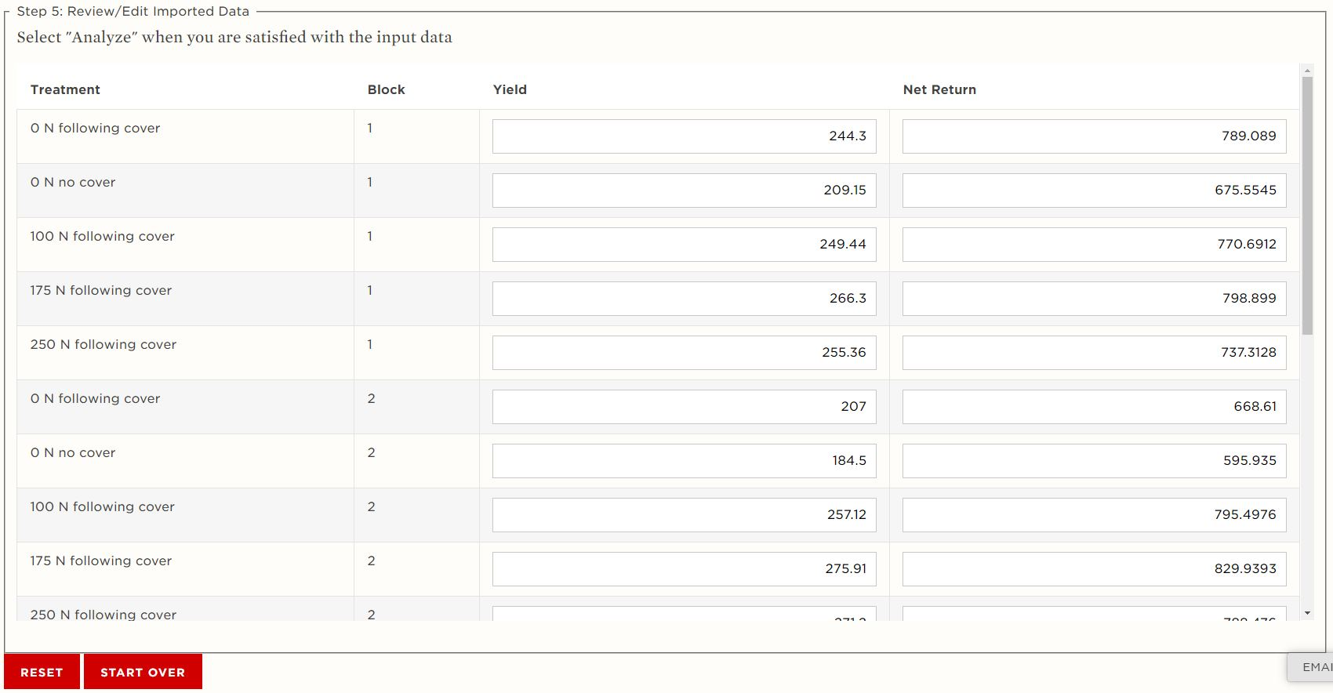
Figure 2 - Title entry and data input table.

“Paste From Excel”
The “Paste From Excel” data entry method should be selected if the data to be analyzed has already been organized into a format that is openable in Microsoft® Excel®.

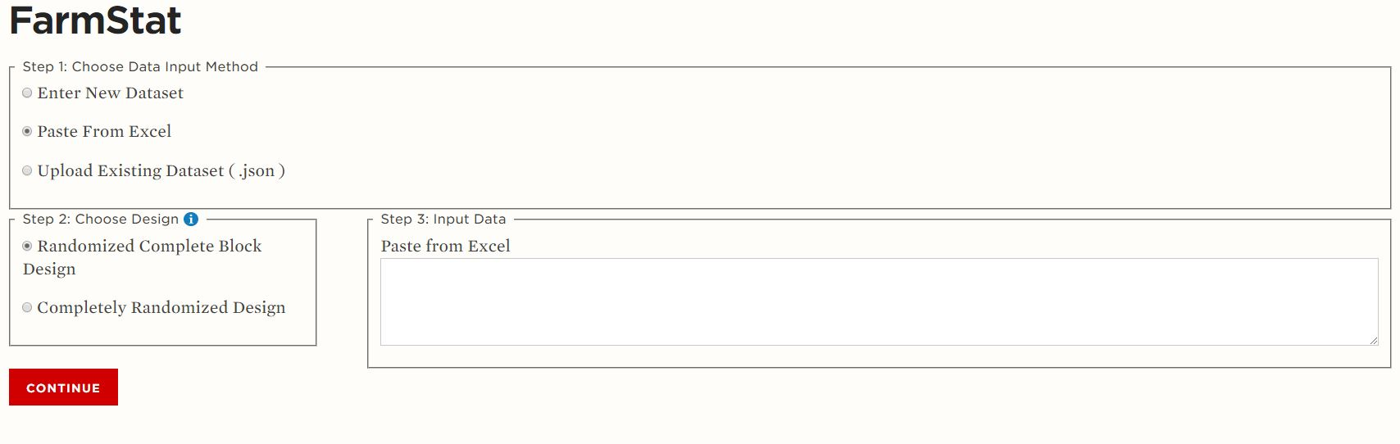
Figure 3 - Getting started with "Paste From Excel" option.

To use the “Paste From Excel” method, these are the steps to follow:
- Open your data in Excel – if your data is in a .txt, .csv, or other format, this may require additional import steps in Excel.
- Properly format the data in Excel according to the guidelines in Organizing Data.
- Select the appropriate design for the data to be analyzed.
- Copy the dataset cells from excel.
- Paste the data into the empty white box under the data input selection section in FarmStat by right clicking in the box and selecting paste.
- Scroll up and down in the box to verify that the data was pasted correctly.
- If the data has been properly populated in the box and the experimental design has been selected, press continue to proceed to the data analysis stage.
- Verify that the data is correct in the table that is presented; if the data is not correct, the data can be edited in individual cells.
  - Additionally, the input data can be erased by clicking the “Reset” button or data can be repasted by clicking “Start Over” and following the process described in this section.
- Finally, ensure that an appropriate title for the data analysis has been entered at the top of the page before proceeding with the analysis.

“Upload Existing Dataset (.json)”
“Upload Existing Dataset (.json)” should be selected if the data to be analyzed has been previously entered for analysis in FarmStat and was saved in a .json file format for future reference and analysis. Once this method has been selected, a “Choose File” button will appear.

Figure 4 - Getting started with "Upload Existing Dataset (.json)" option.
Here’s how to use the “Upload Existing Dataset (.json)” method:
- Click the “Choose File” button to open a file browser window.
- In the file browser window, navigate to the file location of the file with the data to be analyzed.
- Select the file and click “Open” to proceed back to the FarmStat interface.
- If the file name displayed next to “Choose File” is appropriate, click “Import File” to proceed.
FarmStat will now display the data analysis page, including the input data table and title input box. The title will be auto-populated based on the name of the imported file.
- Verify that this title is correct – change it to something else if desired.
- Verify that the data table has been populated correctly and that the expected data has been uploaded.
  - If the entered data needs to be edited, individual cell values can be edited manually. To re-enter all data manually, click “Reset” to erase all existing data. If a different dataset needs to be uploaded instead, click “Start Over” and then follow the process described in this section.
- Once data has been entered satisfactorily, proceed with the analysis.

Analyzing Data
Analyzing data with FarmStat is designed to be straightforward. Once data and a title for the analysis have been satisfactorily entered into the FarmStat program, the final step before analyzing the data is to select the appropriate alpha-level for the analysis. The alpha-level selected will influence the detection of statistically significant differences between treatments and blocks (if using a randomized complete block design). FarmStat offers two common alpha-level options for analyzing data: 0.05 and 0.10. An alpha-level of 0.05 will correspond to 95% confidence in statistically significant differences while an alpha-level of 0.10 will correspond to 90% confidence in statistically significant differences. The alpha-level selected should correspond to the desired level of confidence in the validity of conclusions drawn from the experiment.

Figure 5 - Alpha-level selection is shown under the title entry box.

Instructions for Analysis:
- Select the appropriate alpha-level for the analysis.
- Click “Analyze” to initiate the ANOVA procedure for the data.
- Explore the analysis output – it includes an ANOVA table, block means, treatment means, mean separations, and conclusion statements.
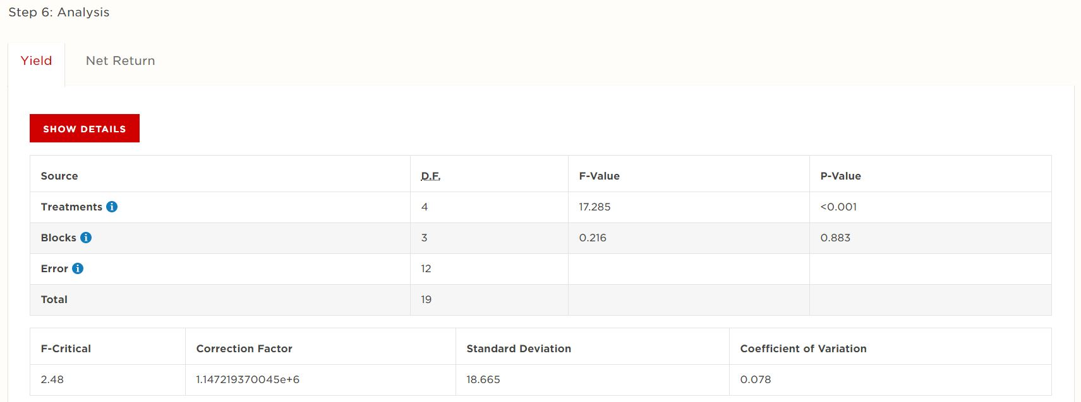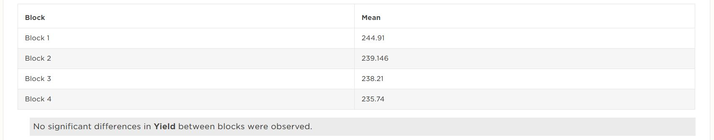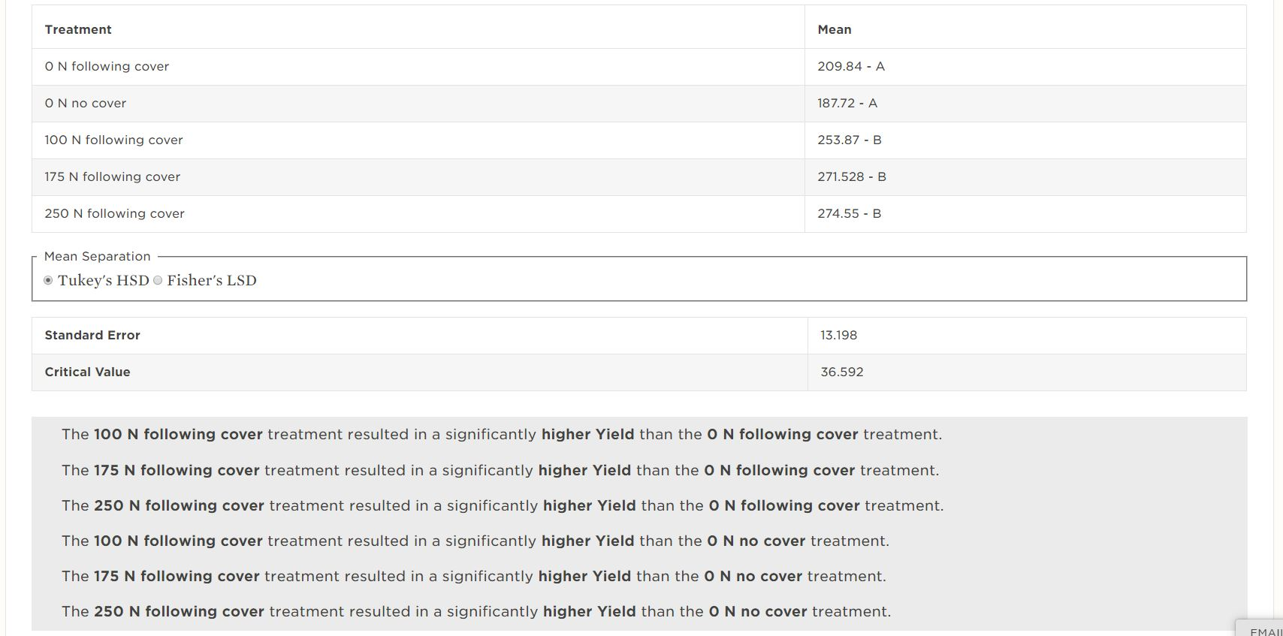
Figure 6 - FarmStat statistical analysis output.
  - Toggle tabs above the ANOVA table to change the variable for which analysis output is being displayed
  - The default ANOVA table shown is simplified – click “Show Details” to see the entire output.
  - View values for block means and use letters to interpret statistical significance – this is only available for RCBD designs.
  - View values for treatment means and use letters to interpret statistical significance.
  - Toggle between Fisher’s LSD and Tukey’s HSD and see if and how the letters (significant differences) change.
  - View the critical values for the Fisher’s LSD and Tukey’s HSD tests reported under the mean separation tables.
- Read the significance (or conclusion) statements generated from the statistical analysis to help interpret the output.
- Save the analysis results and conclusion statements for future reference if desired.

Statistically Significant Differences
Statistically significant differences between treatments or blocks (factors in ANOVA procedures) exist when the corresponding p-value in the ANOVA table is smaller than the alpha-level selected. The p-value can be interpreted as the probability that all the treatments or blocks have the same mean. However, depending on the number of blocks or treatments included in the experiment, the p-value does not necessarily indicate which treatments or blocks were different from each other. Additional tests (called ad-hoc tests) such as Tukey’s HSD or Fisher’s LSD are used to determine specific differences between treatments or blocks. FarmStat uses Tukey’s HSD to determine differences by default, but Fisher’s LSD can also be used. Combinations of letters displayed adjacent to values within mean tables indicate statistically significant differences based on the ad-hoc test. Values with matching letters are not statistically different from each other, and values that do not have any matching letters are statistically different.

Figure 7 - Mean separation table with letters to indicate statistical significance from Tukey's HSD test.

Saving Input Data
Data entered into FarmStat using any of the input methods may be saved for future reference. There are two methods to save only the input data. One method is to save the input data as a FarmStat specific .json file. This method is best when the data should be saved for future analyses and editing within the FarmStat program.
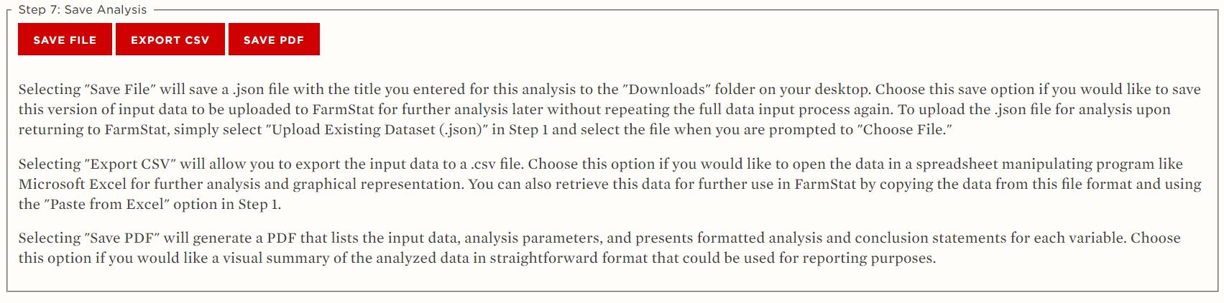
Figure 8 - Save buttons are found below the statistical analysis output.
To save input data in a .json file:
- Click the “Save File” button below the analysis output.
- Make sure the browser shows a download occurring.
- Navigate to the “Downloads” folder on the computer to find the file.
- Move or copy the file from the “Downloads” folder if it should be saved in another location.
Alternatively, input data can be exported as a .csv file. This option is especially attractive when the data may need to be used or analyzed in other programs, such as Microsoft® Excel®.

To export the data as a .csv file:
- Click “Export CSV” which is located adjacent to the “Save File” button.
- Make sure the browser shows a download occurring.
- Navigate to the “Downloads” folder on the computer to find the file.
- Move or copy the file from the “Downloads” folder if it should be saved in another location.

Saving Results
Analysis results, and the corresponding input data, may be summarized and saved in PDF format. PDF output will include full analysis output for all measured and analyzed variables, as well as the title of the analysis, the experimental design, and the alpha-level at which the analysis was conducted.

To generate and save the analysis results PDF:
- Click the “Save PDF” button located adjacent to the “Export CSV” button.
- Make sure the browser shows a download occurring.
- Navigate to the “Downloads” folder on the computer to find the file.
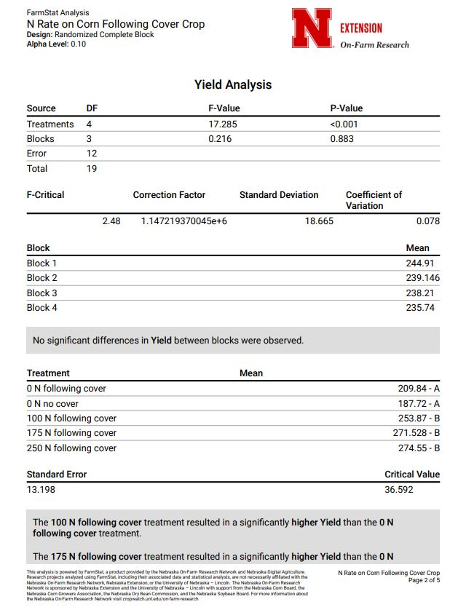
- Move of copy the file from the “Downloads” folder to another location if it should be stored in a more permanent location.
Figure 9 - Example of PDF report of statistical analysis completed in FarmStat.

Using FarmStat Results
FarmStat is a program designed to empower effective agricultural experimentation, on-farm or otherwise, and facilitate statistically supported decisions made from agricultural experiments. Using FarmStat analyses for enhancing agricultural research in any agricultural research domain is encouraged. Analyses generated by FarmStat are provided free of charge for registered users. Analyses generated by FarmStat may be referenced and included in publications (peer-reviewed or otherwise), provided proper attribution is given to FarmStat. Research projects analyzed using FarmStat, including their associated data and statistical analysis, are not necessarily affiliated with the Nebraska On-Farm Research Network, Nebraska Extension, or the University of Nebraska – Lincoln. Improper attribution to FarmStat or misrepresenting FarmStat analyses as research conducted by the University of Nebraska – Lincoln, the Nebraska On-Farm Research Network, or Nebraska Extension will be found in violation of the user agreement and subject to consequence.

