Nebraska Irrigation and Water Management Curriculum

Center Pivot Irrigation

|  |  |  |  |  |
| --- | --- | --- | --- | --- |
| **Grade Level**  7th -12th Grades  **Lesson Length**  90-120 minutes  **Key Terms:**  Center pivot irrigation  Drop tube  End gun  Nozzle  Pivot arm  Pivot point  Sprinkler pad  Tower  **STEM Careers**   * Agronomist * Agricultural Engineer * Design Engineer * Irrigation Specialist * Irrigated Farmer |  | **Overall Goal**  Students will understand how center pivot irrigation systems operate and will discuss factors influencing their water application.  **Learning Objectives**  By the end of this lesson, students will know or be able to:   * Define center pivot irrigation. * Illustrate how center pivot irrigation systems are designed and operate. * Identify alternative sprinkler irrigation systems. * Describe factors that influence water application in center pivot systems.   **Educational Standards Supported**  Nebraska Science Standards: SC.7.7.3.D, SC.7.8.4.E , SC.7.13.5.C, SC.HS.7.2.E, SC.HS.15.5.5.A, SC.HS.15.5.D  **Materials List**   |  |  | | --- | --- | | * Spray bottles with adjustable nozzles * Tape * Small coffee straws * Pipe cleaners * Rubber bands * Paper clips * Scissors * Yarn | * Thumbtack * Tube * Syringe * Clay * Water * Food coloring * Paper |   **Preparatory Work**   * Print Science Notebook pages * Color water with food coloring and pour into spray bottles with adjustable nozzles (Objective 3). * Gather and separate materials for groups of 3-4 students to build center pivot irrigation system. |



Types of Irrigation



[water.unl.edu](https://water.unl.edu) website

[cropwatch.unl.edu](https://cropwatch.unl.edu) website



Check out Nebraska Extension’s Interactive [Agricultural Water Management Guide](http://cropwatch.unl.edu/Agricultural_Water_Management_Guide/index.html)!

**Introduction** (3 minutes)

**Brain Dump**

*In a moment, I will reveal a word or phrase. Upon seeing this word, write down everything you know about it! Capture your thoughts in your Science Journal.*

Reveal the word “Center Pivot.” Allow students 1-2 minutes to write what they know or have experienced with center pivots. Once students are finished writing, ask students to share a few thoughts they captured.

**Preview** (1 minute)

*Thank you for sharing all that you know or have experienced with center pivot irrigation! As we heard, this is one system that producers use to distribute water to their crops. Today we will explore how center pivot irrigation systems are designed and operate, and features that influence how much water is applied to fields.*

**Objective 1 | Define center pivot irrigation** (25 minutes)

**Experience**

*What movement does a center pivot irrigation make? (Listen for: circular)*

*As a class, we will replicate the movement of a center pivot irrigation system. Our objective will be to move in unison – staying in a straight line – through the course of a 360-degree rotation. One individual will serve as the pivot point and remain in the same spot throughout the rotation. Everyone else will act as a pivot tower. The towers will be connected with our arms stretched out and placed on our neighbors’ shoulders.*

Move outside or in a gym for enough space to complete the activity. With a large class, split into two groups. Students positioned furthest from the pivot point will need to walk faster or take larger steps than the students near the pivot point. Once students are moving in unison, instruct them to speed up their pace and/or move in reverse.

If completing the activity outside, have students free up one arm and distribute spray bottles. Have students spray water straight up into the air as they walk. Next, have students direct the spray bottle toward the ground. Ask students to observe the water distribution between spraying in the air and spraying directly on the ground.

**Process:**

* What was difficult about completing a full rotation?
* What adjustments had to be made to complete this task?
* What did you observe about the water distribution?
  + From near the pivot point to the last pivot tower
  + Spraying into the air versus spraying toward the ground
* So what does this illustrate about center pivot irrigation systems?   
  (Listen for: the end of center pivot systems must irrigate a greater area of land while moving at a faster rate.)

*These observations are spot on. Let’s head back inside to capture what we’ve learned.*

**Point**

*Center pivots are the most widely used sprinkler system. Center pivots have been adapted to operate on many soils, to extremely variable terrain, and to provide water to meet many management objectives­. In Nebraska, center pivots are used to irrigate about 6.8 million acres of cropland. The number of acres irrigated by center pivots is increasing each year, largely because the system requires less labor and provides substantial improvements in the operator’s ability to manage and automate irrigation water applications*

*Capture these definitions in your Science Notebooks:*

**Center pivot irrigation** – a water distribution pipeline anchored­ at one end and allowed to rotate or pivot from the stationary end.

**Pivot point** – stationary end of the water distribution pipeline. Connects the water source to the main arm of the pivot.

*About how long do you think a center pivot is?*

*The length of center pivots can vary from 300 feet to more than 2600 feet. However, most center pivots measure 1/4 mile long – about 1300 feet - with 6 or more towers that irrigate approximately 130 acres.*

**Application**Lead a discussion about center pivotirrigation. Consider the following questions to help guide the discussion:

* Why is center pivot irrigation important to Nebraska?
* How does it compare to other irrigation systems we’ve discussed?
* Why do you think center pivot irrigation is the most commonly used irrigation system in the state?

**Objective 2 | Illustrate how center pivot irrigation systems are designed and operate** (30 minutes)

**Experience**

Students will work in teams of 2-3 to design and build a model of a center pivot irrigation system. Provide students materials such as, large drinking straws, small coffee stirring straws, tape, pipe cleaners, paper clips, rubber bands, scissors, yarn, thumb tack, tube, syringe, clay etc. to build their irrigation system. Upon construction, have students demonstrate and explain their system. Ask them to explain:

* How water enters the center pivot (Listen for: Water is pumped into the pivot point from groundwater or surface water.)
* How water is applied to crops (Listen for: water is pushed down the length of the pivot arm and out of the nozzles)
* How center pivots move (Listen for: a motor powers the system to move on wheels in a circular motion)

**Process:**

* What factors influence water distribution in center pivot systems? (Listen for: rate the system is moving, water pump rate, nozzle size)
* What are potential inefficiencies when it comes to center pivot systems? (Listen for: evaporation)
* How could the design improve to reduce evaporation? (Listen for: lower the nozzles closer to the ground, known as a dropped tube)
* What have you learned about center pivot irrigation after designing your own system?

*We have modeled a center pivot irrigation system, now let’s put a name to the components we’ve built.*

**Point**

Show students the images and definitions. Point to the component of the system in the PowerPoint slides. Instruct students to capture definitions and notes in their science notebooks.

**Pivot Arm –** The large pipe extending from the pivot point to the end of the field. The arm span is supported by the towers and moved by the wheels. Transports water to the nozzle while the system moves over the crop.

**Towers:** Structures with wheels that transport the pivot arm.

**Drop Tubes:** A hose that hangs from the pivot arm and delivers water closer to the soil surface. Used to decrease water lost to evaporation.

**Nozzles:** A hollow tube that directs water to be deflected off a sprinkler pad. The size of the nozzle opening can alter the pressure of the water being pushed through it. Nozzles are attached to the top of the pivot arm or the end of a drop tube.

**Sprinkler Pad:** a circular pad that distributes water in a pattern over the crop. The pattern and droplet size is determined by the surface texture, while the distance each droplet is determined by the pad’s curvature and motion.

**End Gun –** High-powered nozzles used to extend the reach of water to the corners of a field.

*With these components, water is supplied to the pivot point and distributed through the pivot arm and sprinkler nozzles where the water hits a sprinkler pad and is applied to the crop.*

Show students [this short video](https://www.youtube.com/watch?v=ND4ZDNud5i4) to watch how center pivot irrigation systems are made and operate.

**Application**

In your science notebook, draw a center pivot irrigation system. Next, label the following components of the system. Draw arrows to represent the flow of water through the system.

* + 1. Pivot Point
    2. Pivot Arm
    3. Towers
    4. Drop Tubes
    5. Nozzles
    6. Sprinkler Pad
    7. End gun

*What components of the center pivot systems are represented in our own center pivot models? Are there any components missing?*

If time allows, allow students to add additional components (such as drop tubes) to their irrigation systems.

**Objective 3 | Identify alternative sprinkler irrigation systems.** (10 minutes)

**Experience**

*Center pivots are one type of sprinkler irrigation systems. While center pivots are the most common, there are other sprinkler systems that are used today. Let’s take a few minutes to investigate online resources to identify at least one alternative sprinkler irrigation system. Be prepared to share the name of a different sprinkler irrigation system and a general description of how it works.*

Provide students about 5 minutes to search online to identify other sprinkler irrigation systems. Have students share with the class what they learned. Summarize the systems they’ve shared using the following points.

**Point**

**Tow Line Sprinklers ­–** Invented in 1950s in Portland Oregon. Consists of sections of pipe coupled together and tall sprinklers every 40 to 60 feet. Can be moved by hand or tractor.

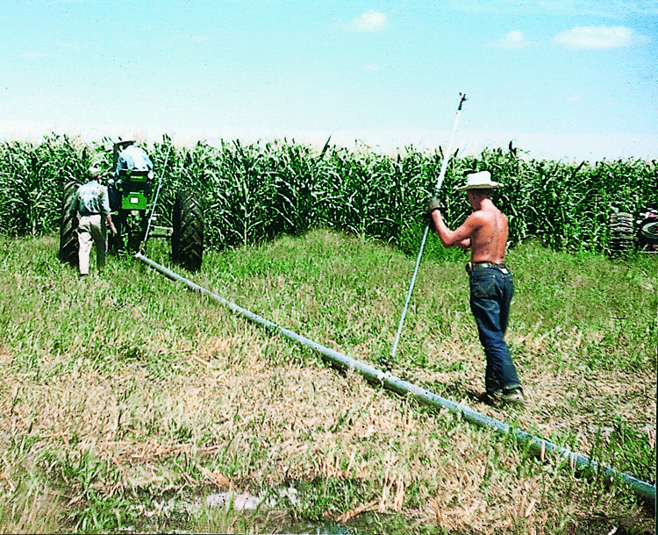

**Traveling Volume Gun Sprinklers ­–** Consists of a large sprinkler (big gun) mounted on a wheeled cart that is mechanically moved across the field, spraying water. Good for irregularly shaped or long rectangular fields. Could be cable-tow travelers or hose-pull travelers.

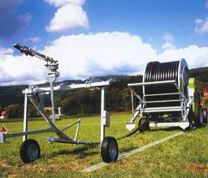

**Lateral (linear) move systems ­–** Similar to center pivot, except the entire system moves horizontally across the field. Designed primarily for use on rectangular shaped fields. Fed water from ditch that extends across field or from a large hose

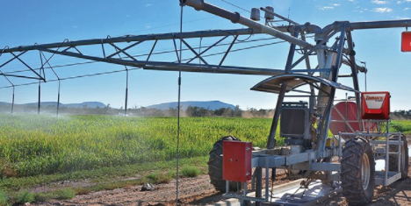

**Application**

*Label the various types of sprinkler irrigation systems in your science notebook. Include a brief description of how the system operates.*

**Objective 4 | Describe factors that influence water application in center pivot systems** (20 minutes)

**Experience**

Provide students with spray bottles that have adjustable nozzles. Fill the spray bottles with water and add food coloring. Students will spray the water onto paper to explore how nozzle settings, speed of application, and movement of the bottle influences water application. If possible, complete this activity outside.

Instruct students to experiment with different nozzle settings, various distances from paper, speed of application, and movement across the paper (static, slow, fast). Ask students to record differences they observe in water application as they alter each variable in their science notebooks.

**Process:**

* + What differences did you observe as you adjusted:
    - Nozzle settings?
    - Distance from the paper?
    - Movement across the paper?
    - Rate of application (i.e.- the amount of pressure applied to the spray bottle)?
  + How do these variables contribute to irrigation efficiency?
  + What does this demonstrate about irrigation management with center pivot systems?

**Point**

*The amount of water applied per irrigation is one of the most important pieces of information needed to manage an irrigation system. Not knowing how much water is being applied could result­ in reduced yields due to under irrigation or excessive­ production costs and nitrogen leaching due to over irrigation. In center pivot systems, water inefficiency can result from evaporation or runoff.*

*Earlier we discussed that in center pivot systems, the end of the pivot must irrigate a larger area of the field. In other words, beginning at the pivot point, each additional foot of the system must irrigate an increasing area. For a 1300-foot-long center pivot making a complete circle, the first 130 feet of the system irrigates 1.2 acres, and the last 130 feet of the system irrigates 23 acres. The outer tower of an average center pivot will travel a distance of approximately 1.5 miles, while the inner tower will travel about ¼ mile.*

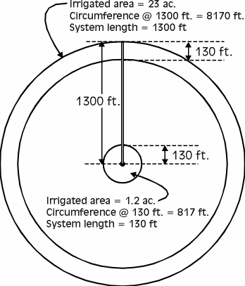

*So what influences the amount of water that is distributed? The primary factors include 1) The speed of pivot and 2) the amount of water being pumped into the system, and 3) the sprinkler package.*

**Speed of pivot –** The producer controls speed of movement.The faster the center pivot rotates around the field, the lighter the application of water. Towers do not move at equal speeds. To distribute the same amount of water to every­ portion of the field, the last 130 feet of the system must receive more than 19 times more water than the first 130 feet in one-seventh of the time.

**Flow rate ­–** Amount of water being pumped into the irrigation system and is controlled by the producer. Measured in gallons per minute (gpm). A system pumping 700 gpm will apply more water than a system pumping 500 gpm.

**Sprinkler package –** A sprinkler package is composed of a nozzle that directs a stream of water under pressure to a circular sprinkler pad, which enlarges the area over which the nozzle applies water.

Nozzles have varying diameters, which help control the volume and pressure of the water being applied to the sprinkler pad. Nozzles near the pivot point will have smaller diameters than those at the end of the system.

Some sprinkler pads are designed to rotate; these spinner pads throw water at greater distances. The surface of a sprinkler pad can range from smooth, to shallow grooves, or deep grooves. The texture of the pad determines the area covered and water droplet size. The deeper the grooves, the larger the water droplet. Larger droplets reduce water loss to evaporation, but could also compact the soil surface.

Losses to evaporation can be reduced by:

* Lowering the water pressure,
* Lowering the spray height,
* Decreasing the distance of the spray,
* Selecting larger diameter nozzles,
* Using sprinkler pads with deeper grooves.

**Application**

Instruct students to draw an image in their science notebooks that represents factors that influence the water application of center pivot irrigation systems.

Next to the images, have students describe why this factor influences irrigation efficiency.

**Review & Reflect** (2 minutes)

#### High-Five Hustle

Ask students to stand up, raise their hands and high-five a peer -- their short-term high-five buddy. When all students have found a buddy, ask a question for them to discuss. Solicit answers from two students. Tell them to “Hustle” and find a different high-five buddy for the next question. Repeat for the third question.

* Water from sprinkler systems are subject to this type of water loss. (evaporation)
* One strategy to reduce evaporation, thereby increasing water efficiency is…
* One interesting nugget I learned today was…

**Celebrate Student Success** (1 minute)

Thank students for their participation in learning about center pivot irrigation. Encourage students to look for center pivot systems when they travel across Nebraska – they cover 6.8 million acres in the state! Provide final announcements and review the next lesson.

 **References**

VanDeWalle, B., Nygren, A., Burr, C., Zoubek, G., Irmak, S. (2016) Agricultural Water Management Guide. Extension Publication. University Of Nebraska - Lincoln Extension.

The Groundwater Foundation. (2006). *Circles of Fun*. Retrieved from [www.groundwater.org](http://www.groundwater.org)

**Irrigation and Water Management**

***Science Notebook***

***Completed by:***______________________________ ***Date:*** ________________

**Center Pivot**

|  |  |
| --- | --- |
| Key Term | Definition |
| Center Pivot Irrigation­­­ |  |
| Pivot Point |  |
| Pivot Arm |  |
| Towers |  |
| Drop Tubes |  |
| Nozzles |  |
| Sprinkler Pad |  |
| End Gun |  |

**Length of system: Acres covered:**

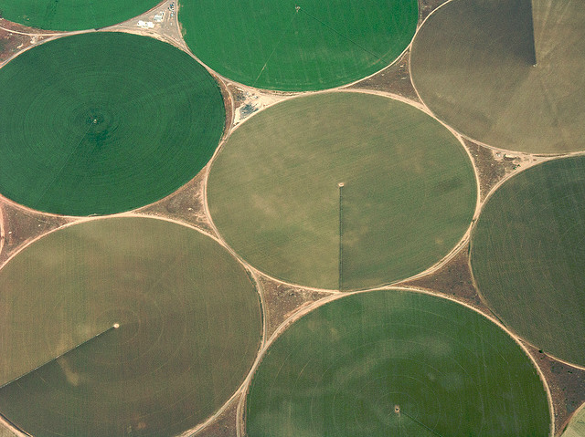

**Center Pivot Design:**

**Draw and label the components of a center pivot irrigation system. Use arrows to demonstrate the flow of water through the system.**

**Label the type of sprinkler irrigation and describe how water is delivered to the crops:**

********

|  |  |  |
| --- | --- | --- |
| Settings | | Observations |
| **Distance from paper** | 2 in. |  |
| 5 in. |  |
| 12 in. |  |
| **Nozzle size** | Wide |  |
| Narrow |  |
| **Rate of application** | High Pressure |  |
| Low Pressure |  |
| **Movement across paper** | Static |  |
| Slow movement |  |
| Fast movement |  |

**Factors that Influence Water Application:**