Soil pH is a measure of soil acidity or alkalinity. It is an important indicator of soil health. It affects crop yields, crop suitability, plant nutrient availability, and soil micro-organism activity, influencing key soil processes. Soil pH can be managed by practices such as applying the proper amount of nitrogen fertilizer, liming, and using cropping systems that increase soil organic matter content and improve overall soil health.

Inherent Factors Affecting Soil pH

Inherent factors that affect soil pH include climate, mineral content, and soil texture. Natural soil pH reflects the combined effects of the soil-forming factors (parent material, time, relief or topography, climate, and organisms). The pH of newly formed soils is determined by the minerals in the parent material.
Temperature and rainfall affect the intensity of leaching and the weathering of soil minerals. In warm, humid environments, soil pH decreases over time through acidification due to leaching from high amounts of rainfall. In dry environments where weathering and leaching are less intense, soil pH may be neutral or alkaline.
Soils that have a high content of clay and organic matter are more resistant to changes in pH (higher buffering capacity) than are sandy soils. Although clay content cannot be altered, organic matter content can be altered by management practices. Sandy soils commonly have a low content of organic matter, resulting in a low buffering capacity and a high rate of water percolation and infiltration. Thus, they are susceptible to acidification.

Soil pH Management

Soil pH is affected by land use and management. The type of vegetation on a soil impacts pH levels. For example, areas of forestland tend to be more acidic than areas of grassland. Conversion of land from forestland or grassland to cropland can result in drastic changes in pH over time. These changes are a result of loss of organic matter, removal of soil minerals when crops are harvested, and erosion of the surface layer. Also, application of nitrogen and sulfur fertilizers can lower soil pH over time.
Measures that minimize or reduce acidification:
- Liming to raise the pH of an acid soil.
- Applying nitrogen and sulfur according to the needs of the crop grown.
- Applying nitrogen fertilizer in appropriate amounts and in a timely manner (relative to crop uptake) and using proper irrigation management to minimize leaching of nitrate nitrogen.
- Diversifying crop rotations to minimize acidifying effects of applied nitrogen fertilizer.
- Applying irrigation water and manure and other organic material that have a high content of calcium or magnesium bicarbonates.
- Using continuous no-till cropping systems, using cover crops, applying solid manure, and using diverse rotations that include high-residue crops, which increase organic matter content and improve soil buffering capacity, minimizing changes in pH.

Table 1.—Crop Yields Relative to pH.
Crop | Soil pH
 | 4.7 | 5 | 5.7 | 6.8 | 7.5
 | Relative yield (100 is best; 0 is worst)
Corn | 34 | 73 | 83 | 100 | 85
Wheat | 68 | 78 | 89 | 100 | 99
Soybeans | 65 | 79 | 80 | 100 | 93
Oats | 77 | 93 | 99 | 98 | 100
Barley | 0 | 23 | 80 | 95 | 100
Alfalfa | 2 | 9 | 42 | 100 | 100
Timothy (grass) | 31 | 47 | 66 | 100 | 95
Methods for Assessing Soil Quality, page 173 (SSSA, 1996).

Problems Related to pH and Relationship of pH to Soil Function

Soil pH is an excellent indicator of the suitability of a soil for plant growth. For most crops, pH of 6 to 7.5 is optimal (table 1).
Soil pH levels that are too high or too low
(fig. 1) lead to a deficiency of many nutrients, decline in microbial activity, decrease in crop yields, and deterioration of soil health. For example, soil pH values below 5.5 and between 7.5 and 8.5 limit the availability of phosphate for plants (figures 2 and 3).
Four major management practices that increase the availability of phosphate for plants are:
- Liming acid soils to increase pH to between 6.5 and 7.0.
- Applying small amounts of phosphorus fertilizer frequently rather than a large amount at one time.
- Banding or injecting the source of the phosphorus (manure and/or fertilizer) into the soil to reduce the contact between the soil and the phosphorus.
- Applying phosphorus fertilizer near crop rows, where roots are most active.
Nitrogen cycling is inhibited by low pH. The effectiveness and degradation of herbicides and insecticides and the solubility of heavy metals are dependent on the soil pH. Some diseases thrive in alkaline or acidic soils.
The effectiveness and potential carryover
of certain herbicides is also impacted by soil pH.
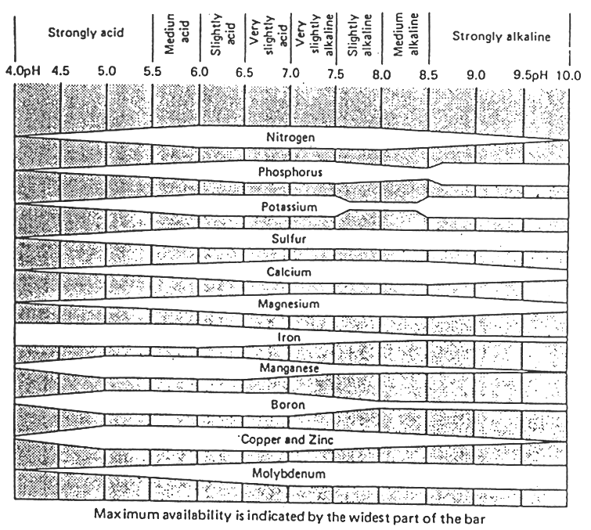
Figure 1.—Relationship between the availability of plant nutrients and soil pH (National Soil Survey Manual, USDA, NRCS).
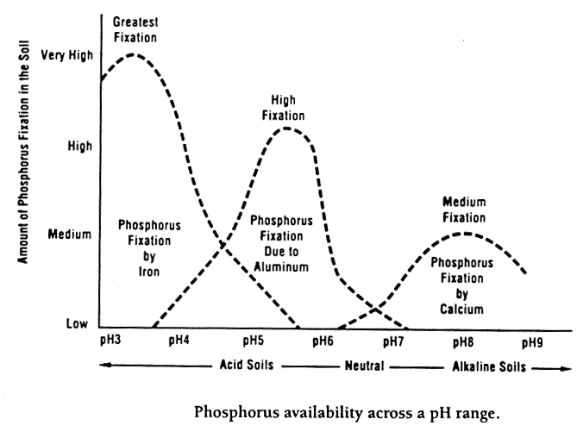
Figure 2.—Availability of phosphorus relative to pH (California Fertilizer Association, 1995).
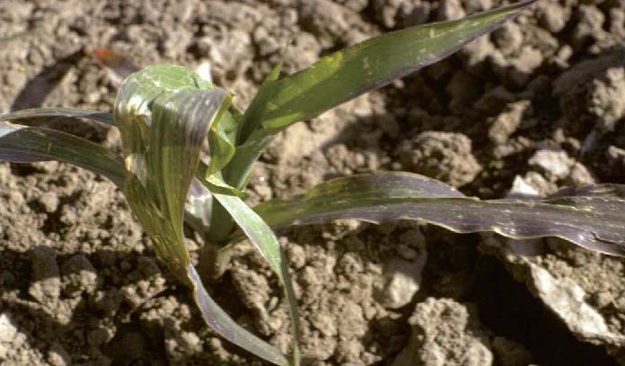
Figure 3.—Corn that is deficient in phosphorus (R.L. Croissant, Bugwood.org).

What current practices affect soil pH?

What impact are these practices expected to have on soil pH and why?

Measuring Soil pH
Materials needed to measure pH:
____ Probe and plastic container for gathering and mixing soil samples
____ Roll of pH test strips
____ 1/8-cup (29.5 mL) measuring scoop
____ Calibrated 120-mL vial with lid for shaking
____ Squirt bottle
____ Distilled water or rainwater
____ Pen, field notebook, permanent marker, and resealable plastic bags
Considerations:
Electrical conductivity should always be measured on a sample before measuring pH. Soil pH levels can be measured using the steps in the following paragraphs.
Quick in-field hand test:
- Soil pH levels vary depending on the location of the field and the time of year. They are affected by the placement of fertilizer (in rows or between rows), soil texture, organic matter content, and application of manure or other fertilizer. Using a soil probe, gather at least 10 small samples to a depth of 8 inches or less randomly from an area that represents a particular soil type and management history. Place samples in the plastic container. Do not include large stones and plant residue. Repeat this step for each sampling area.
- Neutralize hands by rubbing moist soil across palms. Discard soil.
- Place a scoop of the mixed soil in palm, and saturate with “clean” water (distilled water or rainwater).
- Squeeze hand gently until a soil and water slurry forms.
- Touch tip of piece of pH test strip 1 inch long to the soil and water slurry. Leave until the liquid is drawn up at least 1/4 to 1/2 inch beyond the area covered by the soil (fig. 4).
- Compare the color approximately one-third up the strip to the color chart on the test strip dispenser (fig. 5). Record soil pH and interpretations (table 2).
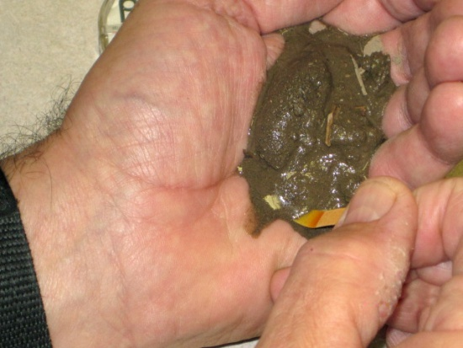
Figure 4.—Quick hand test.
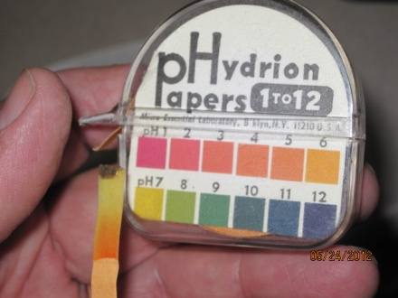
Compare color 1/3 of the way up.
Figure 5.—Soil pH color chart.

1:1 soil to water pH test in classroom:
- Soil sampling should be completed as instructed in step 1 under “Quick in-field hand test.”
- Fill scoop (29.5 mL) with the mixed soil, tamping down during filling by carefully striking scoop on a hard, level surface. Place soil in vial. Add one scoopful (29.5 mL) of water to the vial, resulting in a
1:1 ratio of soil to water, on a volume basis.
- Tightly cap the vial and shake 25 times. Let settle for 1 minute. Remove lid, and carefully decant 1/16 inch of soil and water slurry into lid. Allow to settle for 2 to 3 minutes.
- Immerse tip of piece of pH test strip 1 inch long into soil and water slurry. Leave until liquid is drawn up at least 1/4 to 1/2 inch beyond area covered by soil (fig. 6).
- Compare the color approximately one-third up the strip to the color chart on the test strip dispenser (fig. 5). Record soil pH and interpretations (table 2).
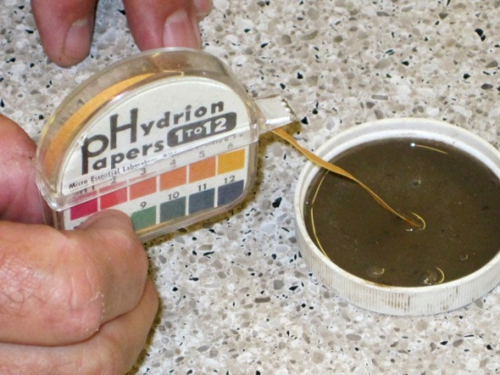
Figure 6.—1:1 soil to water test.

Interpretations

Record soil pH, and complete table 2 by comparing measured soil pH to that given in figure 1, figure 2, and table 1. Answer discussion questions.
In general, pH values between 6 and 7.5 are optimum for crop and forage production and nutrient uptake. Soil pH impacts nutrient availability and overall soil health. Soil acidification can be an indication of excessive application of nitrogen fertilizer.

Table 2.—Soil pH and Interpretations
Site | Soil pH | Soil pH category (from figure 1) | Nutrients impacted by soil pH (from figures 1 and 2) | Crops impacted by soil pH level (from table 1) | Notes
Ex. 1 | 5.8 | Medium acid | Phosphorus, potassium, calcium, molybdenum | All but oats | Spring test on corn stubble

Compare test results recorded in table 2 to values in figure 1, figure 2, and table 1. Are soil pH
levels ideal for crops or forage grown? Why or why not?

Based on results of soil pH test, is liming or other measures to adjust pH recommended? Why
or why not?
USDA is an equal opportunity provider and employer.

Glossary

Acidity.—Soil pH lower than 7.
Alkalinity.—Soil pH higher than 7.
Anion.—Negatively charged ion.
Buffering capacity.—Ability of soils to resist changes in pH levels. Soils that have a high content of clay and organic matter have a higher buffering capacity.
Cation.—Positively charged ion.
Nitrification.—Oxidation of ammonium-nitrogen compounds in organic material or fertilizer into nitrites and nitrates by soil bacteria, making nitrogen available to plants.
USDA is an equal opportunity provider and employer.
Phosphorus fixation.—Tying up of phosphorus by calcium, iron, or aluminum compounds, making it unavailable for plant use. Fixation is impacted by soil pH.
Soil pH.—Measure of soil acidity or alkalinity.

