Nitrogen (N) is the most abundant element in the atmosphere, and it generally is the most limiting nutrient for crops. Nitrogen cycles in soil through various processes and in various forms (fig. 1). Some of the processes convert N into forms that can be used by plants, and some of the processes, such as leaching and volatilization, can lead to N losses. Nitrogen is added to soil naturally through N fixation by soil bacteria and legumes and through rainfall. Additional N typically is applied to the soil by use of fertilizer, manure, or other organic material. Because N is so dynamic, it can easily be lost to the environment, making it difficult to determine adequate N levels throughout the growth cycle of crops. The soil nitrate N level is a reasonable indicator of N cycling in soils, and it can be used to help determine whether carryover nitrogen was used by the previous crop and whether additional nitrogen is needed. In addition, the nitrate N level is an excellent indicator of soil organic matter mineralization and excessive or inadequate application of N fertilizer for optimum crop or forage production. Excessive application of N fertilizer can result in leaching of nitrates below the root zone and into groundwater at a shallow depth or into drainage tiles.
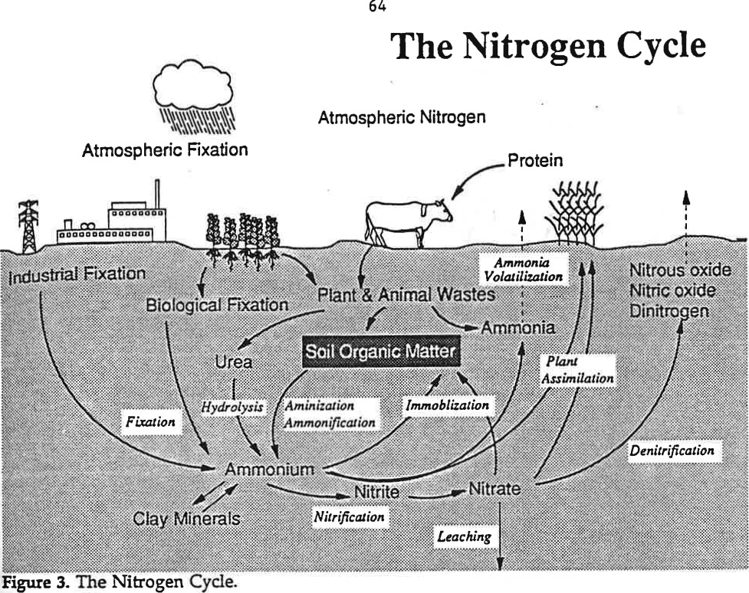
Figure 1.—Nitrogen cycle (“Soil as a Plant Sees It,” University of Nebraska, 1991).

Inherent Factors Affecting Soil Nitrogen

Inherent factors, such as soil drainage, soil texture, calcium carbonate content, and steepness of slope impact the transport and transformation processes of N and limit availability to crops or increase potential for loss. Inherent factors, such as rainfall and temperature, and site conditions, such as soil moisture and aeration (oxygen level) and salt content (electrical conductivity), affect the rate of N mineralization from organic matter decomposition, affect N cycling, and can result in N loss through leaching, runoff, or denitrification. Organic matter decomposes, releasing N, more quickly in warm, humid climates than in cool, dry climates. Nitrogen is also released quicker in well-aerated soils than in saturated soils.
Nitrogen can readily leach out of the root zone in the form of nitrate N. The potential for leaching is dependent on soil texture (percentage of sand, silt, and clay) and soil water content. Water moves more quickly through the large pore spaces in sandy soils than it does through the small pore spaces in clayey soils, and the available water capacity in sandy soils is much lower. Denitrification occurs in soils that are poorly drained and are ponded or saturated with water, resulting in loss of N as gases. This can result in emission of potent greenhouse gases, a reduction in yields, and a need for additional applications of N fertilizer, which can increase cost.
The presence of excessive calcium carbonate in soils can cause ammonium (NH₄₊) to convert to ammonia (NH₃), which can then volatilize. Applying lime does not significantly affect this process.

Nitrogen Management
Management factors, such as the rate, timing, and method of application, source of N, irrigation management, residue management, and type of crops grown, and the presence of a tillage pan can affect how efficiently N is used by crops and the amount of N loss. Management of N in sandy soils is important because of the high potential for loss through leaching. Applying N at the proper rate is the primary management consideration; however, selecting the appropriate source of N, properly timing application to coincide with plant uptake, and using the proper method of application, such as injecting to minimize loss, are also important. Management practices that increase organic matter content and minimize compaction are needed to help stabilize the supply of N to crops, increase aeration, and limit N loss as a result of denitrification in saturated soils.
Apply nitrogen based on the amount needed to optimize yields with consideration of the agronomic, economic, and environmental effects. When determining the proper rate of application of N fertilizer or manure, consider the residual nitrate N in the soil, mineralization of organic matter, N supplied by legumes, manure or other organic amendments applied, nitrate N content in irrigation water, decomposition of residue, and natural sources of N.
Properly time application to provide adequate amounts of N when plants are actively growing and using N rapidly. Loss of applied N can be minimized by delaying application until the crop has emerged (side dressing). Applying some N prior to crop emergence and some after emergence can also increase the efficiency of use by crops.
Select the proper source of N and proper method of application to maximize N recovery by crops and minimize loss from volatilization and leaching. Anhydrous ammonia commonly is the least expensive source of N, but it must be handled properly and injected or knifed into the soil under ideal soil moisture conditions. Urea should be injected to reduce loss from volatilization of ammonia. Surface-applied urea N fertilizers should not be applied during warm, humid conditions or on wet residue because of the high potential for N loss from volatilization. Other sources of N are manure and other organic amendments. Care must be taken to apply manure uniformly at an appropriate rate, accounting for mineralization. If urea and ammonia fertilizers are used on calcareous soils, they should be incorporated or injected under moist conditions to minimize volatilization.
Placement of N fertilizer can be accomplished by several methods. These typically include side dress application after crop emergence; knife application, which places a band of fertilizer below the soil surface; uniform application by broadcasting; and application through sprinkler irrigation systems. The method should be selected according to the type of fertilizer or manure to be applied.
Timing of irrigation is important. Enough water should be applied to optimize yields while avoiding excessive amounts that can increase cost and leach N below the root zone.
To efficiently manage N:
- Apply recommended rate based on expected yields.
- Time N application to align with crop needs.
- Select an ammonium fertilizer that maximizes N recovery by crops.
- Inject N, if possible, to avoid loss through volatilization of ammonia.
- Use N inhibitors unless it is applied during the growing season.
- Consider all sources of N in the soil.
- Irrigate properly.
- Monitor the N needs of the crop grown.
- Test the soil regularly for nitrate content (include deep samples) and salt content (EC).
Yellow coloration of corn leaves in a V-shaped pattern is symptomatic of nitrogen deficiency (fig. 2). This pattern progresses from the end of the leaf to the collar and from the lower leaves to the upper ones. Commonly, the lower leaves die when nitrogen deficiency is severe.
Figure 2.—Nitrogen-deficient corn characterized by yellow coloration in V-shaped pattern.
Nitrogen cycle:
Nitrogen gas (N₂) is the largest constituent of the Earth's atmosphere and is in soil pore spaces. It is relatively unuseable by plants; therefore, it must go through a natural fixation process to become available to plants. Greenhouse gases, including nitrous oxide (N₂O) and nitric oxide (NO), can also be in pore spaces and be released into the atmosphere.
The main inorganic forms of N in soils are ammonium (NH₄) and nitrate (NO₃), which are both useable by plants. Organic nitrogen may be present as a living organism, as humus, or as the intermediate products of organic matter decomposition. The processes included in the nitrogen cycle transform nitrogen from one form into another. Nitrogen processes in soils are carried out by microbes to harvest energy, for microbial growth, or for plant use. These processes make up the nitrogen cycle (fig. 1). Nitrogen fixation, mineralization, nitrification, leaching, plant assimilation, ammonia volatilization, denitrification, and immobilization can occur in the N cycle in a soil, depending on soil conditions and management.

What management practices being used affect N loss from leaching and volatilization, etc.?

Are soil nitrate N levels expected to be high or low? Why?

Measuring Soil Nitrate/Nitrite Levels

Materials needed to measure nitrate/nitrite levels:
____ Plastic containers and probe for gathering and mixing soil samples
____ Nitrate/nitrite test strips
____ 1/8-cup (29.5 mL) measuring scoop
____ Calibrated 120-mL vial with lid for shaking
____ Squirt bottle
____ Distilled water or rainwater
____ Pen, field notebook, permanent marker, and resealable bags
Considerations:
Electrical conductivity (EC) should always be measured before measuring nitrate or nitrite content on a soil sample. Soil phosphates and pH can also be measured on the sample.
Quick in-field hand test:
- Soil nitrate N levels are highly variable, depending on management history, field location, and time of year. Factors include the rate of erosion, soil texture, organic matter content, and applications of manure or fertilizer. Using a soil probe, gather at least 10 small samples randomly from an area that represents a particular soil type and management history. The probe should extend to a depth of 8 inches or less for a surface layer sample and to a depth of as much as 3 feet for a subsurface layer sample. Place samples in a plastic container and mix. Surface layer and subsurface layer samples should be placed in separate containers. Do not include large stones and plant residue. Repeat step 1 for each sampling area.

- Neutralize hands by rubbing moist soil across palms. Discard soil. Place a scoop of mixed soil in palm of hand and saturate with “clean” water (distilled water or rainwater).
- Squeeze hand gently until a soil and water slurry forms.
- Touch tip of nitrate test strip to soil and water slurry. Leave until the slurry is
drawn up at least 1/8 to 3/16 inch on strip (fig. 3).
- After 1 to 2 minutes, measure nitrate by comparing the color of the wet test strip to the color chart on the test strip container (fig. 4). The color that most closely matches the test strip indicates the amount of nitrate in the saturated soil.
- Bend or cut off end of strip to expose the tip for the nitrite test. Repeat steps 2 through 5 to determine the amount of nitrite in the saturated soil.
Figure 3.—Quick nitrate N hand test.
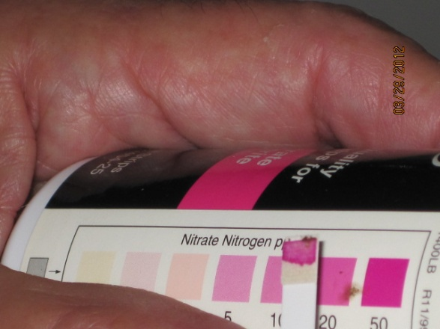
Figure 4.—Nitrate color chart.
1:1 soil to water nitrate/nitrite test for classroom:
- Gather samples as instructed in step 1 under “Quick in-field hand test.”
- Fill scoop (29.5 ml) with mixed soil, tamping down during filling by carefully striking scoop on a hard, level surface. Put soil in vial. Add one scoopful (29.5 ml) of water to the vial, resulting in a 1:1 ratio of soil to water, on a volume basis.
- Tightly cap the vial and shake 25 times. Let settle for 1 minute. Remove cap, and carefully decant 1/16 inch of the soil and water slurry into the cap.
- Allow to settle for 2 to 3 minutes. Touch end of nitrate test strip to soil and water slurry. Leave until liquid is drawn up to least 1/8 to 3/16 inch beyond the area covered by the soil (fig. 5).
- After 1 to 2 minutes, compare color of wet test strip to color chart on the test strip container (fig. 4). The color on the chart that most closely matches the color on the test strip indicates the amount of nitrate in the saturated soil.
- Bend or cut off end of strip to expose the tip for the nitrite test. Repeat steps 2 through 5 to determine the amount of nitrite in the saturated soil.
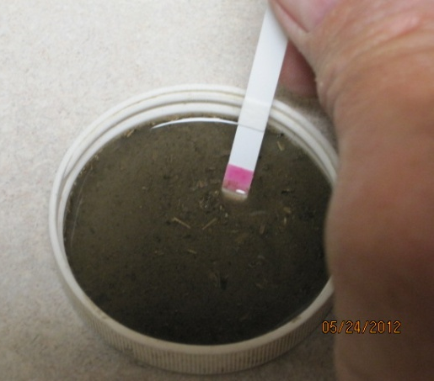
Figure 5.—1:1 soil to water test for nitrate.

Interpretations

Soil nitrate N is an excellent indicator of N cycling in soils. The levels help in determining whether carryover nitrogen was used by the previous crop and whether additional nitrogen is needed. High nitrate N levels indicate excessive application of nitrogen, a high rate of organic N mineralization, and potential for loss from denitrification, leaching, or volatilization.
Typically, an early-season measurement of
20 parts per million (ppm) nitrate N in the surface layer (upper 6 to 8 inches) is sufficient to produce a good yield of corn and most other crops that use a high amount of N. A value of 14 ppm is sufficient in areas where animal manure is applied or a cropping rotation of corn or other crops that use a high amount of N and legumes is used. A nitrate N level of more than 40 ppm in the surface layer restricts the ability of bacteria and legumes to fix nitrogen; therefore, nitrogen applications should be managed to maintain nitrate N levels below this level. Adjust nitrate N levels according to soil bulk density and moisture content, as shown in table 1.
Table 1.—Average bulk density of organic matter and upper part of soils with varying textures (Rawls, 1983;
C. Smith, 2014 [red clayey and volcanic ash soils]).
Organic matter and soil textures | Average bulk density (g/cm³)
Organic matter | 0.22
Sand | 1.56
Loamy sand | 1.54
Sandy loam | 1.50
Loam | 1.45
Silt loam | 1.20
Sandy clay loam | 1.63
Silty clay | 1.55
Clay loam | 1.45
Silty clay loam | 1.40
Red clayey soils | 1.10
Volcanic ash soils | 0.80

Soil nitrate-N calculations (for completing table 2):
Example—silty clay loam; 8 inch sample depth; 2 percent organic matter estimate determined from soil color chart; no bulk density (BD) measurement (BD based on estimated values in table 1).
Sampling depth conversion:
Sampling depth in centimeters (cm) = sampling depth in inches (in) x (2.54)
Example—
8 in x 2.54 = 20 cm sampling depth
Subsample soil water content (gram/gram [g/g]): (weight of moist soil – weight of oven-dry soil)
(weight of oven-dry soil)
Example—
(41.0 g – 32.5 g) = 0.262 g of water/g of soil
32.5 g

Dry weight of soil: (weight of moist soil in scoop) ÷ (1 + soil water content [decimal])
Example—
41.0 g ÷ (1 + 0.262 g/g) = 32.5 g
Volume (weight) of water: Water added to soil (g) + (dry weight of soil x soil water content [g/g])
(1 milliliter water = 1 g)
Example—
29.5 g + (32.5 g x 0.262 g/g) = 38.0 g
Adjusted ppm soil nitrate N: (ppm of NO₃ N in 1:1 mixture) x (volume of water in extract and soil)
dry weight of extracted soil
Example—(20 ppm x 38.0 g) ÷ 32.5 g = 23.4 ppm (adjusted)
Estimated bulk density (BD) (refer to “Bulk density” guide for educators to calculate actual bulk density or use estimates in table 1):
Estimated bulk density (record in table 2) = 100
(percent organic matter) ÷ (organic matter BD) +
(100 - percent organic matter) ÷ (average soil BD)
Example—
100 = 1.26 g/cm3
(2.0 ÷ 0.22 g/cm3) + (100 – 2) ÷ (1.40 g/cm3)
Pounds (lbs) of nitrate N/acre-depth sampled: (adjusted ppm NO₃ N) x (soil sample depth [cm] ÷ 10) x estimated soil bulk density x 0.89 (conversion factor)
Example—(23.4 ppm NO₃ N) x (20 cm ÷ 10) x (1.26 g/cm3 [estimated BD]) x (0.89) = 52.5 lbs nitrate N/acre-20 cm sampling depth (8 in)

Table 2.—Soil nitrate nitrogen
(Based on sampling depth.)
Site | Sample depth (in or cm)* | Nitrate N from test strip (ppm) | Adjusted nitrate N (ppm)* | Bulk density (g/cm3)* | Nitrate N/ acre/sample depth (lbs)* | Nitrite N  from test strip (ppm)** | Notes
Ex. | 8 in, or 20 cm | 20 | 23.4 | 1.26 | 52.5 | N/A | N tested in spring prior to planting
* Follow steps for calculating soil nitrate based on sampling depth.
** If nitrate N exceeds 40 ppm or EC exceeds 0.6 ds/m, soil nitrite should also be measured.
Nitrate and nitrite levels in water:
Nitrate and nitrite levels can be estimated for drinking water, irrigation water, and other water sources. Treatment of drinking water should be considered if nitrate N levels are higher than
10 milligrams per liter, which is considered by the Environmental Protection Agency (EPA) to be the maximum contaminant level. If levels are high, consult your local health officials.
Nitrate levels in groundwater may vary seasonally. If the water tests high or borderline high, retest it every 3 to 6 months. Nitrate in irrigation water can be credited as N for use by crops. Use the formula given in the footnote for table 3.
To test cloudy water samples*—
- Collect water sample in small plastic vial.
- Tightly cap the vial and shake 25 times. Let settle for 1 minute. Remove cap, and carefully decant 1/16 inch of water into the cap.
- Allow to settle for 2 to 3 minutes. Touch tip of nitrate test strip to water. Leave until liquid is drawn up to at least 1/8 to 3/16 inch on the strip.
- After 1 to 2 minutes, compare the color of the wet test strip to the color chart on the test strip container (fig. 4). The color that most closely matches the test strip indicates the amount of nitrate in the saturated soil. Record appropriate nitrate level (ppm) in table 3.
- Bend or cut off end of strip to expose the tip for the nitrite test. Repeat steps 2 through 4 to determine the amount of nitrite in the sample. Record appropriate nitrite level (ppm) in table 3.
*To test clear water for nitrate and nitrite, dip the entire strip into water for 1 second or pass the strip under a gentle stream of water. Follow the rest of the instructions on test strip bottle.
Table 3.—Water nitrate and nitrite nitrogen.
Site | Nitrate N from test strip (ppm) | Nitrite N from test strip (ppm) | Irrigation water applied (in/ac) | Irrigation water N credit  (lbs/acre)
Ex. | 20 | N/A | 12 | 54
* (Pounds of N/ac credit = (water pumped [in/ac]) x
nitrate [ppm] x 2.7) ÷ 12)

Are the nitrate N levels adequate for the needs of the crops grown?

Is the total amount of nitrate N in the soil too high or too low based on the rate, method, and timing
of N application?

Will nitrate N likely be lost through leaching, volatilization, denitrification, or other processes? Why
or why not?

If the drinking water was tested for nitrate or nitrite levels, do the levels exceed the maximum
contaminant level of 10 mg/l nitrate N (ppm)? If so, what management practices should be
considered?

Glossary

Ammonification.—Production of ammonium (NH₄) as a result of soil organic matter decomposition and other processes.
Ammonium.—Nitrogen, referred to as NH₄, that is available for plant use and is part of the N cycle in soils. Produced from soil organic matter decomposition and other processes.
Bulk density.—Weight of dry soil per unit of volume. More compacted soil has less pore space and higher bulk density.
Denitrification.—Conversion and loss of
nitrate N to various nitrogen gases when soil is saturated with water (fig. 1).
Immobilization.—The temporary “tying up” of inorganic N as a result of soil micro-organisms decomposing plant residue. Immobilized N will eventually become available to plants as the decomposition continues; thus, it is not considered as a loss.
Leaching.—Loss of nitrogen in the form of nitrate N, which is water soluble and mobile, as excess water moves below the root zone or into drainage tiles.
Mineralization.—Release of nutrients in a form available for plant use through organic matter decomposition (e.g., phosphorus, nitrogen, and sulfur).
Nitrate N.—Form of nitrogen referred to as NO₃ that is available for plant use and is part of the N cycle in soil. Nitrate N is highly susceptible to loss from leaching.
USDA is an equal opportunity provider and employer.
Nitrification.—Part of the N cycle in which soil organisms convert ammonia and ammonium to nitrite and then to nitrate N, which is available for plant use.
Nitrite N.—Form of nitrogen referred to as NO₂ that is not available for plant use and is part of the N cycle in soil. The susceptibility of nitrite N to loss from leaching normally is short-lived because it converts to NO₃ rapidly under aerobic conditions.
Soil nitrogen fixation.—Conversion of nitrogen in the air into organic forms, which occurs either as a result of soil organisms or in association with legumes.
Volatilization.—Ammonia nitrogen loss from nitrogen fertilizers and other sources. Losses can be especially high if nitrogen fertilizer containing urea is applied directly on the surface of moist residue or on a calcareous soil. Volatilization also occurs through denitrification if free O₂ is absent (as NO, NO₂, and N₂).

