Bulk density is an indicator of soil compaction. It affects infiltration, rooting depth, available water capacity, soil porosity and aeration, availability of nutrients for plant use, and activity of soil micro-organisms, all of which influence key soil processes and productivity. Bulk density is the oven-dry weight of soil per unit of volume at field moisture capacity or at another specified moisture content. It typically is expressed as grams per cubic centimeter (g/cm3). Total volume of the surface layer consists of about 50 percent solids, of which about 45 percent is soil particles and 5 percent or less is organic matter, and about 50 percent pore space, which is filled with air or water (fig. 1). Available water capacity is the amount of soil moisture available to plants. It varies with texture (fig. 2) and is reduced when the soil is compacted. Bulk density can be managed by using practices that minimize compaction, improve soil aggregation, and increase soil organic matter content.

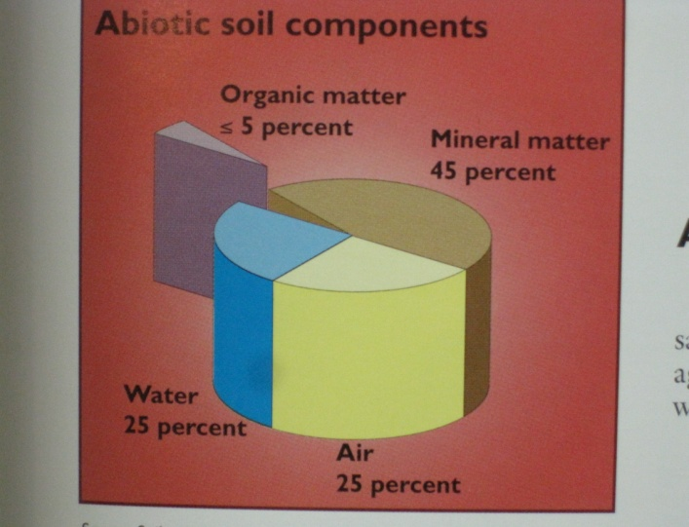

Figure 1.—Four major components of soil volume (Michigan Field Crop Ecology, 1998, E-2646, page 13).

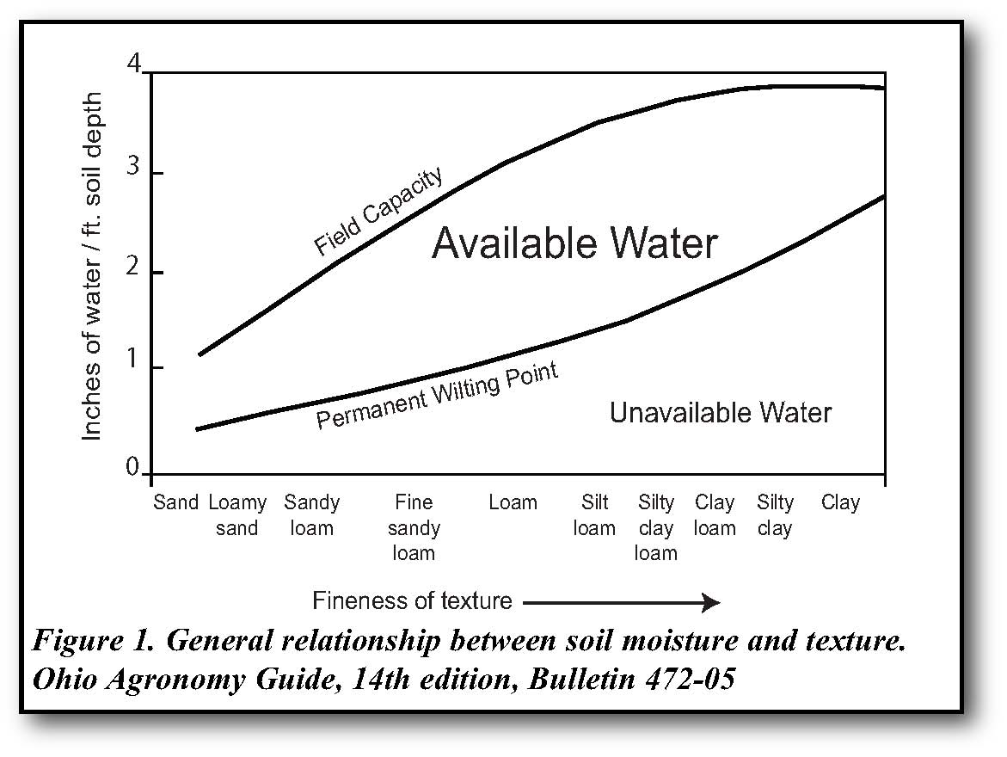

Figure 2.—Relationship between available water and texture (Ohio Agronomy Guide, 14th ed., Bull. 472-05).

# Inherent Factors Affecting Bulk Density and Available Water Capacity

Some inherent factors affect bulk density, such as soil texture. Bulk density is also dependent on the soil organic matter content and density and arrangement of soil minerals (sand, silt, and clay). Generally, rocks have a density of 2.65 g/cm3. Ideally,silt loam has 50 percent pore space and a bulk density of 1.33 g/cm3. Loose, well-aggregated, porous soils and soils high in content of organic matter generally have lower bulk density. Sandy soils have relatively high bulk density because they have less total pore space than silty or clayey soils (not applicable to red clayey soils and volcanic ash soils). Bulk density typically increases as soil depth increases. The subsurface layers are more compacted and have less pore space because they have less organic matter, less aggregation, and less root penetration than the surface layer.

Available water capacity (fig. 2) is affected by soil texture, presence and abundance of rock fragments, soil depth, and restrictive layers. It is also affected by management practices that alter soil organic matter content, structure, and porosity.

# Bulk Density Management

Bulk density can be altered by using management practices that affect soil cover, organic matter content, structure, compaction, and porosity. Excessive tillage destroys soil organic matter and weakens the natural stability of soil aggregates, making them susceptible to erosion by water and wind. When pore spaces are filled with eroded soil particles, porosity is reduced and bulk density is increased. Tillage and equipment use result in compacted soil layers, such as a plowpan, that have higher bulk density (figs. 3 and 4). Tilling prior to planting temporarily decreases the bulk density of the surface layer, but it increases the bulk density of the layer directly below the plow layer. Making multiple trips across a field with farm equipment, periods of rainfall, trampling by animals, and other disturbances also compact the soil. To minimize soil compaction, decrease soil disturbance and increase soil organic matter content.

Organic matter content and compaction also affect the total water capacity and available water capacity of soil. Organic matter increases the ability of a soil to hold water, both directly and indirectly. Compaction increases bulk density and decreases total pore space, reducing available water capacity.

**To increase organic matter content and minimize compaction, improving bulk density and porosity:**

* Use a continuous no-till cropping system, grow cover crops, apply solid manure orcompost, and use diverse rotations that include high-residue crops and perennial legumes or grass.
* Minimize soil disturbance and avoid operating equipment when the soil is wet.
* Use equipment only on designated roads or between rows.
* Limit the number of times equipment is used on a field.
* Subsoil to disrupt existing compacted layers.
* Use multi-crop systems that include plants with different rooting depths to help break up compacted soil layers.

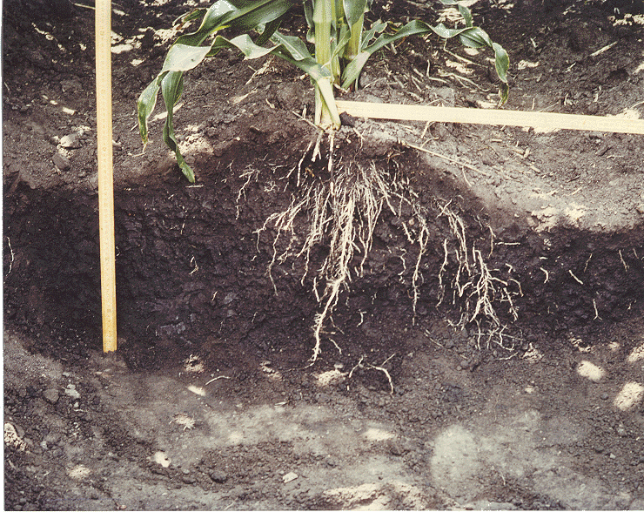

Compacted area between rows restricts roots, worms, aeration, and availability of N.

Figure 3.—Compacted soil between rows as a result of wheeled equipment use.

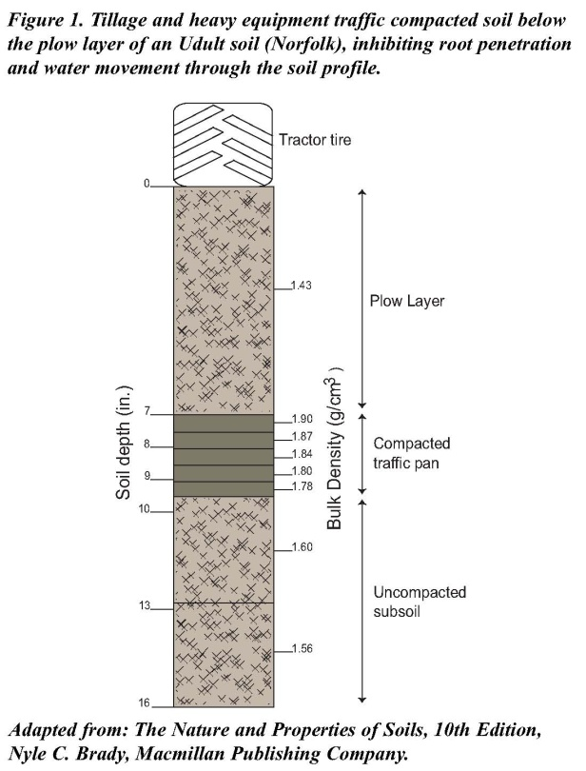

Figure 4.—Compacted plow layer inhibits root penetration and water movement through the soil profile (adapted from *The Nature and Properties of Soils*, 10th edition).

**Water-filled pore space and porosity:**

If 60 percent or more of the pore space is filled with water, important soil processes are impacted. Soil respiration and nitrogen cycling (ammonification and nitrification) increase as soil moisture increases (fig. 5). In dry soils, the rate of these processes decreases because of a lack of moisture. Poor aeration interferes with the ability of soil organisms to respire and cycle nitrogen.

If more than 80 percent of the pore space is filled with water, soil respiration declines to a minimum level and denitrification occurs. This results in loss of nitrogen as gases, emission of potent greenhouse gases, decreased yields, and an increased need for N fertilizer, which increases cost.

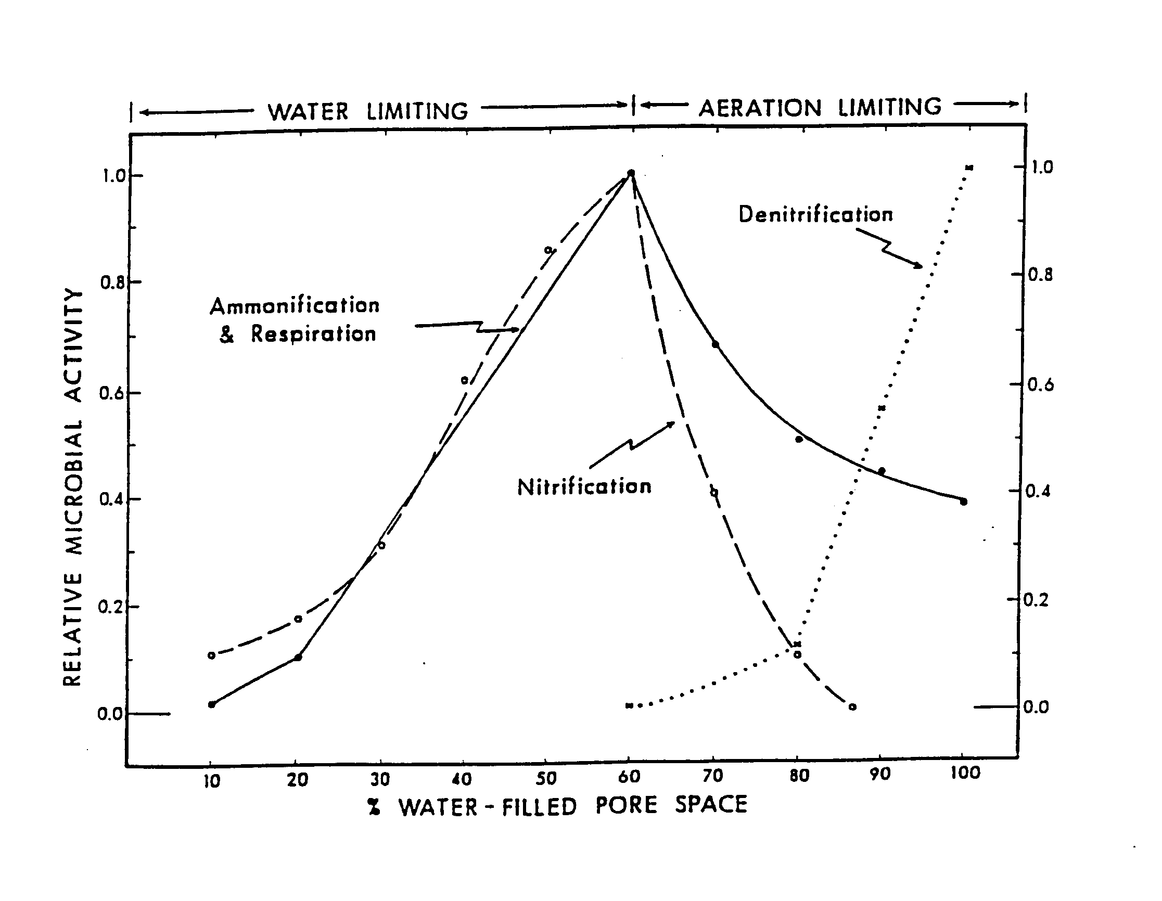

Figure 5.—Relationship of water-filled pore space to soil microbial activity (Linn and Doran, 1984).

# Soil Bulk Density Issues and Their Relationship to Soil Function

High bulk density is an indicator of soil compaction and low soil porosity. It impacts available water capacity, root growth (table 1), and movement of air and water through the soil. Compaction reduces crop yields and restricts the growth of plant cover that helps to protect the soil from erosion. By restricting the infiltration of water into the soil, compaction can lead to increased runoff and erosion in sloping areas or to saturated soils in more level areas.

For laboratory analyses to determine organic matter and nutrient content, adjust the volume of the soil sample according to its bulk density. For example, a 30-percent error in organic matter and nutrient content would result if a soil with a bulk density of 1.3 and one with a bulk density of 1.0 were analyzed similarly, or without adjustment for the difference in bulk density.

Table 1.—General relationship of soil bulk density to root growth based on soil texture*

|  |  |  |  |
| --- | --- | --- | --- |
| **Soil texture** | **Ideal bulk density for plant growth (grams/cm3)** | **Bulk density that affects root growth (grams/cm3)** | **Bulk density that restricts root growth (grams/cm3)** |
| Sand, loamy sand | <1.60 | 1.69 | >1.80 |
| Sandy loam, loam | <1.40 | 1.63 | >1.80 |
| Sandy clay loam, clay loam | <1.40 | 1.60 | >1.75 |
| Silt, silt loam | <1.40 | 1.60 | >1.75 |
| Silt loam, silty clay loam | <1.40 | 1.55 | >1.65 |
| Sandy clay, silty clay, clay loam | <1.10 | 1.49 | >1.58 |
| Clay (>45 percent clay) | <1.10 | 1.39 | >1.47 |

*Does not apply to red clayey soils and volcanic ash soils.

List some management practices that affect bulk density? Why?

What impact do these practices have on soil organic matter content and porosity?

# Measuring Bulk Density and Soil Moisture

**Materials needed to measure bulk density:**

____ 3-inch-diameter aluminum ring

____ Wood block or plastic insertion cap

____ Rubber mallet or weight

____ Flat-bladed knife

____ Resealable plastic bags and permanent marker

____ Scale (1 g precision)

____ 1/8 cup (29.5 mL) measuring scoop

____ Ceramic coffee cup or paper plate

____ 18-inch metal rod, probe, or spade (to check for compaction zone)

____ Access to microwave oven

**Considerations:**

Bulk density can be measured at the soil surface and/or directly in the plow layer. Samples for measuring bulk density, infiltration, and respiration should be taken from the same locations. It may be possible to use the same sample to measure infiltration and bulk density (same process is used for both). When sampling sticky clay soils, apply penetrating oil to the ring for easier removal of the sample.

**Step-by-step procedure:**

1. Carefully clear all residue from the soil surface. Drive ring into soil to a depth of 3 inches with a small mallet or weight and block of wood or plastic insertion cap. The top of the ring should extend 2 inches above the surface (figs. 6 and 7).

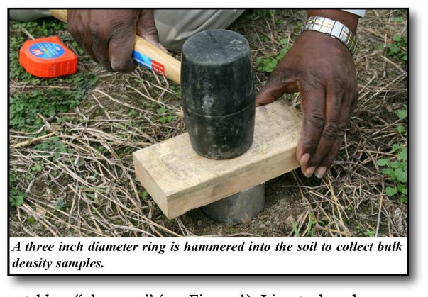

Figure 6.—Drive ring into soil to a depth of 3 inches.



Figure 7.—Ring extends 2 inches above the surface.

1. Remove the ring by first cutting around the outside edge with a small, flat-bladed knife. Place the trowel underneath the ring (to keep the sample in the ring), and carefully lift the ring out.
2. Remove excess soil from the bottom of the ring with the knife (fig. 8).



Figure 8.—Remove excess soil from bottom of ring.

1. Place the sample in a resealable plastic bag. Label the bag.
2. Weigh the sample, including the bag. Record weight in table 2.
3. Weigh an identical, clean, empty bag. Record weight in table 2.
4. Weigh empty cup or paper plate to be used in step 8. Record weight in table 2.
5. Use the entire soil core (or extract a subsample of soil) to determine water content and dry soil weight.
   * 1. Mix soil core thoroughly by kneading the plastic bag.
     2. Remove level 1/8-cup scoop of loose soil (not packed down) from bag, and place it in the weighed cup or plate   
        (step 7). To increase accuracy of measurement, use the entire soil core or use more than one scoop of soil if subsample is extracted.
6. Weigh both moist soil removed from plastic bag and cup or plate. Record weight in table 2.
7. Place soil and cup or plate in a microwave. Dry in 4-minute cycles at medium power.
8. Weigh soil and cup or plate after each   
   4-minute cycle. The soil is dry when the weight no longer changes from one drying cycle to the next. Record weight in table 2.

# Interpretations

Complete table 2. Compare the results to the bulk density values given in table 1 for the applicable soil textures to determine the relative restrictions to root growth. Determine soil water content and porosity, and complete tables 3 through 5. Compare results to figures 2 and 5. Answer discussion questions.

Table 2.—Bulk density and soil water content (core method)*

(Refer to calculations following table for details.)

|  |  |  |  |  |  |  |  |  |  |
| --- | --- | --- | --- | --- | --- | --- | --- | --- | --- |
| **Sample site** | **(a)**  **Wt. of entire moist soil core and bag**  **(grams)** | **(b)**  **Wt. of sample bag (grams)** | **(c)**  **Wt. of cup or plate (grams)** | **(d)**  **Wt. of moist soil subsample and cup or plate (grams)** | **(e)**  **Wt. of moist soil subsample (grams)**  **(d-c)** | **(f)**  **Wt. of dry soil subsample and cup or plate (grams)** | **(g)**  **Dry wt. of soil subsample(grams)**  **(f-c)** | **(h)**  **Soil water content (grams/ gram of soil)**  **(e-g)** ÷ **g** | **(i)**  **Soil bulk density (grams/ cm3)\*** |
| Example | 490 | 5 | 126 | 160 | 34 | 153 | 27 | 0.259 | 1.2 |
|  |  |  |  |  |  |  |  |  |  |
|  |  |  |  |  |  |  |  |  |  |
|  |  |  |  |  |  |  |  |  |  |

*Soil bulk density = [(a - b) x (1 + h)] ÷ volume of soil core (volume of soil core = 321 cm3 for 3-inch core, 2 inches from top of soil to top of ring; refer to volume calculations on following page and to figure 11).

**Abbreviations and letters in examples and following tables:** Wt = weight; π = 3.14; gr = grams;   
r = radius of inside diameter of ring/core; single letters in equations refer to entries in table 2

**Volume of soil core (cm3) (see figure 11):** πr2 x height

Example—

3.14 x (3.66 cm)2 x (7.62 cm) = 321 cm3

**Soil water content of subsample (gr/gr):** (weight of moist soil - weight of oven-dry soil)

weight of oven-dry soil

Example—

(e - g) ÷ (g)

(34 gr – 27 gr) = 0.259 gr of water/gr of soil

27 gr

**Dry weight of soil core based on water content of subsample****(gr):**

Dry wt of soil core = [wt of moist soil + bag (gr) - wt of bag (gr)]

[1 + soil water content (gr/gr)]

Example—

Dry wt of soil core = [(a - b) ÷ (1 + h)] = (490 gr - 5 gr) = 385 gr

(1 + 0.259)

**Bulk density calculation (gr/cm3):** Dry wt of soil core ÷ volume of soil core

Example—

385 gr ÷ 321 cm3 = 1.20 gr/cm3

**Soil water content and porosity calculations:**

Table 3.—Total soil water content

|  |  |  |  |  |
| --- | --- | --- | --- | --- |
| **Sample site** | **Soil water content (by weight)**  **(grams/gram)**  **(h in table 2)** | **Bulk density from table 2 (grams/cm3)** | **Water content (grams/cm3)\*** | **Total inches of water/foot of soil depth\*\*** |
| Example | 0.259 | 1.2 | 0.3108 | 3.7 |
|  |  |  |  |  |
|  |  |  |  |  |
|  |  |  |  |  |

*Water content (gr/cm3) = soil water content (gr/gr) x bulk density (gr/cm3); 1 gram of water (by volume) = 1 cm3/cm3

**Total inches of water/foot of soil depth = water content x 12 inches (1 foot)

Table 4.—Soil porosity

|  |  |  |  |
| --- | --- | --- | --- |
| **Sample site** | **Bulk density from table 2**  **(grams/cm3)** | **Calculation:**  **1 - (soil bulk density ÷ 2.65)\*** | **Soil porosity (percent)** |
| Example | 1.2 | 1 - (1.2 ÷ 2.65) | 54.7 |
|  |  |  |  |
|  |  |  |  |
|  |  |  |  |

*The default value of 2.65is used as a rule of thumb based on the average bulk density of rock.

Table 5.—Water-filled pore space

|  |  |  |  |  |
| --- | --- | --- | --- | --- |
| **Sample site** | **Water content from table 3 (grams/cm3)** | **Soil porosity from table 4** | **Calculation:**  **(water content ÷ soil porosity) x 100** | **\*Percent of pore space filled with water** |
| Example | 0.3108 | 0.547 | (0.3108 gr/cm3 ÷ 0.547)  x 100 | 56.8 |
|  |  |  |  |  |
|  |  |  |  |  |
|  |  |  |  |  |

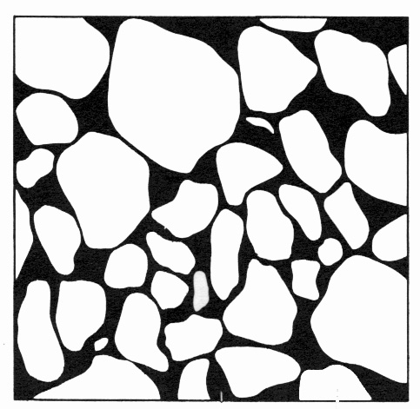

Black

(Pore space)

White

(Soil particles)

Figure 9.—Soil porosity

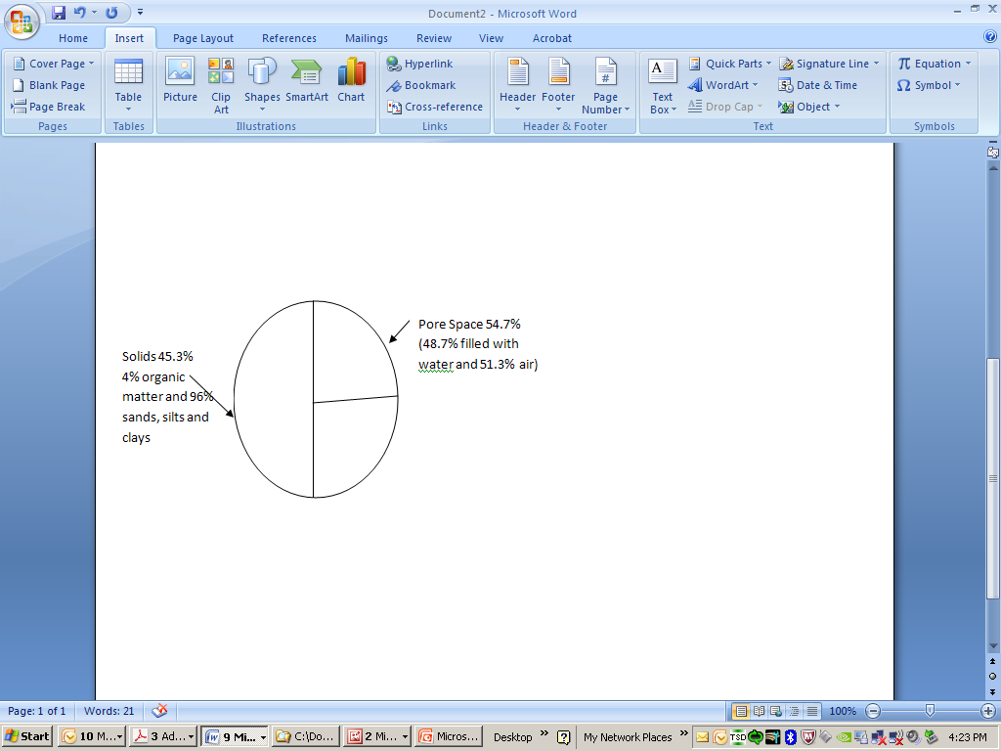

Total pore space 54.7%

(56.8% water-filled and 43.2% air-filled pores)

Air

23.6%

Water

31.1%

Solids

45.3%

Figure 10.—Example soil core volume, by component (volume = 321 cm3).

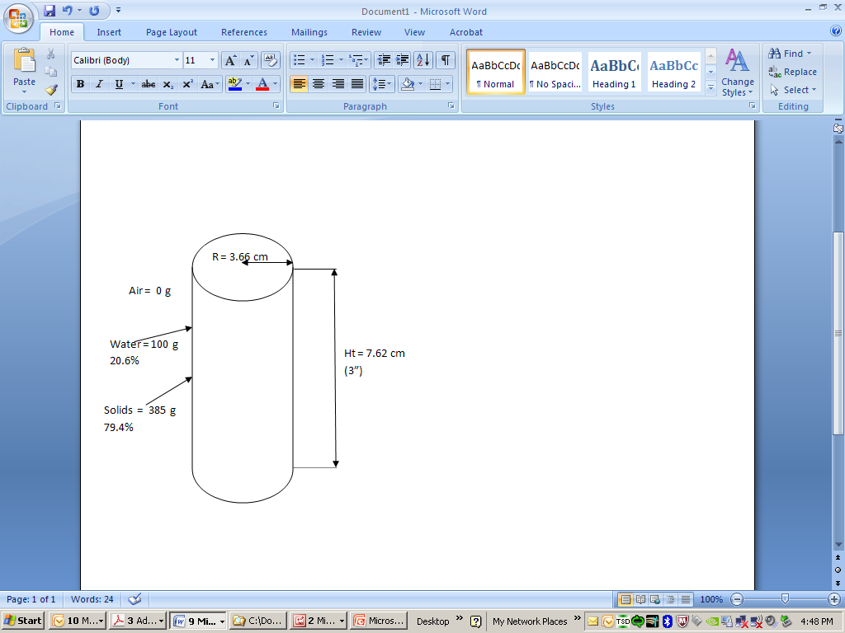

Volume =  
321 cm3

Total

weight =  
 485 g

Figure 11.—Example soil core dimensions, volume, and weight, by component.

Were results of bulk density and porosity tests expected? Why or why not?

Compare results of water-filled pore space calculation to figure 5. Is the ability of the soil organisms  
 to respire and cycle nitrogen impacted? If so, what is the possible impact on production? Are these  
 processes limited by water or aeration?

Compare bulk density of soil sample to values for the similar soil texture given in table 1. Is bulk   
 density ideal based on the soil texture? Why or why not?

*USDA is an equal opportunity provider and employer.*

Compare total water content in table 3 (inches of water per foot of soil depth) to the available   
 water capacity shown in figure 2 for the same soil texture. Is the water content near field capacity?

# Glossary

*Ammonification.—*Stage of nitrogen cycle in which soil organisms decompose organic nitrogen and convert it to ammonia.

*Available water capacity.—*Soil moisture available for crop growth (fig. 2). Also defined as the difference between field capacity and wilting point. Typically expressed as inches per foot.

*Bulk density.—*Weight of dry soil per unit of volume. More compacted soil has less pore space and higher bulk density.

*Denitrification.—*Conversion and loss of nitrate nitrogen as nitrogen gases when the soil is saturated with water.*Nitrification.—*Stage of nitrogen cycle in which soil organisms convert ammonia and ammonium into nitrite and then to nitrate nitrogen, which is available for plant use.

*Respiration.—*Carbon dioxide (CO2) release from soil as a result of decomposition of organic matter by soil microbes and from plant roots and soil fauna (aerobes, or organisms that require oxygen).

*Soil porosity.—*Percent of total soil volume consisting of pore space (fig. 9).*Soil water content, gravimetric.—*Weight of soil water per unit of dry soil weight.

*USDA is an equal opportunity provider and employer.*

*Water content.—*Amount (weight) of water in soil core expressed as grams/cm3. One gram of water equals 1 cubic centimeter, by volume.

*Water-filled pore space.—*Percentage of soil pore space filled with water.