Soil health is determined by examining the physical, chemical, and biological properties of soil and their interactions. The Soil Quality Test Bucket provides the tools needed to conduct tests for physical, chemical, and biological soil properties, which are indicators of soil health. Because of the holistic nature of soil health, all applicable tests should be completed for a particular soil but the results do not have equal relevance for all soils. For example, the electrical conductivity (EC) test for salinity may not be particularly relevant for most of the soils in the eastern part of the United States. Salinity generally is not a problem in this part of the country, except in some coastal plain tidal areas that are affected by a spray or overwash of seawater, particularly after severe storms. The EC test is a good indicator, however, of the amount of nutrients, such as nitrate nitrogen, available for crops. It can also be used to show differences in texture, bulk density, porosity, soil structure, water potential, soil aggregation, and content of electrolytes in soil water. Nonsaline soils that have a higher EC value typically have more available nutrients than those that have a lower EC value. The tests can be used to indicate the capacity of the soil to function for a specific land use. They are conducted primarily to assess agricultural soil health. The results indicate a general trend, or direction, of soil health related to physical, chemical, and biological soil properties, regardless of whether the current management systems are maintaining, enhancing, or degrading the soil. An understanding of the indicators with respect to land use, management, and production and environmental goals is needed for proper interpretation of the test results.

Soil health can be assessed by:

1. Taking measurements periodically over time to *monitor changes or trends*.
2. *Comparing measured values* to a standard or reference soil condition.

Supplies in the Soil Quality Test Bucket can be used to:

* Make side-by-side comparisons of different soil management systems used on a field to determine the relative effects on soil health.
* Take measurements in a sampling area over time to monitor trends in soil health as a result of use and management.
* Compare problem areas in a field to those that are not problematic.
* Compare measured values to a reference soil condition or to the natural ecosystem.

# Sampling Area Characterization

It is important to gather as much information as possible about an area, including the soil properties and management practices, prior to conducting tests. Indicators of soil health mustbe evaluated within the context of the inherent soil properties and site and climatic conditions. The following should be considered in a field soil health assessment:

*Soil series***.**—Name of the soil series is provided in the soil survey for the county. When comparing a soil to a reference soil condition, the texture of the surface layer should be the same as that of the reference soil.

*Signs of erosion***.**—Includes gullies, rills, pedestals, areas where the subsoil is exposed, and damage to plants caused by windblown material, etc.

*Management history***.**—Includes past and present land and crop management; kind, amount, and method of fertilization; prior tillage systems used; and land leveling.

*Slope and topographical features.—*Percent slope at the sampling sites and hills, knolls, ridges, potholes, and depressions, etc.

*Location of field and sampling sites*.—Longitude and latitude (determined by use of global positioning system [GPS], if available), description of the location (distance from landmarks), and indication of field boundaries and sampling areas within a field on an aerial photograph or soil survey map.

*Climatic information***.**—Includes precipitation and average high and low temperatures for each month (data recorded for a county or watershed commonly is sufficient).

*Water features.—*Soil moisture, flooding, saturation, ponding, seasonal high water table, and other water features on the surface and below the surface that impact the site and the functions of the soils.

*Location of environmentally sensitive areas***.**—Includes location of ponds, creeks, wetland areas, or other environmentally fragile areas adjacent to the sampling area.

# Sampling Guidelines

**Important note:** When, where, to what depth, and how many samples should be taken depend on the needs of the individual land manager.

**When to sample?**

Timing of sampling is important because soil properties vary depending on the time of year and type of management practices used, such as tillage or nutrient application just prior to testing. In general, an **annual** **sampling of a field** is recommended for the overall assessment of soil health. This allows for detection of long-term changes in soil health. The best time of year to sample is when the climate is most stable and there have been no recent disturbances, such as after harvesting or at the end of the growing season.

**Where to sample?**

An important consideration when separating sampling areas within a field is the variability of the area. Soil properties naturally vary across a field and even within the same soil type. Soil variability is also affected by management practices. The following general characteristics should be considered when separating sampling areas:

* Areas in rows versus areas between rows.
* Differences in soil type.
* Differences in management (crops grown, manure history, and application of fertilizer, lime, and irrigation water, etc.)
* Tracked areas versus those that have not been tracked.
* Differences in crop growth.
* Salt-affected areas versus those not affected by salt.
* Eroded areas versus non-eroded areas.
* Differences in slope.
* Wet areas versus those that are not wet (drainage, flooding, ponding, and water table).

**General guidelines for selecting sampling sites:**

1. For a general assessment of soil health, select sample sites that are representative of the sampling area. Refer to soil maps in the soil survey of the county to identify differences in soil types and variations within a map unit (fig. 1). A hand auger can be used to make a number of borings to determine the most representative sites of the sampling area.



Figure 1.—Example of soil map.

1. Sample areas that are representative of trouble spots for assessment of these areas (fig. 2).



Figure 2.—Example of a trouble spot.

1. When comparing management systems, select sampling areas that have a similar soil type and similar site and topographic features. For example, if rows compacted by wheeled equipment are avoided in one sampling area, they should also be avoided in the comparison sampling area.
2. When monitoring changes in soil health over time, measure in the same sampling areas within the field each time. Also, measurements should be taken when the soil moisture conditions are similar. In some cases, it might be useful to compare sample points that include different soil types, soil moisture conditions, slopes, or other factors rather than samples at fixed points (fig. 3).



Measurements

Soil types

Soil type gradient

Figure 3.—Soil measurements.

**Number of measurements?**

The number of measurements needed depends on the variability of the sampling area. Measurements for infiltration and bulk density are taken at specific points. When applicable, measurements are also used to compare differences in electrical conductivity, pH, nitrate content, and phosphate content, etc. A minimum of three measurements are recommended for a particular soil type and management area. In general, the higher the variability of the sampling area, the more measurements are needed to determine a representative value.

**Composite samples**

When measuring electrical conductivity, pH, and phosphates and nitrates, ten soil cores, or individual soil samples, should be taken across the sampling area. Collect cores randomly throughout each sampling area within the field to be measured. Take care to adequately represent the entire area. Sample the entire upper layer (commonly to a depth of 6 to 8 inches) for general fertility analysis. Place all of the individual soil cores of the upper layer in a clean plastic container. A separate container should be used for subsurface samples. Break up the soil cores and thoroughly mix. Cores should not be taken from areas that are distinctly different and not representative of the field, such as farm lanes, field borders, fertilizer bands, areas within 150 feet of a gravel road, potholes, and eroded spots, etc. Areas that have different soils, yields, and management history should be sampled separately. For example, the lower end, middle, and upper end of a furrow-irrigated field are sampled separately for nitrates because more water typically is applied at the upper end of the field than at the lower end (fig. 4).

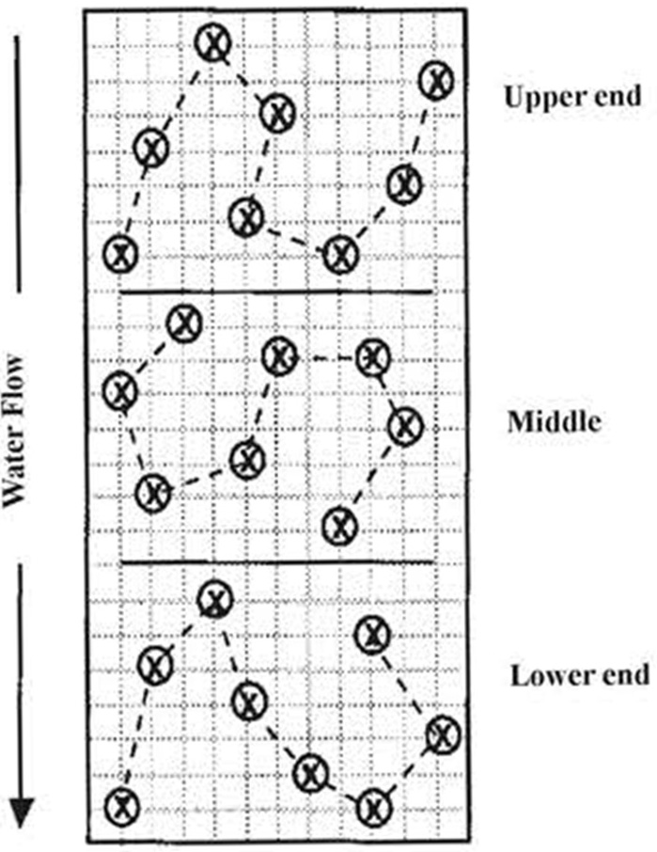

Figure 4.—Example of separate sampling areas and random sampling sites within a furrow-irrigated field.