Estimating Soil Moisture by Feel and Appearance
Approximately 90 minutes
Objectives
By the end of the lesson, students will know or be able to:
- Define: irrigation water management, available water capacity, percent available, soil moisture deficit, in/ft depleted
- Explain the significance of irrigation water management
- Explain key factors that impact observations made in the feel and appearance method
- Differentiate between percent available water capacities in different soil types
- Obtain a soil sample using a probe, auger or shovel
- Squeeze the soil sample firmly to form an irregularly shaped “ball” of soil
- Squeeze the soil sample out of the hand between the thumb and forefinger to form a soil “ribbon”
- Observe the soil texture, ability to ribbon, firmness and surface roughness, water glistening, loose soil particles, soil/water staining on fingers and soil color
- Compare observations with photographs and/or charts to estimate percent water available

Materials
- Vocabulary Puzzle
- 4 Containers (containing soil, water, air, & a plant)
- Guided notes sheet – 1 per student
- 4 clear cups (2 with holes at the bottom
- Sand
- Clay
- Soil Probe
- Soil Auger
- Shovel
- Modeling Clay
- Estimating Soil Moisture by Feel and Appearance handout from USDA

Preparatory Work
- Make necessary copies
- Obtain needed supplies
- Cut out Vocabulary Puzzle
- Determine a location for students to collect soil samples

Enroll the Participants – Approximately 5 minutes

Place four containers containing water, a plant, soil, and air in the front of the classroom. Give the students about 1 minute to discuss what these four things have in common with a partner. After a short time, request students to share their ideas with the class. Explain to students that, in this lesson, we will discover the importance of managing the air and water in soil to benefit plant growth.

Provide the Experience – Define irrigation water management, available water capacity, percent available, soil moisture deficit, and in/ft depleted – Approximately 5 minutes

Vocabulary Puzzle: Cut the vocabulary puzzles into enough pieces so each student has once piece. Note: Students each needs one puzzle piece, not one piece of each puzzle. Randomly hand out a puzzle piece to each student. Instruct students to find the other students with pieces to their puzzle and assemble their key word. Once each puzzle is assembled, instruct students to become familiar with the definition on their puzzle. Have each group share their vocabulary term and its definition with the class.

Label the Information – Approximately 3 minutes

Instruct students to capture the definitions of each of the following terms in their guided notes sheet.
- Irrigation water management: applying water according to crop needs in an amount that can be stored in the plant root zone of the soil
- Available water capacity: the amount of water that a soil can store that is available for use by plants
- Percent available: currently available soil moisture as a percent of available water capacity
- Soil moisture deficit: the amount of water in a soil that can be readily absorbed by plant roots of most crops
- in/ft depleted: inches of water currently needed to refill a foot of soil to field capacity

Demonstrate the Relevance – Approximately 2 minutes

Explain to students that these terms will be key throughout this lesson so it is important to have a basic understanding to be built upon later.

Provide the Experience – Explain the significance of irrigation water management – Approximately 5 minutes

Lead a brief discussion on irrigation and water usage. Consider discussing management of the Ogallala Aquifer, the recent drought, or local irrigation water issues.
Pose the question to students, “Why is it important to manage irrigation water?” Look for answers such as water conservation, cost of water, sustainability, benefits to crops, use by other agronomic inputs, etc.

Label the Information – Approximately 5 minutes

Encourage students to capture the significance of irrigation water management in their guided notes. Guide them through a brief conversation about each of these points as they are capturing the information.
Determines:
- How much water is available for plant use
- When to irrigate
- How much irrigation water to apply
- Conserves soil and irrigation water

Demonstrate the Relevance – time varies

Guide students through a class discussion on irrigation water management. Elicit personal experiences about irrigation water management from students, these could be related to production agriculture, a flower or vegetable garden, or even turf grass in their yard.

Provide the Experience – Differentiate between percent available water capacities in different soil types – Approximately 5 minutes

Poke several small holes in the bottom of two clear cups. Fill one about half way with sand and the other with clay. Place each cup over another cup or container to catch leaching water. Add equal amounts of water to each cup of soil and observe. Encourage students to watch the water as it percolates through the soil. After a few minutes, measure the amount of water in the bottom containers.
Note: This could also be demonstrated with several different sponges with a variety of pore sizes. Determine how much water each sponge can hold and compare the results.

Label the Information

Instruct students to record their observations in their guided notes sheet.

Soil Texture | Percolation Speed | Water filtered completely through cup | Water that remained on top of the sample | Other observations
Sand
Clay

Demonstrate the Relevance

Encourage students to complete the review questions for this demonstration in their guided notes with a partner. After a few minutes, guide the class through a discussion of their answers.
- What are the differences in filtration of sand and clay?
- Why do these differences exist (consider pore space)?
- How does this demonstration relate to available water capacity?

Provide the Experience – Obtain a soil sample– Approximately 2 minutes

Show students a soil probe, auger, and a shovel. Ask students what these tools are used for; look for the answer collecting soil samples.

Label the Information – Approximately 5 minute

Introduce students to each of these tools and briefly explain how each tool is used. Encourage students to draw a picture of the tool and a description in their guided notes. Consider demonstrating proper use of each tool.

Demonstrate the Relevance – time varies

Allow students to collect soil samples that will be used later in the lesson using a shovel, auger, and soil probe. Encourage students to use each tool and collect samples at various locations and at various depths. When collecting samples instruct students to place their sample in a bucket or bag and label their sample with location of the sample.

Provide the Experience – Estimate soil moisture and texture by feel and appearance and explain key factors that impact observations – Approximately 10 minutes

Give each student a small portion of modeling clay or play-doh and have them follow along as you demonstrate the process of estimating soil moisture and texture by feel and appearance.
- Squeeze the sample firmly in your hand several times to form an irregularly shaped “ball”.
- Squeeze the soil sample out or your hand between thumb and forefinger to form a ribbon.
- Observe texture, ability to ribbon, firmness and surface roughness of ball, water glistening, loose soil particles, soil/water staining on fingers, and soil color.
Allow students to practice this process with the clay several times. Observe individual students and offer guidance through this process.

Label the Information – Approximately 5 minutes

Instruct students to write the step by step instructions for estimating soil moisture and texture by feel and appearance in their guided notes.
Also discuss and encourage students to record key factors that impact observations made in the feel and appearance method:
- Rock fragments
- Organic matter
- Bulk density

Demonstrate the Relevance – time varies

Using the collected soil samples instruct students to test various soils for soil texture and soil moisture.
Guide students through the “Texture by Feel Procedure” graphic to determine soil texture. Encourage students to work with a partner using the same soil to discuss while working to determine soil texture.
Using the “Estimating Soil Moisture by Feel and Appearance” guide, encourage students to work with a partner and several soil samples to determine the available water capacity.

Review the Content – Approximately 5 minutes

Instruct students to complete the “Learned what? So what? Now what?” chart in their guided notes. After a few minutes allow students to work in small groups to add to their chart. As students are working listen to their conversations and select a few a key concepts being discussed and ask those students to share their information aloud with the group.

Celebrate Student Success – Approximately 2 minutes

Thank students for their participation and willingness to get dirty to discover more about soil. Congratulate students on their ability to collect soil samples, and determine soil texture and soil moisture by feel and appearance. Explain that this skill will be important in the land evaluation competition to identify soil texture and permeability.
Take a few minutes to preview the next lesson.

Guided Notes: Estimating Soil Moisture by Feel and Appearance?
Notes Completed by:____________________________

Irrigation water management:

Available water capacity:

Percent available:

Soil moisture deficit:

in/ft depleted:

Why is irrigation water management important?

Percent Available Water Capacity

Soil Texture | Percolation Speed | Water filtered completely through cup | Water that remained on top of the sample | Other observations
Sand
Clay

What are the differences in filtration of sand and clay?

Why do these differences exist (consider pore space)?

How does this demonstration relate to available water capacity?

Collecting a Soil Sample:

Soil Probe

Soil Auger

Shovel

Feel and Texture Method:
1.

2.

3.

Factors that impact observations in feel and texture method:
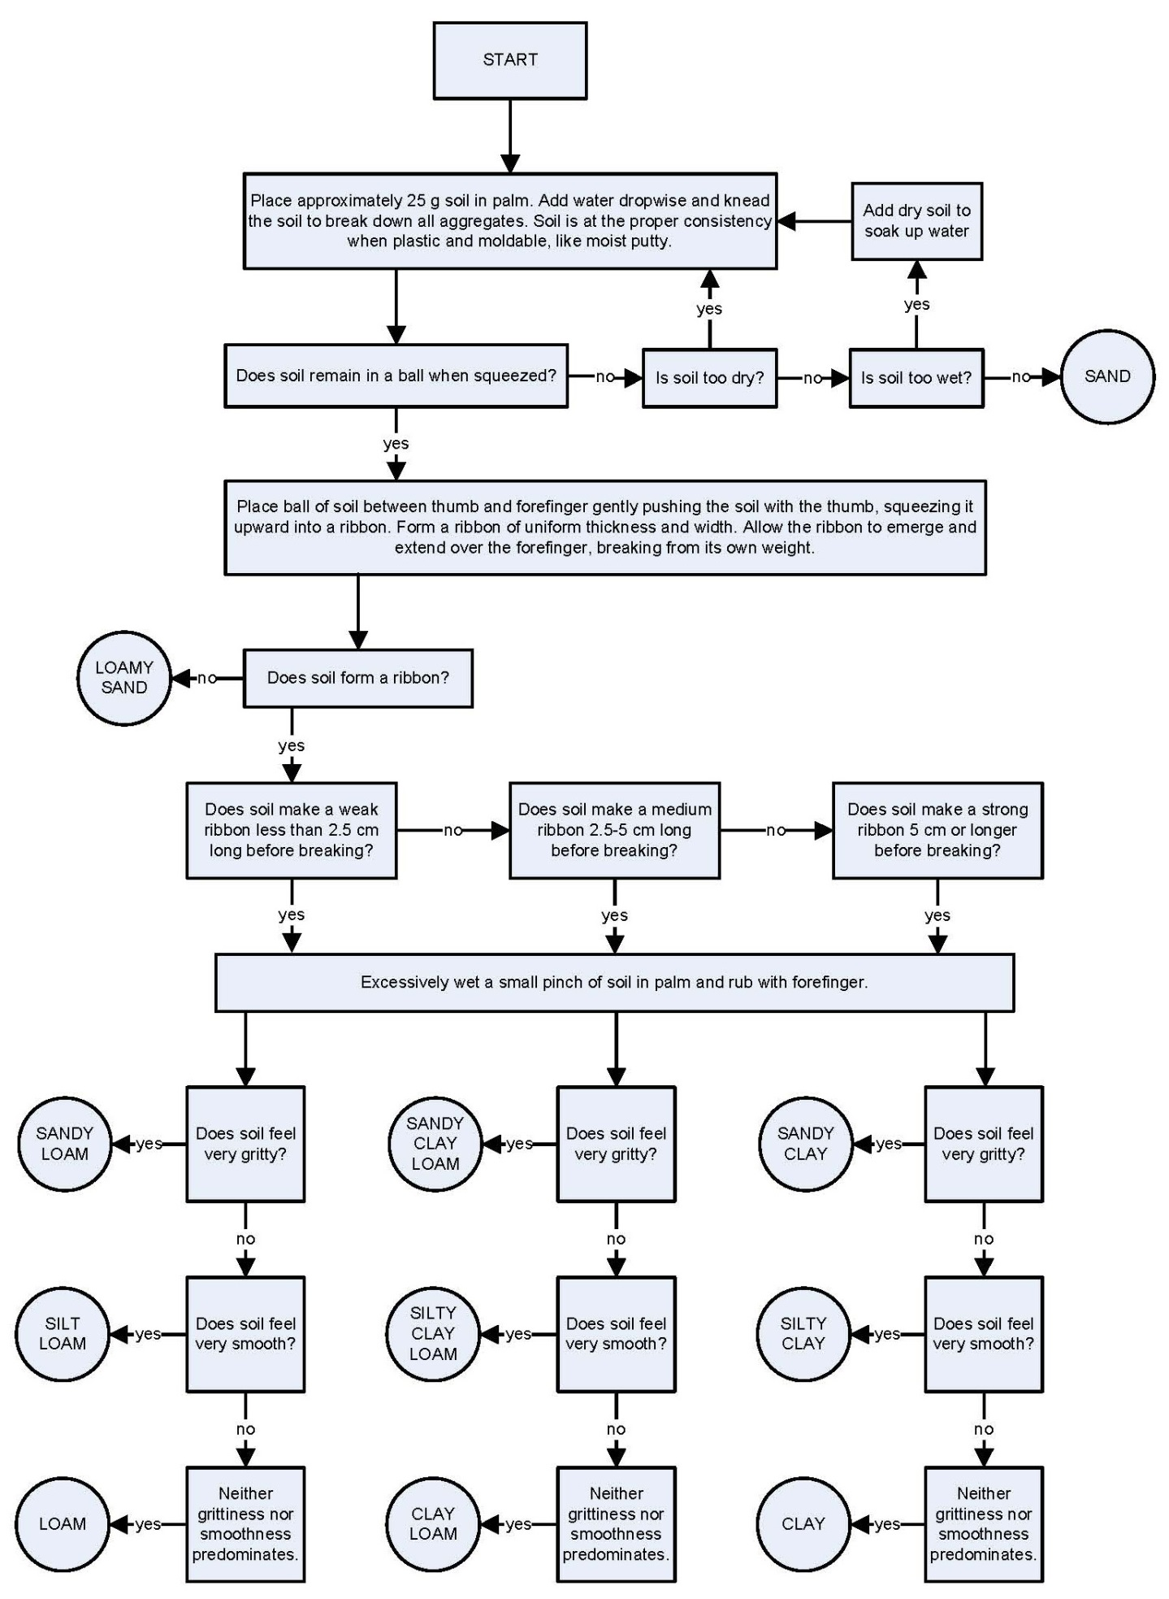
Soil Texture by Feel Procedure
Vocabulary Puzzle: Cut out each box. Then, cut each box into pieces so there are enough pieces for each student to have one piece. Example if there are 25 students in class cut each box into 5 pieces for a total of 25 puzzle pieces
Irrigation water management: is applying water according to crop needs in an amount that can be stored in the plant root zone of the soil.

Available water capacity: is the amount of water that a soil can store that is available for use by plants

Percent available: currently available soil moisture as a percent of available water capacity

Soil moisture deficit: is the amount of water in a soil that can be readily absorbed by plant toots of most crops

in/ft depleted: Inches of water currently needed to refill a foot of soil to field capacity

