Soil Phosphorus
Approximately 135 minutes
***Content and lab derived from the USDA-NRCS Guides for Educators. Please see the Guides for additional helpful pictures and diagrams.***
Objectives
By the end of the lesson, students will know or be able to:
- Define: immobilization, mineralization, phosphorus cycle, phosphorus fixation, soil phosphate
- Diagram the relationship of phosphorus inputs and soil processes
- List and describe inherent factors that affect soil phosphorus
- Describe phosphorus management techniques
- Identify plants with phosphorus deficiencies
- Measure soil phosphate and interpret results

Materials
- Guided notes (one per student)
- Land to take soil samples
- All laboratory supplies (See Lab Guided Notes)
Preparatory Work
- Print all necessary copies
- Secure permission to collect soil samples from the land owner

Enroll the Participants – Approximately 4 minutes

Show students the following diagram and facilitate a discussion about soil phosphorus to determine what they may know about the nutrient from other classes.
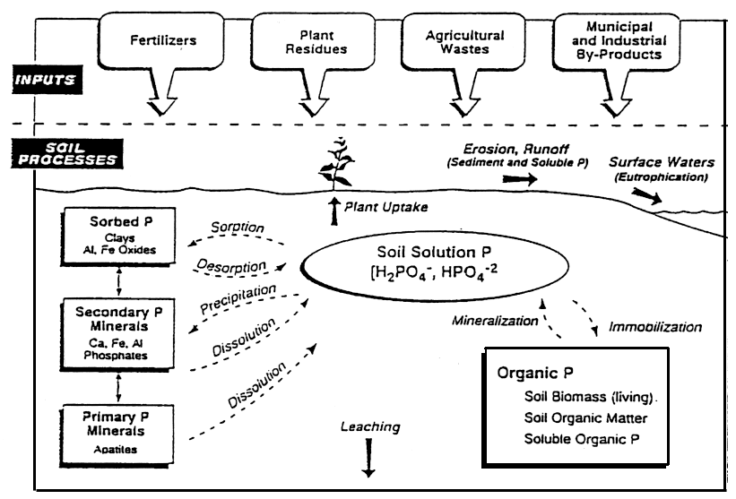
Figure 1. Soil phosphorus cycle (Pierzinski et al., 1994).
Preview with students that during this lesson, the class will explore the relationship of phosphorus to soil and plant growth.

Provide the Experience – Defining key terms – Approximately 3 minutes

List off the five key terms and ask students to share with the class what they currently know about the terms.

Label the Information – Approximately 5 minutes

Review the terms and definitions using the accompanying PowerPoint or the information found here:
Immobilization: temporarily “tying up” of water soluble phosphorus by soil microorganisms decomposing plant residues. Immobilized phosphorus will be unavailable to plants for a time, but will eventually become available again as decomposition proceeds.
Mineralization: nutrients contained in soil organic matter are converted to inorganic forms that are available to crops during respiration.
Phosphorus Cycle: phosphorus cycles between many different forms in soil. Some forms are available to plants and other forms are not. Unavailable forms are generally fixed to iron, aluminum and calcium minerals.
Phosphorus Fixation: phosphate fixates to iron, aluminum and calcium minerals and attached to clay minerals. pH levels affect fixation and availability of phosphorus.
Soil Phosphate: a form of phosphate available to plants and is expressed as PO₄.

Demonstrate the Relevance – Approximately 4 minutes

Discuss the following key points with the class:
Phosphorus is the second most limiting factor in terms of plant growth, next only to nitrogen.
Phosphorus plays a key role in plant growth and reproduction – promotes root growth, hardiness, quicker maturity, efficient water use, increased yields and promotes above ground shoot growth.

Provide the Experience – Inherent Factors Affecting Soil Phosphorus – Approximately 5 minutes

List the following factors that are affected by soil properties and climate for the class:
Soil aeration
Rainfall
Temperature
Moisture
Salinity
Elicit thoughts from the students as to how each of those factors might affect soil phosphorus.

Label the Information – Approximately 7 minutes

Share the following points with the class:
- Inherent factors affect the rate of phosphorus mineralization from the decomposition of organic matter
- P releases quickly in warm, humid areas with well-aerated soil
- P releases slowly in cool, dry areas with saturated soil
- P is most available in soil with a pH range of 6-7.5
- pH levels of <5.5 or between 7.5 and 8.5 limit P availability
- P is most frequently lost through erosion and runoff
Demonstrate the Relevance – Approximately 3 minutes

Provide the following scenario and question to students and elicit student thoughts.
In a well-aerated soil found in an area that is warm and humid, what would you anticipate the phosphorus levels to be, given a pH of 5.0?
Even though the soil has the right climate and aeration conditions, the pH has a greater influence and will cause the P availability to be low.
Provide the Experience – Symptoms of Deficiency and Management of Soil Phosphorus – Approximately 3 minutes
Show students the PowerPoint slide with the pictures of phosphorus-deficient plants. Ask students to identify the characteristics of the plants that they see with the deficiency.

Label the Information – Approximately 5 minutes
Share the following information with the students and encourage them to add it to their guided notes:
- Symptoms of a phosphorus deficiency include
  - Purple leaf tissue
  - Purple coloring moves from the leaf tips to the leaf margins
  - Symptoms appear on lower leaves; leaves may eventually die
- Emerging leaves may be green because plants move P to youngest leaves
- Cool and wet growing conditions increase symptom occurrence
- Plants with small or poor root systems are very vulnerable
- When root growth is prohibited by these factors, the problem is enhanced
  - Cool temperatures
  - Too wet or dry
  - Compacted soil
  - Damage from herbicides
  - Damage from insects
  - High salinity
  - Damage to roots
Demonstrate the Relevance – approximately 7 minutes

Direct students to their guided notes to capture the following information.
- P deficiency reduces the yield of plants
  - Delays maturity
  - Stunts growth
  - Restricts energy utilization by the plant
- Soil pH, organic matter amount and placement of fertilizer affect the availability of P
- Adding lime to acidic soils can help correct pH to 6.5-7.0
- Place phosphorus two inches below the planted seed
- Make several small applications of fertilizer rather than one big application
- Place the phosphorus near the crop row where the roots have immediate contact with it.

Provide the Experience – Measuring and Interpreting Soil Phosphate – Approximately 3 minutes

Review the laboratory scenario with students. Students can find the scenario in their guided notes.
After walking through several cornfields, Tom and Rik noticed that several plants have purple leaves. Tom recalled from his agronomy class last fall that purple leaves can indicate a shortage of phosphate. Together, they determine that they need to test each of their fields for inadequate phosphate levels.

Label the Information – Approximately 15 minutes

Review and identify each of the supplies from the soil testing kit that will be used during the lab activity.
- Soil probe for gathering soil samples
- Plastic bucket for mixing soil samples
- Phosphate test strips
- 1/8-cup (29.5-mL) measuring scoop
- Calibrated 120-mL shaking vial with lid
- Squirt bottle
- Distilled water or rainwater
- Pen, field notebook, sharpie and zip-lock bags
Review the steps of the laboratory activity and provide any instructions specific to your classroom expectations and time. If possible, play the phosphate test video provided by the NRCS.

Demonstrate the Relevance – approximately 125 minutes

See the attached laboratory guided notes for the steps to complete the laboratory. Review the results and analysis steps of the lab.

Review the Content – Approximately 4 minutes

Instruct students to find a partner and to “interview” one another about key points learned during the soil phosphorus lesson.

Celebrate Student Success – Approximately 2 minutes

Congratulate students on their discovery of phosphorus level results for their tested soil. Encourage students to continue being curious during each of the laboratory activities of the soil science unit.

Guided Notes: Soil Phosphorus

Immobilization:

Mineralization:

Phosphorus Cycle:

Phosphorus Fixation:

Soil Phosphate:

The Factors that Affect Soil Phosphorus:

Phosphorus Deficiency:

Guided Notes: Soil pH Laboratory
Soil pH Scenario
After walking through several cornfields, Tom and Rik noticed that several plants have purple leaves. Tom recalled from his agronomy class last fall that purple leaves can indicate a shortage of phosphate. Together, they determine that they need to test each of their fields for inadequate phosphate levels.

Laboratory Supplies
- Soil probe for gathering soil samples
- Plastic bucket for mixing soil samples
- Phosphate test strips
- 1/8-cup (29.5-mL) measuring scoop
- Calibrated 120-mL shaking vial with lid
- Squirt bottle
- Distilled water or rainwater
- Pen, field notebook, sharpie and zip-lock bags
Laboratory Steps
Electrical conductivity measurements should always be completed first, before measuring phosphate on the same sample. Soil nitrate/nitrite and soil pH can also be assessed on the same sample using the following steps.
Phosphate levels are variable, depending on field location, past management and time of year. Phosphorus fertilizer placement, soil texture, organic matter content and applications of manure or fertilizer affect the phosphate levels.

In-Field Quick Hand Test
- Using a soil probe, gather at least 10 small samples randomly from the area that represents the soil type and management history to be tested. Ensure that each sample is taken at a depth of eight inches.
- Place each sample into the plastic bucket provided.
- Remove large stones and plant residue from the sample.
- Mix the soil together.
- Rub wet soil across your palms to neutralize your hands. Discard this soil.
- Place a scoop of mixed soil in your palm and saturate the soil with distilled water or rainwater.
- Squeeze the wet soil gently until the water runs out of the cup of the hand and onto the side of the soil sample.
- Touch the phosphate test strip into soil water slurry so that the tip is arely wet until the liquid is drawn up at least 1/8” to 3/16” beyond the area masked by soil.
- After one to two minutes, measure the phosphate by comparing the color of the wetted test strips to the color scale on the test strip container. The color that most closely matches that of the test strip is the amount of phosphate in water saturated soil. Record the value in Table 1.

1:1 Soil-Water Soil Phosphate Test in Classroom
- Complete Step 1 from the In-Field Quick Hand Test.
- Tamp down one sampling scoop (29.5 mL) of mixed soil by striking the scoop carefully on a hard, level surface. Place the sample in the plastic mixing vial.
- Add one scoop (29.5 mL) of water to the same vial. The vial will contain a 1:1 ratio of soil to water, on a volume basis.
- Place the cap on the vial tightly and shake the vial 25 times.
- Let the sample settle for one minute.
- Remove the vial cap and gently pour 1/16 inch of soil-water solution carefully into the lid.
- Let the sample sit in the lid for two or three minutes.
- Immerse the end of the phosphate test strip 1/16” into the 1:1 soil water mixture until liquid is drawn up at least 1/8” to 3/16” beyond the area masked by soil.
- After one or two minutes, measure phosphate by comparing the color of the wetted test strips to the color picture scale on the bottle in which test strips were stored. The color that most closely matches the test strip is the index value of phosphate in water saturated soil.
- Record the soil phosphate value in Table 1.

Table 1. Phosphorus test results and recommendations for corn in Nebraska soils based on standard extractable P tests and water soluble PO₄ test for a 1:1 soil:water mixture.
Site | Water Soluble PO4 Test Reading for 1:1 Soil:Water Mixture |  | Soil P Test Values (ppm) by P-test Method
 | PO₄ (ppm) | Relative PO₄ Level | Water Soluble PO₄

