Soil Nitrogen
Approximately 135 minutes
***Content and lab derived from the USDA-NRCS Guides for Educators. Please see the Guides for additional helpful pictures and diagrams.***
Objectives
By the end of the lesson, students will know or be able to:
- Define: ammonification, ammonium, bulk density, denitrification, immobilization, leaching, mineralization, nitrate-N, nitrification, soil nitrogen fixation, volatilization
- List and describe inherent factors that affect soil nitrogen
- Describe factors of nitrogen management
- Identify plants with nitrogen deficiency
- Diagram the nitrogen cycle
- Measure soil nitrate/nitrite and interpret results
- Calculate: subsample soil water content, dry weight of soil, volume of water, adjusted ppm soil Nitrate-N, estimated bulk density, pounds of nitrate-N/acre/depth sampled and water nitrate content

Materials
- Terms and Definitions
- Clear plastic cup with gravel in it
- Clear plastic cup with play-doh or clay pressed into it
- Rice
- Water
- Management areas
- Land to take soil samples
- All laboratory supplies (See Lab Guided Notes)
Preparatory Work
- Print all necessary copies
- Secure permission to collect soil samples from the land owner
- Cut apart terms/definitions
- Cut apart individual management points

Enroll the Participants – Approximately 5 minutes

Instruct students to inhale a deep breath.
Ask students what is in the air they inhaled. Elicit responses.
Share the following information
- The air we breathe in is 78% nitrogen, 21% oxygen and contains trace amounts of carbon dioxide, argon, helium and other elements.
- Nitrogen is the most abundant atmospheric element, and most limiting crop nutrient.
- The Nitrogen processes
  - Turn N into useable forms for plants
  - Lead to N losses
  - Add N through N fixation, atmospheric deposition and fertilizers

Provide the Experience – Defining Key Terms: Soil Nitrogen – Approximately 5 minutes

Divide the class of students into 10 small groups. Provide each group with one of the following terms and its definition. Instruct the small groups to develop a creative way to share the definition with the rest of the class. They might draw a picture, act out the definition, develop a creative way to write the term that depicts the definition, etc.
Ammonification
Ammonium
Denitrification
Immobilization
Leaching
Mineralization
Nitrate-N
Nitrification
Soil Nitrogen Fixation
Volatilization

Label the Information – Approximately 15 minutes

Instruct students to capture the definition of each term on their guided notes page as the small groups share the information with the class.

Demonstrate the Relevance – Approximately 4 minutes

Instruct students to identify what they already know about each of the terms from other courses they may have taken.

Provide the Experience – Inherent Factors Affecting Soil Nitrogen – Approximately 5 minutes

Post the following factors in a location that is visible to all students:
Soil drainage
Soil texture
Slope steepness
Rainfall
Temperature
Site conditions (moisture, soil aeration, salt content)
Facilitate a discussion with the class about how these factors might affect soil nitrogen.
Label the Information – Approximately 7 minutes

Share the following information with students:
- Soil drainage, soil texture and slope steepness all impact nitrogen transportation and transformation processes that limit the availability of nitrogen to crops or lead to loss.
- Rainfall, temperature and site conditions all impact the rate of nitrogen mineralization from organic matter decomposition, nitrogen cycling and nitrogen losses through leaching, runoff or denitrification. Organic matter decomposition releases quickly in warm, humid and aerated soils; it releases slowly in cool, dry, less aerated soils.
- Nitrogen in the nitrate nitrogen form can leach out of the root zone.
- Leaching rate is affected by soil texture and soil water content.
  - Large pore spaces = quick leaching
  - Small pore spaces = water pools = loss of nitrogen as a gas
Demonstrate the Relevance – Approximately 4 minutes

Show students the clear plastic cup with the gravel in it. Pour a small amount of rice on top of the gravel and pour water over the rice. Point out how the rice moves from the top of the gravel down into the large pour spaces. Compare the rice to nitrogen.
Show students the clear plastic cup with play-doh or clay pressed into it. Pour a small amount of rice on top of the play-doh or clay and pour water over the rice. Point out that the rice and water both collect on top of the play-doh or clay. Compare the rice to nitrogen and point out that it would evaporate into the atmosphere.

Provide the Experience – Soil Nitrogen Management – Approximately 10 minutes
Post the following 8 ½ x 11” signs around the classroom or in an open area.
Sandy Soil
Time
Source
Placement
Irrigation Scheduling
Management Strategies
Provide the class with the stack of nitrogen management points. Instruct students to attach their points to the correct management topic.
After all points have been posted, review each management topic and help the students move incorrectly assigned points to the correct location.

Label the Information – Approximately 12 minutes
- Sandy Soil
  - Leaching is a concern because of pore size
  - Nitrogen rate selection is the first concern
  - Rate is determined by assessing the amount of Nitrogen needed to optimize yield based on the agronomic, economic and environmental considerations.
  - Increase the soil organic matter
  - Avoid compaction
- Time
  - Apply adequate amounts when the plants are growing and will use the N quickly
  - Apply N after the plants emerge (side dressing)
  - Apply a portion of N prior to emergence and a portion following emergence
  - Avoid applying urea materials during warm/humid conditions
- Source
  - Anhydrous Ammonia (least expensive N source)
  - Urea must be injected to reduce loss from ammonia volatilization
  - Organic amendments or manure, must be applied uniformly
- Placement
  - Side dressing: applications after plants emerge
  - Knifed applications: placing a band of fertilizer below the soil surface
  - Broadcast applications: uniformly distribute nitrogen
  - Sprinkler irrigation applications: applying fertilizer through the water distribution of an irrigation system
- Irrigation Scheduling
  - Goal: to supply enough water to optimize yield while avoiding excess water, which can increase costs and cause nitrogen to leach below the root zone.
Demonstrate the Relevance – approximately 5 minutes

Share the following general management strategies with students:
- Management Strategies
  - Select an ammonium containing fertilizer which provides greater nitrogen recovery by crops
  - Inject nitrogen if possible to avoid ammonia or volatilization losses
  - Use nitrogen inhibitors when nitrogen is applied outside of the growing season
  - Monitor crop nitrogen needs by scouting
  - Conduct regular soil testing for nitrate and soil salt content
  - Monitor for the common signs of nitrogen deficiency in plants
    - Yellow “V”-shaped pattern
    - Progresses from the leaf tip to the leaf collar and from lower leaves to upper
Provide students with the Nitrogen Cycle image with the terms whited out so that students may write the terms in on their blank copy of the cycle.
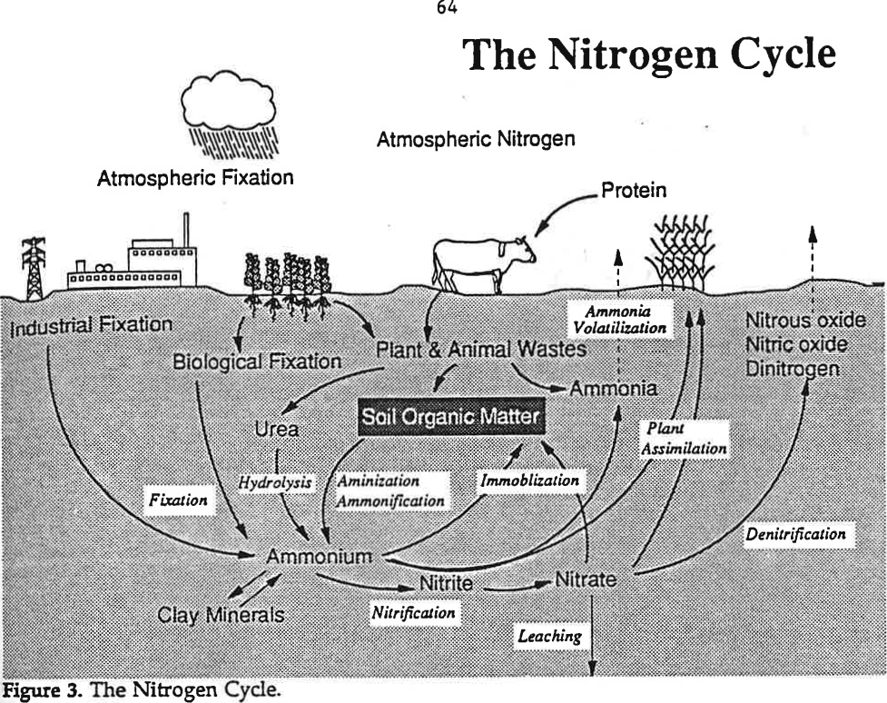
Nitrogen cycle (“Soil as a Plant Sees It”, University of Nebraska, 1991).

Provide the Experience – Measuring and Interpreting Soil Nitrogen – Approximately 3 minutes

Review the laboratory scenario with students. Students can find the scenario in their guided notes.
Marty and Stephen notice that the leaves on their sweetcorn have been gradually turning yellow progressing from the base of the stalk to the upper leaves on the stalk. After consulting with Ben, a local agriscience student and FFA member, they learned that this description matches that of a nitrogen deficiency in plants. They plan to test their plot for nitrogen levels to determine if that is the cause of the yellowing leaves.

Label the Information – Approximately 15 minutes

Review and identify each of the supplies from the soil testing kit that will be used during the lab activity.
- Soil probe for gathering soil samples
- Plastic bucket for mixing soil samples
- Nitrate/nitrite test strips
- 1/8-cup (29.5-mL) measuring scoop
- Calibrated 120-mL shaking vial with lid
- Squirt bottle
- Distilled water or rainwater
- Pen, field notebook, sharpie and zip-lock bags
Review the steps of the laboratory activity and provide any instructions specific to your classroom expectations and time.

Demonstrate the Relevance – approximately 70 minutes

See the attached laboratory guided notes for the steps to complete the laboratory. Review the results and analysis steps of the lab
Review the Content – Approximately 4 minutes

Facilitate students in making applications of the nitrate nitrogen information to lives of consumers in the community. Consider discussing blue baby syndrome and the negative effects of heavy nitrates in water for the elderly.

Celebrate Student Success – Approximately 2 minutes

Congratulate students on their discovery of nitrate levels and encourage them to share the information with their parents.

Ammonification: Production of ammonium (NH₄) from soil organic matter decomposition and other sources.
Ammonium: Form of nitrogen expressed as NH₄, which is a plant-available form of nitrogen that occurs as part of the nitrogen cycle in soil; occurs from soil organic matter decomposition and other sources.
Denitrification: Conversion and loss of nitrate nitrogen to various nitrogen gases when soil becomes saturated with water.
Immobilization: The temporary “tying up” of inorganic nitrogen by soil microorganisms decomposing plant residues is not strictly a loss process. Immobilized nitrogen will be unavailable to plants for a time, but will eventually become available again as residue decomposition proceeds.
Leaching: Loss of nitrogen in the form of nitrate nitrogen which is a water soluble, mobile form, with excess water that moves below the root-zone, or to drainage tile.
Mineralization: Organic matter decomposition which releases nutrients in a plant available form.
Nitrate Nitrogen: Form of nitrogen expressed as NO₃, which is a plant-available form of nitrogen that occurs as part of the nitrogen cycle in soil. Nitrate is the form of nitrogen most susceptible to leaching loss.
Nitrification: Part of the nitrogen cycle where soil organisms convert ammonia and ammonium to nitrite and next to nitrate-nitrogen which is available to plants.
Soil Nitrogen Fixation: Conversion of nitrogen in the air to organic nitrogen forms, which occurs either by soil organisms or in association with legumes.
Volatilization: Ammonia nitrogen loss from nitrogen fertilizers and other sources. Loss can be especially high when nitrogen fertilizers containing urea are surface-applied directly on moist residue.

- Sandy Soil
  - Leaching is a concern because of pore size
  - Nitrogen rate selection is the first concern
  - Rate is determined by assessing the amount of Nitrogen needed to optimize yield based on the agronomic, economic and environmental considerations.
  - Increase the soil organic matter
  - Avoid compaction
- Time
  - Apply adequate amounts when the plants are growing and will use the N quickly
  - Apply N after the plants emerge (side dressing)
  - Apply a portion of N prior to emergence and a portion following emergence
  - Avoid applying urea materials during warm/humid conditions
- Source
  - Anhydrous Ammonia (least expensive N source)
  - Urea must be injected to reduce loss from ammonia volatilization
  - Organic amendments or manure, must be applied uniformly
- Placement
  - Side dressing: applications after plants emerge
  - Knifed applications: placing a band of fertilizer below the soil surface
  - Broadcast applications: uniformly distribute nitrogen
  - Sprinkler irrigation applications: applying fertilizer through the water distribution of an irrigation system
- Irrigation Scheduling
  - Goal: to supply enough water to optimize yield while avoiding excess water, which can increase costs and cause nitrogen to leach below the root zone.

Sandy Soil

Time

Source

Placement of Nitrogen Fertilizer
Irrigation Schedule

Additional Management Strategies

Nitrogen cycle (“Soil as a Plant Sees It”, University of Nebraska, 1991).

Guided Notes: Soil Nitrogen
Ammonification:
Ammonium:
Denitrification:
Immobilization:
Leaching:
Mineralization:
Nitrate Nitrogen:
Nitrification:
Soil Nitrogen Fixation:
Volatilization:

Notes about Factors affecting Soil Nitrogen
Soil drainage Soil texture Slope steepness

Rainfall Temperature Site conditions

Nitrogen Management
Sandy Soil Time Source

Placement Irrigation Scheduling Management Strategies

Guided Notes: Soil Nitrogen Laboratory
Soil Nitrogen Scenario
Marty and Stephen notice that the leaves on their sweetcorn have been gradually turning yellow progressing from the base of the stalk to the upper leaves on the stalk. After consulting with Ben, a local agriscience student and FFA member, they learned that this description matches that of a nitrogen deficiency in plants. They plan to test their plot for nitrogen levels to determine if that is the cause of the yellowing leaves.
Laboratory Supplies
- Soil probe for gathering soil samples
- Plastic bucket for mixing soil samples
- Nitrate/nitrite test strips
- 1/8-cup (29.5-mL) measuring scoop
- Calibrated 120-mL shaking vial with lid
- Squirt bottle
- Distilled water or rainwater
- Pen, field notebook, sharpie and zip-lock bags
Laboratory Steps
Electrical conductivity measurements should always be measured first, before measuring nitrate or nitrite on the same sample. Soil phosphate and soil pH can also be measured using the following steps.
Soil nitrate nitrogen levels are highly variable, depending on management history, field location and time of year. For example, erosion rates, soil texture, organic matter content and applications of manure or fertilizer.

In-Field Quick Hand Test
- Use the soil probe to gather a minimum of 10 small soil samples randomly from an area that represents the soil type and management history you desire to test. Samples should be taken from a depth of eight inches for the surface test and a depth of three feet for subsurface testing. Place the samples in the small bucket and exclude large stones and residue from the sample. Repeat this step for each sampling area.
- Neutralize your hands by rubbing moist soil across your palms and discard the soil.
- Place a scoop of mixed soil in the palm of your hand and saturate it with clean distilled or rain water.
- Squeeze the soil gently until a water slurry runs out into the cup of your hand on the side.
- Touch the nitrate test strip tip directly to soil water slurry so that the tip is barely wet so solution is drawn up at least 1/8” to 3/16”.
- After one to two minutes, measure nitrate by comparing color of wetted test strips to color picture scale on container test strips were stored. The color that most closely matches the test strip is the amount of nitrate in water saturated soil.
- To test nitrite levels, the procedure is repeated after nitrate test pad on the end of the strip is cut off to expose the nitrite test strip to the soil slurry.

1:1 Soil-Water Soil Nitrate/Nitrite Test in Classroom
- Use the soil probe to gather a minimum of 10 small soil samples randomly from an area that represents the soil type and management history you desire to test. Samples should be taken from a depth of eight inches for the surface test and a depth of three feet for subsurface testing. Place the samples in the small bucket and exclude large stones and residue from the sample. Repeat this step for each sampling area.
- Add one sampling scoop (29.5 ml) of mixed soil that has been tamped down during filling by striking carefully on a hard level surface. Then add one scoop (29.5 ml) of water to the same vial resulting in a 1:1 ratio of soil to water, on a volume basis.
- Tightly cap the vial and shake 25 times. Let the mixture settle for one minute. Remove cap and gently pour 1/16” of the soil water 1:1 mixture carefully into the lid.
- After setting for two to three minutes in the lid, immerse the end of the nitrate test strip 1/16” into 1:1 soil water mixture until the liquid is drawn up at least 1/8 to 3/16” beyond the area masked by soil.
- After one to two minutes, measure nitrate by comparing the color of the wetted test strips to color picture scale on container test strips were stored. The color that most closely matches the test strip is the amount of nitrate in water saturated soil.
- To test nitrite levels, the procedure is repeated after the nitrate test pad on the end of the strip is cut off to expose the nitrite test strip to the soil slurry.

Interpretations
Soil nitrate nitrogen is an excellent indicator of nitrogen-cycling in soils, whether carryover nitrogen was used by the previous crop and whether additional nitrogen is needed. High nitrate nitrogen levels also signal potential for excessive nitrogen applied in the past, high rates of organic nitrogen mineralization and potential for losses from denitrification, leaching or volatilization.
Typically, an early season measurement of 20 parts per million nitrate nitrogen in topsoil (30 cm) is sufficient to produce a good corn yield and most other high nitrogen-use crops, whereas a value of only 14 parts per million is sufficient where animal manure is applied or where corn or other high nitrogen use crop follows a legume crop. A very high soil nitrate nitrogen value above 40 parts per million in topsoil will turn off the ability of bacteria and legumes to fix nitrogen. Therefore, nitrogen applications should be managed to keep nitrate nitrogen levels below this value. Nitrate nitrogen levels must be adjusted for soil bulk density and moisture content of the soil as shown in Table 1.
Table 1. Average bulk density for soil minerals (texture) and organic matter (Rawls 1983).
Class (texture, organic matter) | Average Bulk Density (g/cm³)
Organic Matter | 0.22
Sand | 1.56
Loamy Sand | 1.54
Sandy Loam | 1.50
Loam | 1.45
Silt Loam | 1.20
Sandy Clay Loam | 1.63
Silty Clay | 1.55
Clay Loam | 1.45
Silty Clay Loam | 1.40

Soil Nitrate Nitrogen Calculations – Use to Complete Table 2
Ex. 1 Data: Silty Clay Loam texture, 8 inch sample depth; 2% organic matter estimate from soil color chart; no bulk density (BD) measurement (BD based estimated values from Table 1).
Sampling depth conversion: Sampling depth in centimeters (cm) = inches (sampling depth) x (2.54cm/in)
Ex. 1: 8 inch (sampling depth) x 2.54 = 20 cm sampling depth
Subsample Soil water content (g/g) = (weight of moist soil – weight of oven dry soil)
(Weight of oven dry soil)
Ex. 1: (41.0g – 32.5g) = 0.262 g of water/g of soil
32.5 g
Dry weight of soil = (weight of soil in scoop) / (1+ soil water content(decimal))
Ex. 1: (41.0gr / (1 + .262g/g) = 32.5g
Volume (weight) of water = water added to soil in grams + (dry weight of soil x soil water content g/g)
(1ml water = 1g)
Ex. 1: 29.5g + (32.5g x .262g/g) = 38 g
Adjusted ppm soil Nitrate-N = (ppm NO₃-N of 1:1 mix) x (volume of water content in extract & soil)
dry weight of soil extracted
Ex. 1: (20ppm x 38.0g) / 32.5g = 23.4 ppm (adjusted)
Estimated Bulk Density (refer to bulk density educator guide to calculating actual bulk density or use estimate from Table 1 as shown below)
Est. Bulk Density (Table 2) = 100
% organic matter/organic Matter BD) + ((100 - % organic matter)/avg soil BD))
Ex. 1: 100 = 1.26 g/cm3 (estimated bulk density (BD))
(2.0/0.22 g/cm3) + ((100 – 2)/1.40 g/cm3)
Lbs of nitrate-N/ acre/depth sampled = (adjusted ppm NO₃-N) x (cm depth soil sampled/10 ) x estimated soil bulk density x 0.89 (conversion factor)
Ex. 1: 23.4 ppm NO₃-N X (20 cm/10) x 1.26 g/cm3(estimated BD) x 0.89 = 52.5 lbs/Nitrate Nitrogen/20cm sampling depth

Table 2. Soil nitrate nitrogen (based on sampling depth).
Site | *Sample Depth (inches or cm) | Nitrate-N (ppm) From test strip | *Adjusted Nitrate-N (ppm) | *Bulk Density (g/cm3) | *Lbs of nitrate-N/ acre/depth sampled | **Nitrite-N  (ppm) from test strip | Notes:
Ex1 | 8" or 20cm | 20ppm | 23.4 ppm | 1.26 | 52.5 lbs | NA | Spring N-test just prior to planting
* Follow soil nitrate calculation steps based on sampling depth (Ex. 1 is based on 8 inch sample depth).
** When nitrate-N exceeds 40 ppm, or EC exceeds 0.6 ds/m nitrite should also be measured.

Water Nitrate or Nitrite Content

Water nitrate and nitrite levels can be estimated for drinking water, irrigation water and other water sources. Cloudy samples, such as runoff or water from ponds, will need to be filtered first before testing. Drinking water treatment should be considered if nitrate levels exceed 10 mg/l nitrate nitrogen parts per million. This is considered the maximum contaminate level by the Environmental Protection Agency.
Consult your local health officials and be aware that nitrate levels in groundwater may vary seasonally. If your water tests high or borderline high, retest your water every three to six months. Nitrates in irrigation water can be credited for nitrogen supplied to crops using the formula footnoted in Table 3.
- Collect water sample in a small plastic container.
- Filter the water sample if it is cloudy.
- Place one or two drops of water on the nitrate/nitrite test strip.
- After 30 seconds, compare the color to the nitrite scale on the bottle and record the nitrite levels.
- After 60 seconds, compare the color to the nitrate scale on the bottle and record the nitrate in ppm on Table 3.
Table 3. Water nitrate and nitrite nitrogen.
Site | Nitrate-N (ppm) from test strip | Nitrite-N  (ppm) from test strip | Irrigation Water Applied (inches/ac pumped) | Irrigation Water N Credit lbs of N/acre
Ex1 | 20ppm | NA | 12” | 54 lbs N/ac

Are the soil nitrate levels adequate for crops being grown?

Does the total amount of nitrate nitrogen in the soil appear too high or too low based on nitrogen application rates, methods and timing of application?

Do you expect nitrate nitrogen to be lost to leaching, volatilization, denitrification or other losses? Why or why not?

If you tested drinking water for nitrate nitrogen, do levels exceed 10 mg/l nitrate nitrogen ppm? If so, what steps should you take?

