Nebraska Irrigation and Water Management Curriculum

Variable Rate Technologies
Grade Level  7-12th Grades  Lesson Length  60-90 minutes  Key Terms:  Management zone  Variable rate irrigation  Water use efficiency  Yield map  STEM Careers  - Agronomist  - Biological Systems Engineer  - Irrigation Specialist  - Irrigated Farmer  - Mechanical Engineer  Types of Irrigation  Center Pivot  water.unl.edu website  cropwatch.unl.edu website  Check out Nebraska Extension’s Interactive Agricultural Water Management Guide! |  | Overall Goal  Students will explore the approaches in which irrigation is applied at variable rates and propose solutions for how technology can enhance agricultural water efficiency in the future.  Learning Objectives  By the end of this lesson, students will know or be able to:  - Discover the value of variable rate technologies in increasing water efficiency.  - Explain two types of variable rate irrigation systems and how the systems operate.  - Create solutions to enhance water efficiency with the use of technology.  Educational Standards Supported  Nebraska Science Standards: SC.7.7.3.D, SC.7.8.4.E , SC.7.13.5.C, SC.HS.7.2.E, SC.HS.15.5.5.A, SC.HS.15.5.D, SC.HS.6.1, SC.HS.13.3, SC.HS.15.4  Materials List  - Notecards  - Styrofoam cups  - Plastic cups  - Water in 16 oz. bottles  - Scissors  - Straws of various sizes  - Tape  Preparatory Work  - Print Science Notebook pages.  - Gather and separate materials for groups of students to build variable flow system.  - Measure and mark 2 oz., 6 oz., and 8 oz. on clear cups.  - Load videos from Obj. 1 and Obj. 2.

Introduction (5 minutes)
Challenge students to brainstorm and identify the many ways that technology is utilized in agriculture. Create a competition by dividing the class into two groups. The objective is to generate the most ideas for how technology is used in agriculture. Have teams write each idea on a notecard, one answer per notecard. Teams earn one point for every answer the other team didn’t capture. For example, if both teams capture “GPS systems in tractors”, no points are awarded for this answer.

Provide teams three minutes to brainstorm and write their answers. Elicit responses from alternating teams and award points for unique answers.

Preview (1 minute)
Congratulate both teams for the many thoughts that were brought up. Highlight the answers that mentioned technology used in water management or irrigation – such as using phones and tablets to turn center pivot systems on and off or variable rate irrigation systems. Inform students that today’s lesson will focus on how technology is used to enhance water efficiency and irrigation management.

Objective 1 | Discover the value of variable rate technologies in increasing water efficiency. (15 minutes)
Experience
Show students the yield map of a field. Ask students to study the map and lead a discussion about what the map is illustrating. Arrive to the point that uniform distribution of production inputs has not been translated into uniform yield, giving way to variable rate applications. Consider the following questions:
- What is this map revealing? (Listen for: different areas of the field produce different yield levels.)
- What causes yields to be uneven across a field? (Listen for: soil types and characteristics, nutrients, and moisture content, etc. can vary across a field.)
- What does this suggest about production inputs, such as fertilizer, chemical, and irrigation water? (Listen for: different areas of the field might require different amounts of inputs. High-nutrient soil may not require as much fertilizer application, for example).
- How can a producer address the uneven field conditions while minimizing inputs? (Listen for: Variable rate technology, or applying inputs only where it’s needed in the field instead of applying inputs uniformly across the field.)
- Why is this beneficial to water management? (Listen for: increase yield, conserves water and energy, takes into account water needs based on soil characteristics).
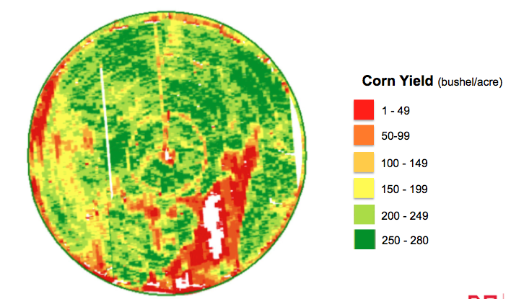
Traditionally, the objective of a center pivot sprinkler irrigation system has been to apply water as close to 100 percent uniformity as possible. However, 100 percent uniformity is being questioned in light of the variation in grain and forage yields displayed in yield maps produced by harvesting equipment. In essence, yield maps suggest that uniform distribution of production inputs has not been translated into uniform yield.

Point
Capture the following information in your science notebooks:

Agricultural field productivity may vary due to differences in:
- topography,
- soil texture and quality,
- fertility levels,
- depth to groundwater,
- nonuniform emergence and crop development, and
- localized pest distributions.
One way to make more efficient use of the water applied may be to tailor water applications to field productivity levels.

Variable rate irrigation: water application systems designed to apply variable amounts – or the right amount water – to different areas of a field rather than one uniform rate across the entire field. Also known as sector, zonal, precision application, or site-specific irrigation.

Water use efficiency: ratio of the yield of an irrigated crop and the amount of total water used to produce the yield. The higher the value, the more efficient the water use.

Yield map: data collected on crop yield and characteristics, such as moisture content, while the crop is being harvested. Various methods, using a range of sensors, have been developed for mapping crop yields.

Show students the following video about VRI from Nebraska Extension.

Higher irrigation efficiency leads to:
- Lower operating costs
- Improved production per unit of water delivered
- Improved environmental benefit
Application
Students will review what they learned as if they are reporting breaking news. Students will play two roles: 1) irrigation expert and 2) interviewer. As an interviewer, students address an imaginary camera, with microphone (pen) in hand, and welcome the viewing audience to “Today with Dr. (fill in the student’s name).” Then they pose questions to the expert about variable rate irrigation. (Note: Have students prepare questions before the activity begins.)

Have students stand, pair up, and get ready to go “live” at your signal. Midway through, have student switch roles. After everyone has played both roles, ask students to share what they learned from the experts they interviewed.
Objective 2 | Explain two types of variable rate irrigation systems and how the systems operate. (30 minutes)
Experience
Students will work in a team of 3-4 to build a system that divides 16 ounces of water into three cups with 2 oz., 6 oz., and 8 oz. of water in each cup. Each group will build this system using materials provided by the instructor to develop a plan and build the system.

Provide students with materials including Styrofoam cups, clear cups (with lines marking 2, 6, and 8 ounce levels), straws of various sizes, 16 ounces of water, tape, and scissors.

Give students 10 minutes to plan and develop their system. Have each group demonstrate and test their system to discover if the design allocates water as desired.

Process:
- What worked well?
- What was challenging?
- How could you improve your design?
- How does your model represent a variable rate irrigation system?
- How do producers vary the amount of water distributed to different sections of the field?
(Listen for: change the speed of the center pivot, turning sprinklers on and off)
After experience the challenges of allocating water in different amounts, let’s explore how variable irrigation works in agriculture.

Point
Show students this video about variable rate irrigation. Start the video at 0:33 seconds and stop at 2:20.

What are two ways to control the amount of water applied to fields? Water application can be varied by 1) speed of irrigation and 2) zone control. The goal is to maximize the economic and/or environmental return of the irrigation water applied.

- Speed or Sector Control
- Adjusting the system speed of travel effectively changes the application depth in pie-slice-shaped areas, known as radial sectors.
- Generally, no additional hardware is needed.
- The challenge is that field variation seldom occurs in pie-slice-shaped parcels.
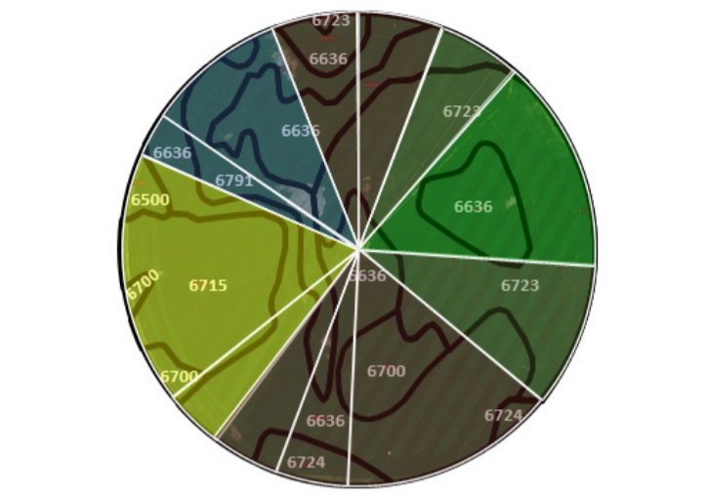
What are advantages to using this approach? Disadvantages?

- Zone control
- Management zone - specific areas within a field that respond to management practices in a similar way.
- Zone control involves the spatial definition of irregularly-shaped management zones based on crop yield maps, soil textures, fertility levels, topographic variations, or no irrigation areas.
- Most zone control systems vary water application depths using the on-off cycling of individual sprinklers or groups of sprinklers using a single system speed.
One approach available today to vary water application depth along the center pivot is to control groups or individual sprinklers as the pivot moves across management zones.

The field soils map presented below (part a) is based upon the soil-mapping units for a quarter section of land in Nebraska.

Part b shows a VRI management zone - which is not an actual map developed for this field – rather, it provides an example of how the system is set up. Using blocks of sprinklers does limit the ability to implement management zones due to limitations in matching sprinkler blocks with irregularly shaped management zones.

Part c represents an approach to independently control each individual sprinkler along the pivot system. Using the soil map from part a, map c demonstrates that as the pivot makes a revolution, individual sprinklers can be turned on or off based on the field management zones and not based on the center pivot’s plumbing. This approach will come closest to matching water application with the water requirements of individual management zones but adds complexity to the system.

What are advantages to using this approach? Disadvantages?

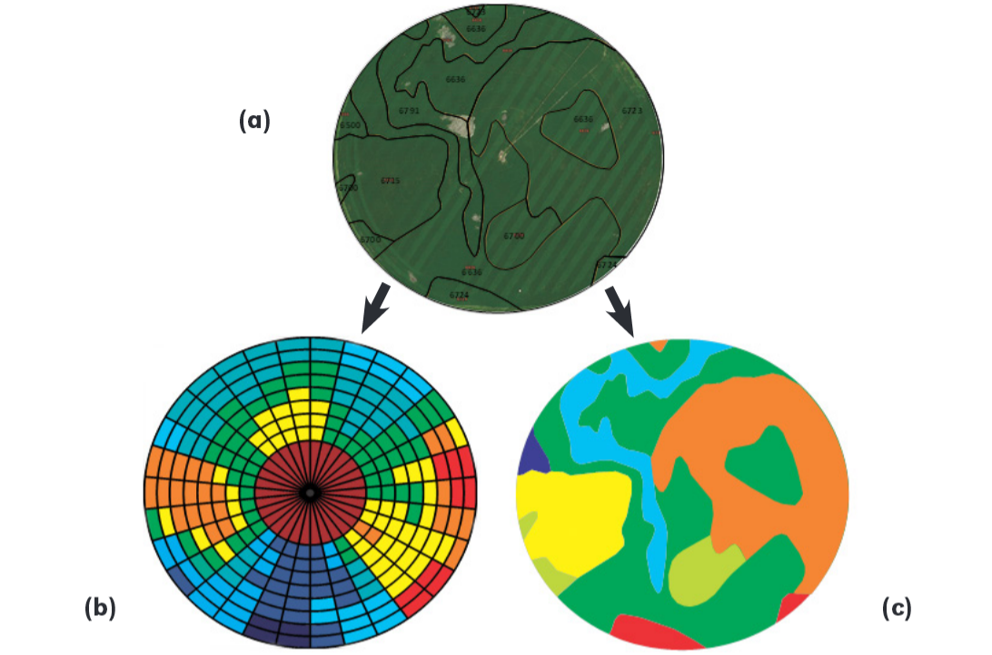

In your science notebook, illustrate these types of variable rate application systems and describe the differences between them.

Application
Students will create a concept of a new technology - or an improvement on an existing one - that will enhance water efficiency in agriculture. Encourage students to be creative and consider the many aspects of irrigation management. Researching current variable rate irrigation technologies can be useful to begin generating ideas.

Students will present their concepts and ideas to the class through a 2-3 minute presentation. Students can illustrate their technology by building a model, PowerPoint presentation, poster, or skit.
Ensure students address the following:

- How does this technology work?
- How does this advancement enhance water efficiency?
- Why is increasing water efficiency important?
This project can be assigned as homework.

Review & Reflect (5 minutes)
Share on Twitter: Ask students to reflect on how technology has changed agriculture, and imagine the impact technology will have on irrigation and water use in the future. Have students construct a tweet (under 140 characters) of what they learned about variable rate technology or their ideas to enhance water efficiency. Have students share their tweet with the class and tweet their responses to Nebraska extension at @UNLExtension and @bvaderwalle2.

Celebrate Student Success (1 minute)
Thank students for their participation in learning about variable rate technology and envisioning the role technology will play in water management in the future. Provide final announcements and review the next lesson.

References
VanDeWalle, B., Nygren, A., Burr, C., Zoubek, G., Irmak, S. (2016) Agricultural Water Management Guide. Extension Publication. University Of Nebraska - Lincoln Extension.

Kranz, W., Irmak, S., Derrell, D.M., van Donk, S.J. (2014). Variable Rate Application of Irrigation Water with Center Pivots. Extension Publication, EC2000. University of Nebraska-Lincoln Extension.

Irrigation and Water Management
Science Notebook

Completed by:______________________________ Date: ________________

How is technology used in agriculture?

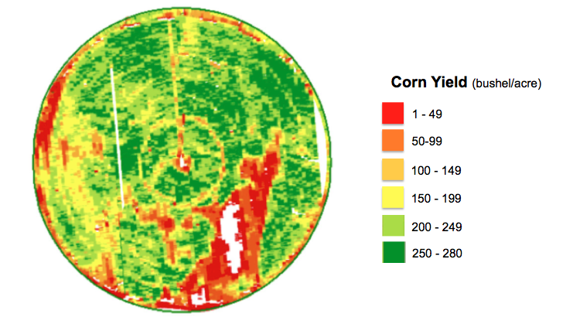

Agricultural field productivity may vary due to differences in:

Key Terms | Definition
Variable rate irrigation

Water use efficiency

Yield map

Management zone

Value of Variable Rate Irrigation…

Water application can be varied by:

Illustrate what these irrigation maps.

Describe the differences between these approaches to variable rate irrigation:

Reflect & Share…
- How has technology changed agriculture?

- What impact will technology have on the industry in the next 10 years? 50 years?

- What have I learned about variable rate technology?

- What are my ideas to enhance water efficiency in Nebraska?

