Nebraska Irrigation and Water Management Curriculum

Overview of Irrigation Past and Present
Grade Level  7-12th Grades  Lesson Length  45-60 minutes  Key Terms:  Groundwater level  High Plains Aquifer  Irrigation well  Natural Resources Districts  STEM Careers  - Conservation Specialist  - Extension Educator  - Geologist  - Irrigation Specialist  - Irrigated Farmer  Types of Irrigation  water.unl.edu website  cropwatch.unl.edu website  Check out Nebraska Extension’s Interactive Agricultural Water Management Guide! |  | Overall Goal  Students will understand how irrigation practices have evolved over time and the current impact of irrigation in Nebraska and beyond.  Learning Objectives  By the end of this lesson, students will know or be able to:  - Describe the evolution of irrigation practices in Nebraska.  - Explain the prevalence of irrigation in Nebraska and across the U.S.  Educational Standards Supported  Nebraska Science Standards: SC.7.7.3.D, SC.7.8.4.E , SC.7.13.5.C, SC.HS.7.2.E, SC.HS.15.5.5.A, SC.HS.15.5.D  SC.HS.6.1, SC.HS.13.3, SC.HS.15.4  Materials List  - Access to YouTube videos  Preparatory Work  - Print Science Notebook pages  - Print timeline cards  - Load “Evolution of Dance” video  - Load “High Plains Aquifer” video

Introduction (5 minutes)
Show students a few minutes of the “Evolution of Dance” video.

Process and Transition:
- What is the video illustrating?
- What else has changed with time?
- How has agriculture evolved over time? (Write responses to this question in science notebook. Elicit responses from students).
Preview (2 minutes)
Those are great examples of how agriculture has changed with time. From the machinery that’s used, to the way records are kept, and the increasing productivity, agriculture is still evolving and will look different in another century! Irrigation and water management practices are another area of agriculture that has evolved over time, which is the focus of today’s class.

Objective 1 | Describe the evolution of irrigation practices in Nebraska
(20 minutes)
Experience
Print the timeline cards found at the end of this lesson. Distribute these cards in a random order to students. Instruct students to work as a group to place the cards in the correct order, from earliest to most recent. Once students have the correct order, use a piece of tape to hang the cards where students can see.

Correct Order:
- Irrigation ditches are constructed in Nebraska
- Nebraska has 214 irrigators
- Nebraska’s first irrigation law is passed
- Drought occurs and Nebraska’s extensive irrigation system is formed
- Nebraska State Irrigation Association forms
- There are approximately 1200 irrigation wells
- Drought occurs and Nebraska’s extensive irrigation system grows
- Center pivots are created
- Corner pivot systems & lateral-move sprinkler systems develop
- Nebraska has approximately 75,000 irrigation wells
- Nebraska Agricultural Water Management Network was established to assist producers in achieving efficient irrigation management
- Nebraska has over 112,000 irrigation wells.

Point
Capture the timeline and key terms in your science notebooks.

Nebraskans have long realized that using soil and water resources wisely is important, particularly since the state's economy relies on agriculture. Irrigation ditches were constructed in Nebraska as early as 1856. However, Nebraska's current extensive irrigation system stems from the droughts of the 1890s and 1930s (Dust Bowl Era).

Initially, Nebraska received all its irrigation water from streams and rivers practicing surface (gravity) irrigation method. These waterways continue to supply water for much of Nebraska's cropland today, especially in the western Nebraska. What rivers are most important from an irrigation perspective? The Platte, Loup and Republican rivers were especially important.

Instruct students to draw these rivers in their science notebook.

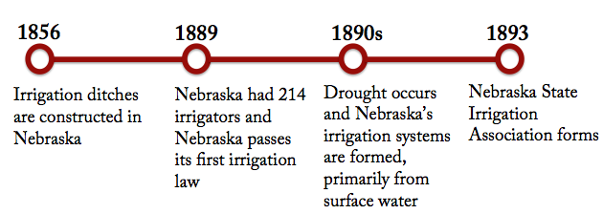

Since 1940, however, irrigation from wells has increased dramatically. Of Nebraska's 8 million irrigated acres in 1990, about 7,000,000 million acres were irrigated from wells, with the rest coming from streams and rivers. The number of irrigation wells installed per decade peaked in the 1970s. Since the seventies about 10,000 wells were installed each decade.

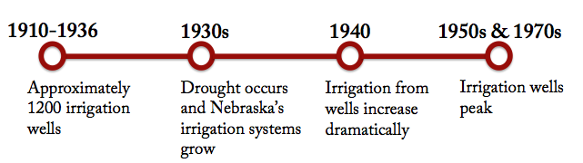
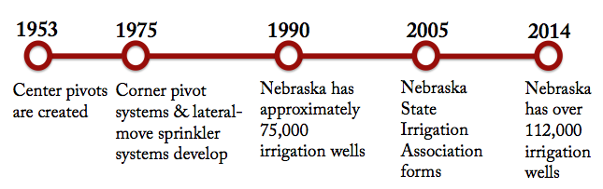

Currently, there are over 173,000 active irrigation wells in Nebraska. The highest density of wells are located in the Central Platte Valley where over 16 irrigation wells have been installed per square mile of land. The location of irrigation wells reflects the availability of groundwater, the suitability of the land for irrigation and the need for irrigation to meet crop water requirements. Distribution/density of active irrigation wells is presented in Figure below. Each red dot represents an irrigation well and most of the wells are located in the central and south central part of the state along the Platte River

Show map of irrigation wells across Nebraska.

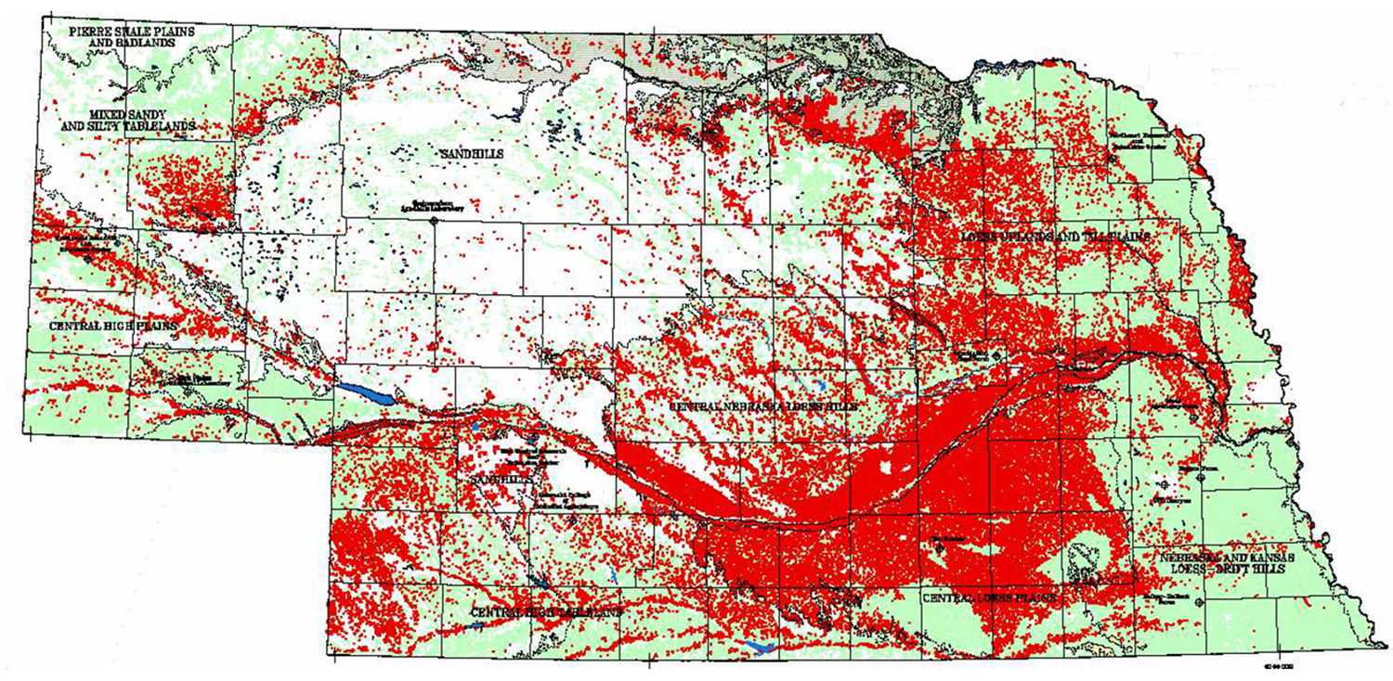

These irrigation wells pump groundwater to provide water to most of Nebraska’s irrigated acres. This water comes from the High Plains Aquifer.

Watch the short video with groundwater geologist, Jesse Korus.

Irrigation development has caused declines of groundwater levels (depth to groundwater from the soil surface) in some areas of the state. The most severely affected areas are the Box Butte area, western end of the Republican River Basin and parts of the Blue River Basin. Natural Resources Districts (NRDs) have implemented management plans in these areas to regulate groundwater resources use.

Application
Select the county you live in and one county in a different region of Nebraska. For each of these counties, answer the following questions in your science notebook. Use the maps and resources provided in the Agricultural Water Management Guide to begin your research.

- Describe the irrigation well density in this county.
- What is the primary source of irrigation water in this county?
- How have groundwater levels shifted in this county over the last 10 years? Over the last 30 years?
- What Natural Resources District (NRD) is this county part of?
- Are there any water regulations in this county? If so, describe them.
Provide students time to research and answer the questions. Ask students to share what they learned with a partner or summarize on a poster. (May assign this as homework.)

Objective 2 | Explain the prevalence of irrigation in Nebraska and across the U.S. (15 minutes)
Experience
Divide the class into teams of 3-4 students for irrigation trivia using the following questions. Teams should capture their answers on a sticky note before revealing the correct answer. Each correct answer is worth 10 points. Instruct students to capture the information from these questions in their science notebooks.

Point
- What percentage of U.S. farmland is irrigated?
Answer: 6%
Additional info: In 2013, there were 55.3 million acres of irrigated land in the U.S.

- Nebraska ranks ____ among states in number of irrigated acres?
Answer: 1st
Additional info: Nebraska has the highest number of irrigated acres at 8.3 million, followed by California at 7.5 million acres.

- Cropland accounts for ______ of all irrigated land.
Answer: 95%
Additional Info: Cropland accounted for 95% of all irrigated land while 5% accounted for permanent pasture/grassland.

- What type of irrigation covers the highest number of acres?
Answer: Sprinkler systems
Additional Info: In 2013, 34.9 million acres were irrigated with sprinkler systems, followed by gravity systems at 21.5 million acres and lastly with a variety of drip, trickle, or other low-flow micro irrigation systems at 4.9 million acres.

- What is the average annual amount of water (in acre-feet) applied to each acre from irrigation?
Answer: 1.6 acre-feet
Additional info: Review the “irrigation math” chart.

- Irrigation consumes _________ of all the groundwater pumped in Nebraska and _________ of the entire surface water diverted.
Answer: 95%, 47%

Application
Compare the prevalence of irrigation in Nebraska to one other state. Create a Venn Diagram to summarize similarities and differences between states. Consider the following questions:

How common is irrigation? Why?
How many acres are irrigated in the state?
What crops are irrigated?
What types of irrigation systems are utilized?

Instruct students to capture the similarities and differences in the Venn Diagram in their science notebook.

Review & Reflect (5 minutes)
Ask students to reflect on and summarize what they learned about the history of irrigation in Nebraska, the current state of irrigation, and imagine the future of irrigation in the state.
Instruct students to journal about the following prompt in their science notebook.

Irrigation in Nebraska…
- Where has it been?
- Where is it now?
- Where is it going?

Celebrate Student Success (1 minute)
Thank students for their participation while learning about the evolution of irrigation. Summarize the key points from this lesson and preview the next lesson.

References
VanDeWalle, B., Nygren, A., Burr, C., Zoubek, G., Irmak, S. (2016) Agricultural Water Management Guide. Extension Publication. University Of Nebraska - Lincoln Extension.

Irrigation and Water Management
Science Notebook

Completed by:______________________________ Date: ________________

How has agriculture evolved over time?

Timeline of Irrigation in Nebraska:

Key Term | Definition
Irrigation Well

High Plains Aquifer

Groundwater level
Natural Resources Districts (NRD’s)

Nebraska Rivers Critical to Early Irrigation

Nebraska’s extensive irrigation system stems from _____________________.

The number of irrigation wells installed per decade peaked in ____________.

The majority of Nebraska’s irrigation water comes from the _______________________.

 | My County: | Other:
Describe the irrigation well density in this county.

What is the primary source of irrigation water in this county?

How have groundwater levels shifted in this county over the last 10 years? Over the last 30 years?

What Natural Resources District (NRD) is this county part of?

Are there any water regulations in this county? If so, describe them.

What I learned from Irrigation Trivia:

Nebraska __________________

Nebraska Irrigation…

Where has it been?

Where is it now?

Where is it going?

Center pivots
are created

Corner pivot systems & lateral-move sprinkler systems develop

Drought occurs and Nebraska’s extensive irrigation system grows

Drought occurs and Nebraska’s extensive irrigation system is formed

Irrigation ditches are constructed in Nebraska

Nebraska’s first irrigation law is passed

Nebraska State Irrigation Association is formed

There are approximately 1200 irrigation wells

Irrigation wells reach 75,000

Irrigation wells reach 112,000

Nebraska has 214 irrigators

Nebraska Agricultural Water Management Network is established to help producers achieve efficient irrigation management

