Agricultural Water Management Basics

Plant Sciences & Natural Resources
Grade Level  7-12th Grades  Lesson Length  60-120 minutes  STEM Careers  - Irrigation Specialist  - Irrigated Farmer  - Engineer  - Agronomist  - Software Developer  Life Skills  - Reason, Make Decisions  Irrigation Careers Interview  Types of Irrigation  water.unl.edu website  cropwatch.unl.edu website  Check out Nebraska Extension’s Interactive Agricultural Water Management Guide! |  | -What is agricultural irrigation?  -What is the importance of water management in agricultural irrigation?  Learning Objectives  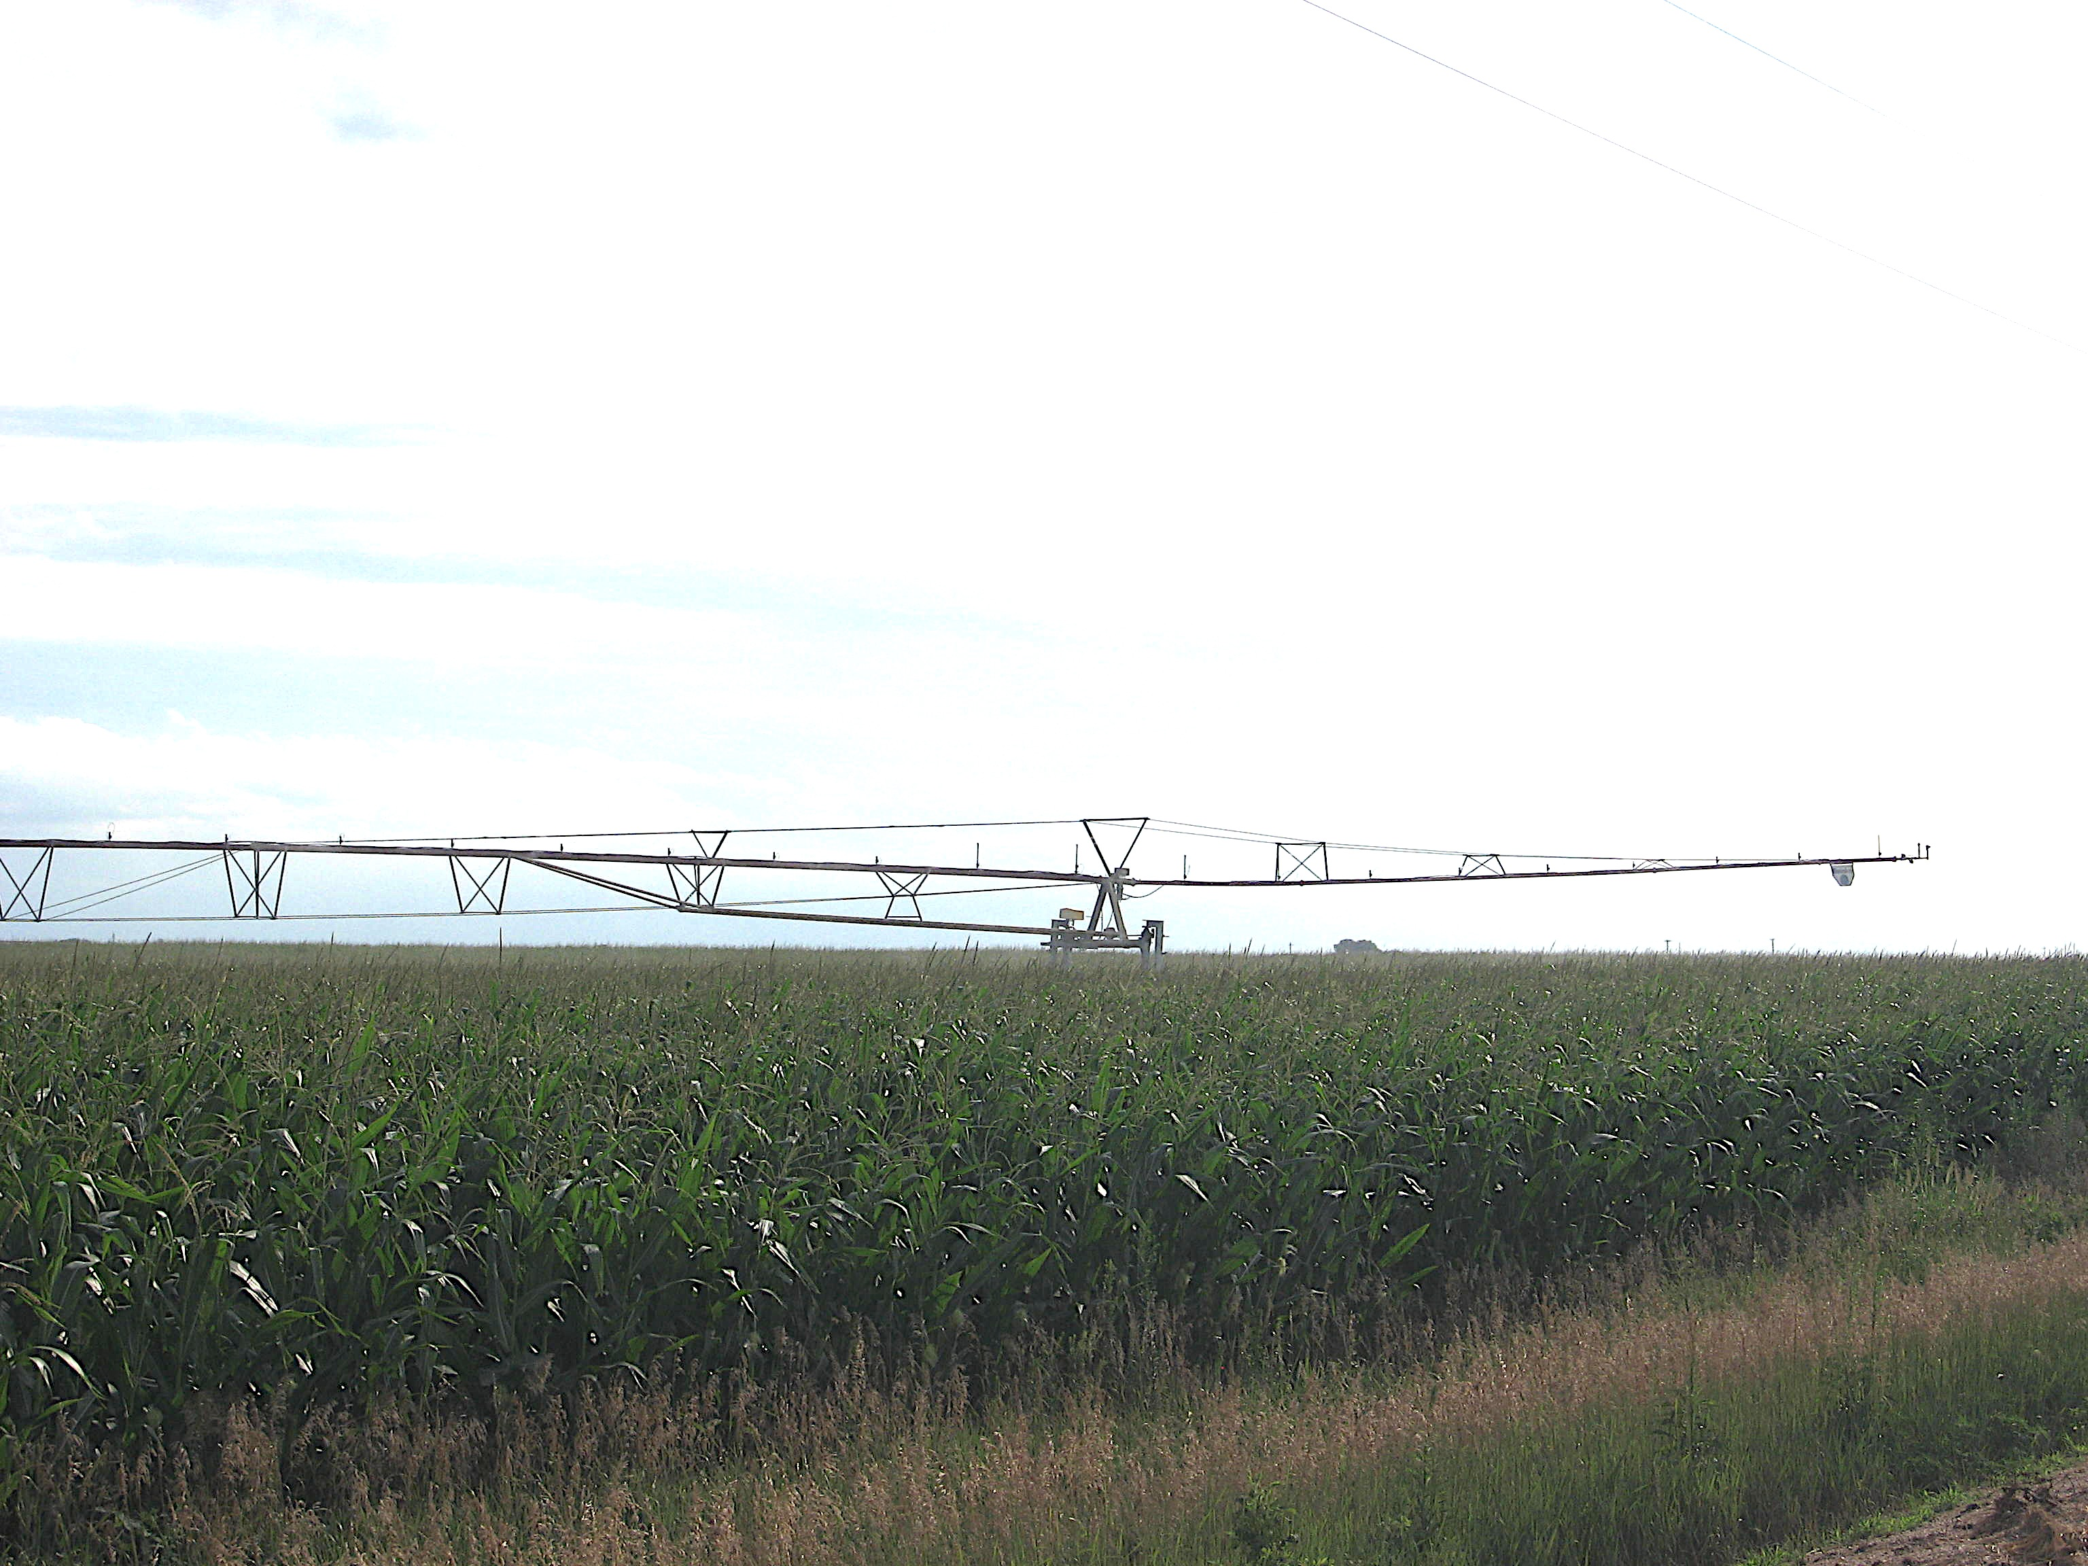  By the end of the lesson, students should be able to:  - Define basic irrigation terminology.  - Explain the importance of irrigation and water management in agriculture and factors that determine irrigation amounts.  - Identify problems associated with under or over-irrigating crops and provide solutions to those problems.  Educational Standards Supported  Nebraska State Standards: SC.12.1.1.f  Materials List  - Access to the Internet  - Sites to create info graphics such as piktochart.com or canva.com OR markers/crayons to create an info graphic by hand  - Journals or science notebook handouts  - 3-4 corn/soybean plants in containers (if not available, use 3-4 potted plants of some kind that you don’t mind if it dies) -1 healthy plant, 1 over-watered for about 3-4 days, 1 under-watered and starting to die  - Paper towels  - Handouts (following lesson)  Do Ahead  - Obtain three plants (preferably corn and/or soybeans, but any plant will work) in the same containers. A couple of weeks prior to the lesson, overwater one plant, properly water one plant and deprive the other plan of any water.
Introduction  The goal of irrigation management is to use water in the most profitable way at sustainable production levels. For production agriculture, this generally means supplementing precipitation with irrigation when crop water demand is high. For example, recent years there have been declines in groundwater levels in Nebraska, almost statewide, and other High Plains states. Considerable areas of Nebraska are considered fully or over-appropriated. This means that in those over-appropriated areas, there will be no new development of irrigated acres. In fully appropriated areas, the water demand and use are relatively in balance and the basin or watershed cannot sustain additional water use development. Additional areas that are not considered fully or over-appropriated have established regulations limiting the expansion of irrigated acres.  Opening Questions  Why did irrigation first start?  Supplement the crop with needed water so it wouldn’t die  Why is irrigation important?  It not only makes a significant contribution to the value of U.S. agricultural production, but also has implications on livestock production and consumer food prices and food security.  What careers work with irrigation?  Have youth brainstorm careers; then share as a group.  Possibilities include: farmer, agronomist, irrigation manufacturers, engineers, software developers, researchers, pivot & irrigation equipment sales, community planners, etc.  Experience - Activity One  Today we are agronomists; you will explore why irrigation is important and you will have the opportunity to determine factors that should be taken into consideration when irrigating. First, your friends want to know why farmers irrigate and why it is important.  Using resources such as the Agricultural Water Management Guide and other internet tools, create an info graphic which illustrates the impact irrigation has on agriculture and society. Free internet sources such as piktochart.com or canva.com may be used for an electronic version. Youth may also draw by hand if so desired in their notebooks or science journals, as applicable.  (This can be given as homework or worked on during class with teacher guidance and students can share their info graphics if time allows.)  Experience - Activity Two  Now that you as an agronomist have explained the importance of agricultural irrigation, your client has three plants and it is your job to investigate if any problems have occurred with them. You will need to advise your client, a farmer how to effectively manage irrigation in his operation.  First, we need to define basic irrigation terms and concepts.  Share/Pair: With a partner jot down key concepts the following words possess or how they impact irrigation.  Soil water (Ground water is subsurface water in sufficient quantity that wells or springs can use it.)  Available soil water (It is the amount of water held by the soil between field capacity and permanent wilting point.)  Excess soil water or gravitational water (Since drainage takes time, plants may use part of the excess water before it moves out of the root zone.)  Field Capacity (It is the amount of water remaining in a soil after the soil has been saturated and allowed to drain freely for approximately 24 hours.)  Permanent wilting point (When plants have removed all of the available water from a given soil, they wilt and will not recover.)  Show youth the following picture, or draw it out to illustrate the concept of available water, field capacity and permanent wilting point. Hand out field capacity and permanent wilting point to put in their science notebook.  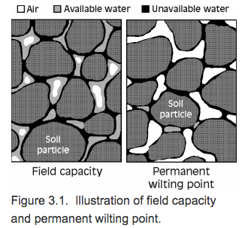  Experience - Activity Three  (Put the plants where youth can see them, but not necessarily touch the soil or see it soybeans work well for hiding the soil surface.)  The farmer calls you, the agronomist out to look at these three plants that represent three fields. Plants are the same hybrid & variety with similar soil types.  What are the differences between these plants?  One should be healthy, the others should be stressed, yellowed,  dying or possibly even dead.  What types of conditions do you think were present for each plant?  One was flooded, one had optimal water conditions, one had very  little water.  What can we learn from these three plants/fields?  Plants require a certain amount of water to thrive.  Adopting proper irrigation management strategies can reduce negative impacts of over-irrigation and provide a balance between the crop water requirements and available water. Over-irrigation leads to water loss, increases energy use for pumping, causes leaching of nitrogen and other micronutrients and wastes time.  What factors will affect the amount of irrigation water applied? Jot these down in your science notebooks.  Measure soil water status, rainfall, irrigation water applied, estimating crop water use, type of crop, stage of crop’s growth, take into account weather related factors such as humidity, temperature and wind, etc.  Reflection  - What is the importance of irrigation management?  - What is the definition of irrigation management?  - What are key terms related to irrigation?  - What are problems associated with under or over irrigating crops?  - What are careers related to irrigation?  - As an agronomist or farmer, why is it important to effectively manage water? |  |  | To gauge students’ previous knowledge of irrigation, have them jot a few notes in their science notebook.  The goal of irrigation management is to use water resources to meet crop water requirements in the most profitable way at sustainable production levels.  Over-appropriated: There will be no development of irrigated acres  Fully appropriated area: The water demand and use are relatively in balance and the basin or watershed cannot sustain additional water use development  Did you know?  Efficient irrigation systems and water management practices can help maintain farm profitability in an era of increasingly limited and more costly water supplies.  Resource:  For the latest nationwide summary on irrigation and water use go to USDA’S Economic Research Service at  http://www.ers.usda.gov/  (Search for irrigation)  FREE Info graphic sites:  Piktochart.com  Canva.com  Terms  Soil water: water contained within or flowing through the soil profile. Surface water must infiltrate the soil profile to become soil water.  Excess soil water or gravitational water: water that drains or readily percolates below the active root zone by the force of gravity.  Available soil water: water that is retained in the soil and can be extracted by the plant. The available soil water is most important for crop production.  Field capacity: the water content of a soil at the upper limit of the available soil water range  Permanent wilting point: the lower limit of the available soil water range.  Fact: Agricultural water users can optimize water use efficiency and protect the quality of water resources by applying basic and research-based information about irrigation systems, crop water use and management practices.  Discuss…  What happens to crops that receive excess water?  They will “drown” out b/c they need oxygen to survive  The impact of excess water on crop growth and yield is influenced by crop type, soil characteristics, duration of excess water or flooding, initial soil water and nitrogen status of the soil before flooding, crop stage, air temperature, etc.  Resource:  Irmak, S., & Rathje, W. R. (2014). Plant Growth and Yield as Affected by Wet Soil Conditions Due to  Flooding or Over-Irrigation. Extension NebGuide, G1904. University of Nebraska-  Lincoln Extension.  Fact: One acre can grow 100-300 bushels/acre of corn, with 200 bushels being an average.
Apply/Generalize to Your Life  So now you are all agronomists! What are were some things you found out as you learned about irrigation?  How does science, technology, engineering and math relate to irrigation? What STEM skills did you use in this lesson?  How can you use skills used today in different situations?  As you can see, STEM skills and careers are all around us and you were able to experience some of those skills and careers. |  |  | EXTRA REVIEW  Create a chart labeled What We Learned in your Science Notebook, which might include: irrigation management goal, terms defined, careers related to irrigation, impacts of over/under irrigation, etc.
Evaluation Link  Coming Soon  References  Irmak, S., & Rathje, W. R. (2008). Plant Growth and Yield as Affected by Wet Soil Conditions Due to Flooding or Over-Irrigation. Extension NebGuide, G1904. University of Nebraska-Lincoln Extension.  VanDeWalle, B., Nygren, A., Burr, C., Zoubek, G., Irmak, S. (2016) Agricultural Water Management Guide. Extension Publication. University Of Nebraska - Lincoln Extension.  Author  Brandy VanDeWalle, Extension Educator  Reviewed by Nebraska Extension’s STEM Careers Team on DATE |  |  | Connect via tweeter @bvandewalle2  #NAWMN  Check out cropwatch.unl.edu - youth webpages

Supplemental Information

Nebraska Facts
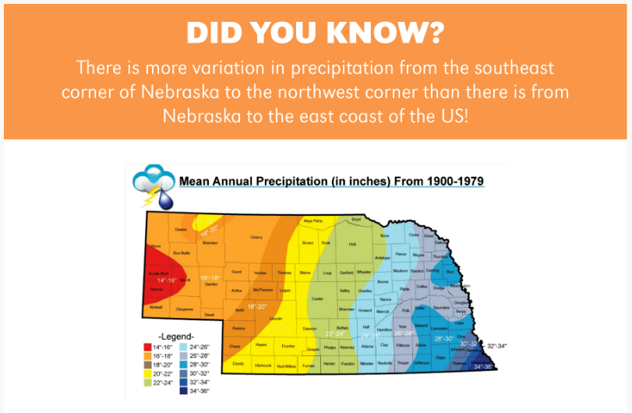

RESEARCH OPPORTUNITY…
See what areas are fully or over-appropriated at http://www.dnr.ne.gov/iwm/fully-appropriated-and-overappropriated-surface-water-in-nebraska

Agricultural Water Management Basics
Science Notebook

Thoughts about irrigation….

The goal of irrigation management is…..

Over-Appropriated:

Fully Appropriated:

Careers involved in irrigation include

Irrigation is important!

Water Management Basics
Science Notebook
Key concepts with irrigation include:

Soil Water Available Soil Water

Excess soil water or gravitational water

Field Capacity Permanent Wilting Point

Water Management Basics
Science Notebook

As an agronomist, examine the three plants. What are the differences between the plants? What types of conditions do you think were present for each plant?

What can we learn from these three plants?

What I have learned from this lesson…….

OTHER LESSONS TO FOLLOW:
- History of irrigation & types of irrigation, present irrigation
- Irrigation types: Surface, Sprinkler, Trickle/Drip
- Irrigation Management Strategies
  - Soil types
  - Limited or Deficit
  - Irrigation Timing
- Tools used to irrigate
  - ETgage
  - Watermark Sensors
- Variable Rate Irrigation & Future of Irrigation
- Nebraska Ag Water Management Network (tie to citizen scientist)
- Resources Page
  - Apps
  - Z-Mag

