Nebraska Irrigation and Water Management Curriculum

Irrigation Management Overview
Grade Level  7th -12th Grades  Lesson Length  60-90 minutes  Key Terms:  Deficit irrigation  ET Gauge  Evaporation  Full irrigation  Limited irrigation  Soil Moisture Sensor  Transpiration  STEM Careers  - Agronomist  - Extension Educator  - Irrigation Specialist  - Irrigated Farmer |  | Overall Goal  Students will discover factors that influence irrigation management practices and decisions.  Learning Objectives  By the end of this lesson, students will know or be able to:  - Identify factors that influence irrigation and water efficiency.  - Describe strategies for irrigating when water is limited.  - Identify tools available to manage water and irrigation.  - Develop an irrigation management strategy.  Educational Standards Supported  Nebraska Science Standards: SC.7.7.3.D, SC.7.8.4.E , SC.7.13.5.C, SC.HS.7.2.E, SC.HS.15.5.5.A, SC.HS.15.5.D  Materials List  - One gallon of water  - ½ measuring cup  - Bowl  - Eyedropper  - Two soil containers (one with bare soil, the other with crop cover)  - Candy bars/cookies (or other type of snack)  - One marker per student  - Clear white board or large sheet of paper  Preparatory Work  - Print Science Notebook pages  - Fill one gallon container with water
Types of Irrigation
Irrigation and Water Management Basics

water.unl.edu website
cropwatch.unl.edu website

Check out Nebraska Extension’s Interactive Agricultural Water Management Guide!

Introduction (5 minutes)
Students will realize the amount of freshwater available for use.
Directions:
- Fill a one-gallon container (such as a plastic ice cream bucket) with water. Explain to students this represents all the water on Earth.
Where is most of this water located? (Listen for: ocean)
What percentage of water Earth’s water is salt water? (Listen for: 97%)

We cannot use salt water without first removing the salt in a process known as desalination. While technology is improving this process, it is still very expensive.

- Pour one half-cup of water from the one-gallon container into a bowl. Explain to students that the water in the bowl represents all of the freshwater on Earth, which is less than three percent of the total water on Earth.
Where is freshwater found? (Listen for: ice caps, lakes, streams, groundwater)

- With an eyedropper, place one drop of water onto a small plate.
Most of Earth’s fresh water is frozen in ice caps and glaciers! This small drop represents the 1% of freshwater that is easily accessible and available for our use – from rivers, lakes, and aquifers.

Process and Transition:
- What does this demonstrate about water? (Listen for: it’s a limited natural resource)
- How can we be good stewards of this natural resource?
- How can agricultural producers help to conserve and protect freshwater?
Preview (1 minute)
Agricultural producers utilize a portion of our water supply to raise crops and livestock. Water is essential to growing food, but it’s also important to producers and to manage this resource in a sustainable way. Today we will explore factors that influence water management decisions and develop strategies to effectively manage this natural resource.

Objective 1 | Identify factors that influence irrigation and water efficiency (10 minutes)
Experience
Place two pots of soil in front of the class. One pot should be bare soil, and the second should have crop residue covering the surface (could use mulch to demonstrate crop residue).
Process:
  - What do you observe about these pots?
  - Imagine that these pots represent fields. How would you describe the tillage of these fields? (Listen for: tilled vs. non-tilled soil)
  - Which of these pots – or tillage practices – is more useful to conserving water? Why?
  - What other factors might influence the efficiency of irrigation? (Listen for: water-holding capacity of soil, crop root depth, soil type, recent precipitation)
These are excellent ideas to consider. Let’s dive deeper into what production practices influence water management. We’re about to hear an expert’s opinion on what practices reduce the need for irrigation. Capture what you learn from this video in your science notebook.

Point
Play the residue animation video. Ask students to listen closely to complete the fill-in-the-blank section of their science notebook.

Maintaining crop residue and reducing tillage:
- Increases amount of water that infiltrates the soil from irrigation or precipitation
- Decreases the amount of water that runs off the soil surface
- Reduces the rate of evaporation of water from the soil
- Reduces the amount of irrigation water needed to grow a crop
Long term no-till leads to better soil structure, less soil crusting, greater infiltration of water, and less surface runoff.

Soil type
- Coarse soils, such as sands and gravels, have relatively large pores. However, the number of pores is small when compared to a finer textured soil.
  - Have roughly 0.5-1.0 inches of available water per foot of soil depth

- Fine soils, like clays or clay loams, have relatively small pores. Having many small pores means that a fine textured soil can hold more water than a coarse textured soil.
  - Silt loam soils have roughly 2 inches (or more) of available water per foot of depth
Crops can use about half of the available water without experiencing water stress and associated yield reduction. With the large range of available water for different soil types, a better understanding of soil water and soil physical properties is needed before fine tuning an irrigation schedule.

Application
Talk about it – Write about it – Sketch about it
Students will answer the following questions. Provide students a choice of how to process – talking, writing, or drawing. Designate “processing stations” around the room and ask students to answer the following questions:

- What factors influence the efficiency of irrigation?
- How does crop residue facilitate water efficiency?
- How does pore size affect water availability for crops?
Objective 2 | Describe strategies for irrigating when water is limited (10 minutes)
Experience
Allocating limited resources
Provide the class with a small bag of snacks (crackers, candy bars, or cookies, etc.). For the activity, offer fewer snacks than there are students to create a scare resource. For example, if there are 6 students, provide 4 candy bars. Allow students to determine how to divide the snack.

Process:
  - How did you decide how to split the snack?
  - Why did you take this approach?
  - By having fewer snacks than people, a limited resource was created. What limited resources exist in agriculture? (Listen for: water)
  - What might cause limited water availability? (Listen for: drought, low water table depths, water allocation requirements)
  - If water is limited for an agricultural producer, how do they allocate their irrigation? (Listen for: evenly distribute irrigation water across the growing season and only irrigate at critical growing periods)
There are scenarios in which producers have access to less water than what they need to fully irrigate their crops. When irrigation water is limited, producers must decide how to best allocate what’s available to them. Next, we’ll explore two irrigation strategies for irrigating when water is limited.

Point
Managing irrigation to prevent crop water stress during the entire growing season at any plant growth and development stage is usually referred to as full irrigation management.

full irrigation management – irrigating to prevent crop water stress during the entire growing season at any plant growth and development stage

As we discussed, full irrigation management is not always an option due to the effects of drought, declining water table depths, reduced stream flow, water allocations, irrigation system design capacity, water quality issues, etc. Therefore, less irrigation than what is required to meet the crop water requirement is applied, which has led to the development of limited and deficit irrigation management practices.

Deficit irrigation – consists of withholding water at crop growth stages that are less sensitive to water stress than others

limited irrigation – distributes the total seasonal available water with fixed amounts throughout the growing season, independent of crop growth stage

Therefore, the main difference between deficit and limited irrigation practices is that deficit irrigation management accounts for crop growth stages and limited irrigation management does not.

What are critical growing periods for corn, soybeans, or other crops grown in our area? Show students the chart of critical stages for growth by crop.

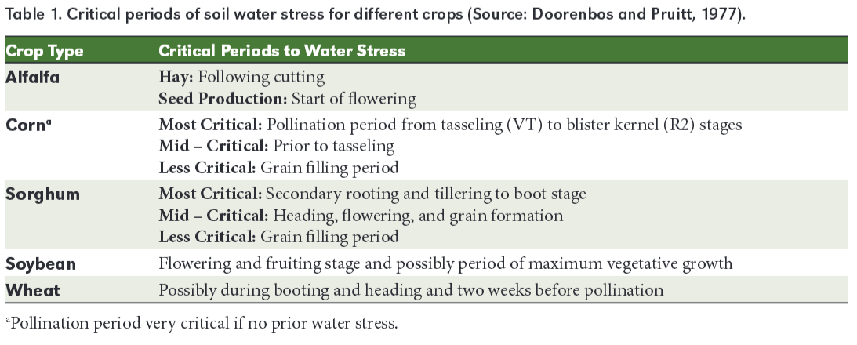

Application
How can you decrease your water usage?
Agricultural producers who utilize irrigation must be good stewards of the natural resources they use, including water. Even those of us who aren’t involved in production agriculture use water everyday. We too play a role in being a good steward of water. What are ways that we use water? How can we be more efficient in our water usage?

Instruct students to capture their thoughts in their science notebook. Elicit responses from students.

Objective 3 | Identify tools available to manage water and irrigation (30 minutes)
Experience
How do producers know when it’s time to irrigate? (Elicit responses from students)

Knowing when to irrigate can take time and experience. Thanks to technology, there are now tools available that help producers make irrigation decisions. Let’s explore these tools and how they work.

Divide the class into two groups. Each group is responsible for researching a tool used for water and irrigation management, and subsequently teaching the class about this tool. Encourage students to utilize the Agricultural Water Management Guide and other online resources. Provide students with about 20 minutes to research and prepare a 3-minute presentation. Students can present this information through a demonstration, activity, or skit.

Topics to Research:
- ET Gauge
- Soil Moisture Sensors
During the presentation, instruct students to capture important information in their science notebook. Ensure the following points are covered in the student presentations:

Point
ET Gauge – a device used to measures evaporation and transpiration, or EVAPOTRANSPIRATION, from soil and plants. Most important use for ET Gauge is for irrigation scheduling, when to irrigate and how much to apply.

Evaporation – loss of water from soil surface

Transpiration – loss of water from the leaves of crop

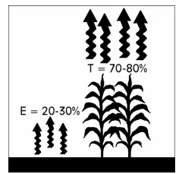

Components of Evapotranspiration (ET)
Transpiration | Evaporation
Over a growing season, 70 to 80 percent of all evapotranspiration is made up of transpiration. Water is drawn from the soil through the roots and up through the plant to be evaporated from the surface of the leaves. This is highly useful water consumption. It cools the leaves and helps move nutrients from the soil into the plant. | Evaporation from the soil makes up 20-30 percent of the total evapotranspiration. It represents a direct flow of water vapor from the soil to the air above. To a considerable extent, evaporation is a waste. It can’t be avoided; however, it can be controlled to some degree by residue cover and by when and how much tillage is done.

Soil Moisture Sensors - a device that measures the quantity of water contained in soil. Provides critical information in the irrigation scheduling process. Combines the net effect of all of the factors that influence the availability of water in a soil for producing a crop into a single measurement.

Sensors are installed as a set of at least three with varying foot depths. A sensor reading – taken one to two times per week – helps to determine the soil moisture level and when to apply the next irrigation.

Application
Develop an Irrigation Management Plan (can be assigned as homework)
Pat and Pam Producer grow corn and soybeans in Nebraska. They’ve decided to turn 140 dryland acres into irrigated acres and need your help with the water and irrigation management strategy. Pat and Pam plan to grow corn on these acres in the coming year. They have hired you to develop an irrigation management strategy for the growing season.

Work with a partner to develop an irrigation management plan for Pat and Pam. Make sure the plan addresses the following questions.

Consider:
- What type of tillage practice should Pat and Pam utilize?
- What type of irrigation system should Pat and Pam develop? Why?
- If implementing full irrigation, how many inches of water does their crop need from April – October?
- Assume the 140 acres receives the amount of precipitation outlined in the chart below (indicated by the bar chart). How much irrigated water should be applied each month from April – October?
- What tool(s) do you recommend Pat and Pam install? How will this help them make water management decisions?
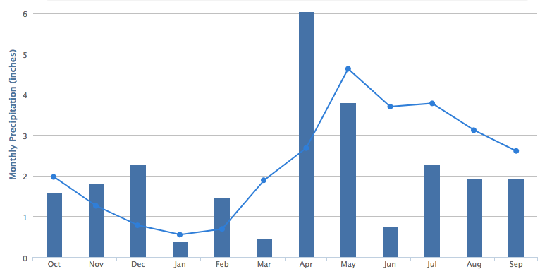

Bars = precipitation by month in one-year period
Line = 30-year average precipitation by month

To provide students with local precipitation history, check out the precipitation recorded in your county here.

Review & Reflect (5 minutes)
Chalk Talk: Chalk Talk is a silent activity. Students are provided a prompt and respond to the response through writing. Students may pose additional questions and respond to one another’s comments. All communication happens by writing and drawing connections to questions or ideas. The instructor can participate and prompt conversation by writing additional questions.

The writing can take place on a spacious whiteboard or a large sheet of paper on the wall or floor, similar to the image below.

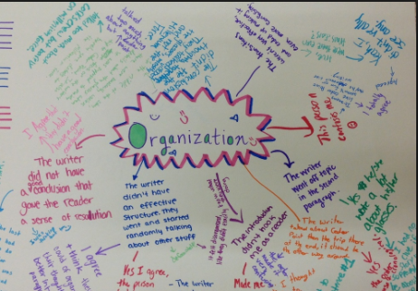

In the chalk talk, students will review what they have learned about irrigation and water management. To start off the chalk talk, the instructor will write the prompt:
“Irrigation and water management …”

Provide each student with a marker to share thoughts and ideas in silence.

As the instructor, join in on the conversation by writing questions such as,
- Why is irrigation management important?
- What will you do to conserve water in your household?
- How can producers be good stewards of water resources?
After providing adequate time for students to read and respond to the prompts and comments, summarize what was shared in the chalk talk.

Celebrate Student Success (1 minute)
Thank students for their participation and summarize that water is a limited natural resource that must be managed in a sustainable manner. Preview the next lesson.

References
VanDeWalle, B., Nygren, A., Burr, C., Zoubek, G., Irmak, S. (2016) Agricultural Water Management Guide. Extension Publication. University Of Nebraska - Lincoln Extension.

Irrigation and Water Management
Science Notebook

Completed by:______________________________ Date: ________________

How much water in the world is available for human use?

Factors that Influence Irrigation Video:

1) Maintaining crop residue and reducing ____________:
- ____________ amount of water that infiltrates the soil from irrigation or precipitation
- Decreases the amount of water that _________ ________ the soil surface
- Reduces the rate of __________________ of water from the soil
- ______________ the amount of irrigation water needed to grow a crop

2) ____________ type:

__________ soil __________ soil
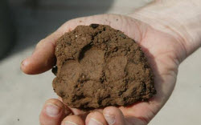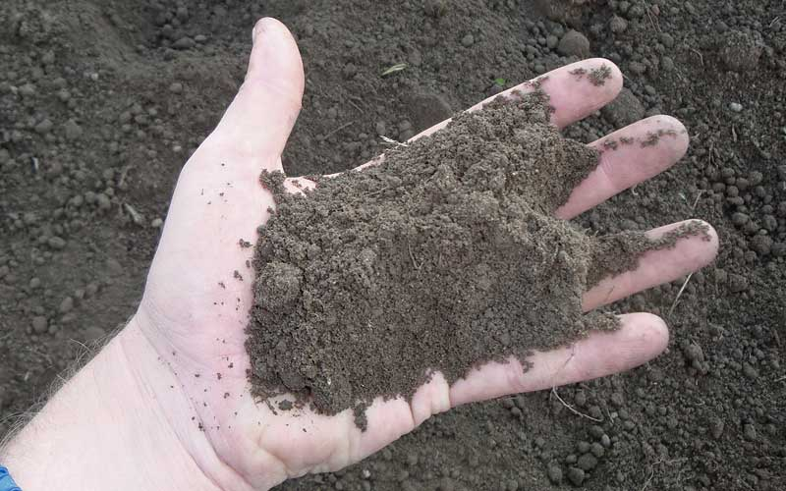

Draw the
soil pores:

Key Term | Definition
Full Irrigation

Deficit Irrigation

Limited Irrigation

Evaporation

Transpiration
ET Gauge
Soil Moisture Sensor

Describe the difference between deficit and limited irrigation practices.

How do I use water?

I can be more efficient with water by...

Tools used in irrigation management:
What do they measure? How do they work?

Irrigation Management Plan
Scenario: Pat and Pam Producer grow corn and soybeans in Nebraska. They’ve decided to turn 140 dryland acres into irrigated acres and need your help with the water and irrigation management plan. Pat and Pam plan to grow corn on these acres in the coming year. They have hired you to develop an irrigation management strategy for the growing season.

Make sure the plan addresses the following questions:

- What type of tillage practice should Pat and Pam utilize?
- What type of irrigation system should Pat and Pam develop? Why?
- If implementing full irrigation, how many inches of water does their crop need from April – October?
- Assume the 140 acres receives the amount of precipitation outlined in the chart below (indicated by the bar chart). How much irrigated water should be applied each month from April – October?
- What tool(s) do you recommend Pat and Pam install? How will this help them make water management decisions?

Bars = precipitation by month in one-year period
Line = 30-year average precipitation by month

