Nebraska Irrigation and Water Management Curriculum

Conventional Furrow Irrigation
Grade Level  7-12th Grades  Lesson Length  60-90 minutes  Key Terms:  Conventional furrow irrigation  Furrows  Gated pipe  Ridges  Set size  Siphon tubes  Soil infiltration rate  STEM Careers  - Agronomist  - Biological Systems Engineer  - Design Engineer  - Irrigation Specialist  - Irrigated Farmer |  | Overall Goal  Students will understand how conventional furrow irrigation systems operate and will discuss their advantages and limitations.  Learning Objectives  By the end of this lesson, students will know or be able to:  - Define conventional furrow irrigation.  - Demonstrate how conventional furrow irrigation systems are designed and operate.  - Discover the factors that influence the effectiveness of conventional furrow irrigation systems.  - Discuss strategies to enhance the efficiency of conventional furrow irrigation systems.  Educational Standards Supported  Nebraska Science Standards: SC.7.7.3.D, SC.7.8.4.E , SC.7.13.5.C, SC.HS.7.2.E, SC.HS.15.5.5.A, SC.HS.15.5.D  Materials List  - Ping-Pong ball - Tape - Straws - Tubes - Aluminum foil - Rubber bands - Water - Measuring cup - Paper cups - Paper clips - Water basin - Three-four jars filled with soil  Preparatory Work  - Print Science Notebook pages  - Fill three jars with soil. Each jar should contain one of the following:  - Loosely packed, dry soil  - Tightly packed, dry soil  - Soil soaked with water  - Gather and separate materials for groups of 3-4 students to build irrigation system.
Types of Irrigation
Center Pivot Lesson

water.unl.edu website
cropwatch.unl.edu website

Check out Nebraska Extension’s Interactive Agricultural Water Management Guide!

Introduction (5 minutes)
Students will move a Ping-Pong ball across a table to a designated destination without touching it.

Directions:
- Create an “X” with tape in two locations on a table.
- Show students a Ping-Pong ball and inform them that the goal is to get the ball from one end of the table (Point A) to cross each “X” (Point B and Point C) – without touching the ball. If the ball falls on the floor, they will start at the beginning. Students are free to use materials in the front of the room (include straws in materials), but the materials cannot touch the ball.
- Students may accomplish this task by surrounding the table and blowing air through a straw to direct the ball to the destinations.
- End the activity after 3-5 minutes.
Process and Transition:
- What was the overall goal?
- What was difficult about achieving this goal?
- Think about agricultural production. What agricultural objects might the Ping-Pong ball represent – objects that farmers must move from one point to another? (Listen for: water)
- Why is it important for producers to distribute these objects from one point to another?
Preview (2 minutes)
In agriculture, farmers must figure out how to distribute water across their fields to all of their crops in order for crops to grow. There are several systems that help producers distribute water, and today our class will explore one of these systems.

Objective 1 | Define conventional furrow irrigation (5 minutes)
Experience
With a partner, have students brainstorm ways that water is delivered to crops. Students should capture their ideas in their science notebook. Ask students to share with the class.

How is water delivered to crops?
Listen for: gravity irrigation, surface irrigation, flood irrigation, furrows, or pipe.

You’ve identified a handful of ways that crops can receive water. Today we’ll be focusing on one of those methods, a type of surface irrigation called conventional furrow irrigation. Surface irrigation is the oldest method and most common form of irrigation throughout the world. In the U.S., surface irrigation accounts for approximately 43 percent of the irrigated acres. In Nebraska, it is used on about 28 percent of the land, and the majority of this surface-irrigated land uses furrow systems.

Let’s define some terms associated with this type of irrigation.

Point
Capture these definitions in your science notebooks:

Conventional furrow irrigation – a type of surface irrigation where water applied to the field is guided by narrow channels – furrows – dug between the rows of crops.

Furrows – sloping, parallel channels cut into the soil surface between crop rows.

Ridges – long, raised strips of land.

Soil infiltration rate – water movement in the soil. Pore space in soil is the channel that allows water to infiltrate and percolate, or move downward through the soil.

Show students the following pictures to illustrate conventional furrow irrigation.

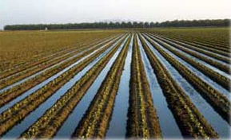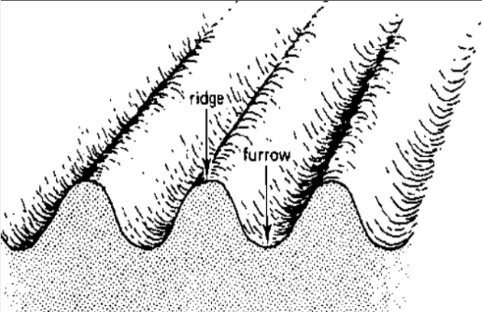

Application
Using the image on the right, ask students to identify and label the 1) ridge, 2) furrow, and 3) soil infiltration in their science notebook. Next, have students draw where the seed/crop is located and where the water flows in a furrow irrigation system.

Objective 2 | Demonstrate how conventional furrow irrigation systems are designed and operate (30 minutes)
Experience
Students will work in teams of 3-4 to design and build a furrow irrigation system. The goal is to move two cups of water a distance one foot and distribute it evenly in two separate cups. They will build their irrigation system using materials provided by the instructor to develop a plan and build their irrigation system.

Provide students materials such as paper cups, straws, tape, paper clips, clay, water, etc. to build their irrigation system. Upon construction, have students demonstrate and explain their system.

Process:
- What worked well?
- What was challenging?
- If you could redesign your system, what would you do differently?
- What have you learned about surface irrigation after designing your own irrigation system?
After designing our own irrigation systems, let’s explore how producers are able to distribute water across an entire field!

Point
Instruct students to capture definitions and notes in their science notebooks.

In furrow irrigation systems, farmers dig furrows between crop rows. Water is delivered to the top of each row using siphon hoses or gates. The crop is irrigated as water flows from the top (where the water enters the furrow) to the bottom of each row (the furthest point from the pipe or siphon).

Applying water to the furrow:

- Head ditch and siphons
- Gated pipe
Show students the following images and definitions. Point to the head ditch and siphon tubes in the image.

Water is pumped into the head ditch that stretches across the field. The head ditch is the reservoir from which the siphon transfers water into the furrows.

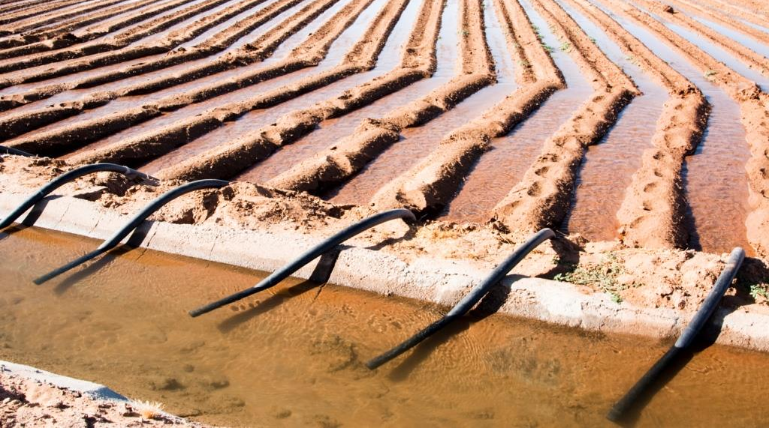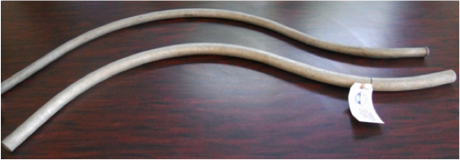

Siphon tubes – small curved pipes, ½ - 4 in. in diameter, that deliver water to the furrows. Siphon tubes transfer water from the head ditch to the furrows.

The widespread use of these tubes for irrigation was due to their development in 1934 and marketing by a Cozad, NE irrigator.

Show students this short video to observe how farmers siphon water into the furrows.

An alternative to using siphon tubes is gated pipe. Water is pumped through a pipe that stretches across the field. The gates along the pipe slide, and are adjustable. This allows the producer to regulate the amount of water released into the furrows.

Show students the following images and definitions. Point to the pipe and gates in the image.

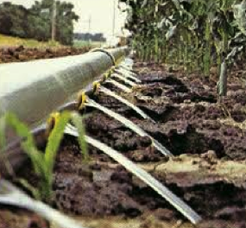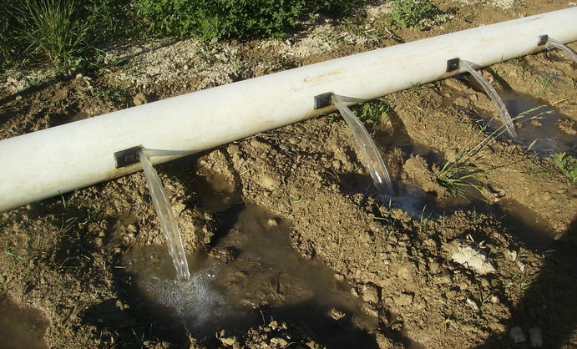
Gated pipe – large portable pipe (up to 17 inches in diameter) with gate openings spaced to deliver water to the furrows. Water is pumped from the source through a pipe, and openings of the gated pipe can be regulated to control the amount of water allows into the furrows

Gated pipe was first produced in California – but the second company to produce gated pipe is Hastings Irrigation Pipe!

The set size – the number of gates opened or tubes set – significantly impacts both how fast water advances across the field and the amount of water being applied.

In furrow irrigation systems, water moves down the furrows laterally while it infiltrates into the soil vertically.

Application
After reviewing how conventional furrow irrigation systems are designed and work – what elements of our own irrigation system design reflect the head ditch/siphon and gated pipe? How big was our set size?

Have students draw their irrigation system in their science notebook and label what portions of their system represent the head ditch/siphon, gated pipe, and set size.

Objective 3 | Discover the factors that influence the effectiveness of conventional furrow irrigation systems. (10 minutes)
Experience
Place the 3 jars of soil prepared before class (see preparatory work) in front of the class. Have three volunteers describe the soil in the jar. Next, have these students pour one cup of water into the jars at the same time. Ask students to observe the rate the soil absorbs the water.
Process:
  - What did you observe?
  - Which cup absorbed the water the fastest? Why?
  - Which cup absorbed the water the slowest? Why?
  - What might this tell us about the infiltration rate?
(Listen for: soil conditions influence the rate at which water is absorbed)
  - Why does this matter to furrow irrigation systems?
(Listen for: water near the pipe/gate may be absorbed quickly, and may take a long time to travel to the end of the row. Could have issues with excess water or not enough water in certain parts of the field.)
Point
Uniform application of water is not possible with a conventional furrow irrigation system. However, understanding the irrigation system and factors that influence its effectiveness can help improve uniformity.

3 factors that influence the effectiveness of conventional furrow irrigation systems:
- Soil texture: Furrows can be used on most soil types. However, very coarse sands are not recommended because percolation losses can be high.

- Soil surface conditions: Very loose or recently tilled soil can result in a very high infiltration rate, and result in too much water being absorbed at the furrow inlet. On the other hand, if the soil has been packed by heavy rains or by water flowing over the surface, infiltration may be reduced. Considering if the soil is loose or tightly packed, wet or dry will influence the infiltration rate in furrow systems.

- Slope of field: Uniform flat or gentle slopes are preferred for furrow irrigation.
Soil infiltration rate is critical to furrow irrigation systems. If the infiltration rate is too high, the depth of water that infiltrates near the furrow inlet will be much larger than at the end of the field. The infiltration rate of soil ultimately determines the feasibility of furrow irrigation. To efficiently operate a furrow irrigation system, management practices must be adapted to the field conditions at the time of the irrigation.

Show students the infiltration profiles below. Discuss what soil conditions lead to excess water. Note that the Infiltration rate varies from one irrigation to the next and from season to season.
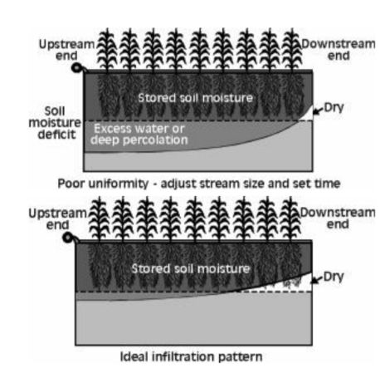

The correct amount of water to apply at each irrigation depends on many factors, including the amount of soil water consumed by the plants between irrigations, the water-holding capacity of the soil and root depth.

Application
Instruct students to draw an image in their science notebooks that represents the three factors that influence the effectiveness of furrow irrigation systems.

Next to the images, have students describe why this factor influences irrigation efficiency.
Objective 4 | Discuss strategies to enhance the efficiency of conventional furrow irrigation systems (10 minutes)
Experience
Instruct students to work as a group to identify and list advantages and inefficiencies of conventional furrow irrigation systems in their science notebook. Encourage students to use the Agricultural Water Management Guide and other online resources to support their answers.

Next, ask students for ideas on how to improve upon these inefficiencies. Create a new column entitled “Solutions” to list their ideas. Use the following table to guide discussion.

Point
Minimizing inefficiencies to irrigation systems can save money and labor. Normal wear and tear associated with piecing together sections of irrigation pipe and opening and shutting gates can cause significant inefficiencies to irrigation over time.

The efficiency of any irrigation system, including furrow systems, is strongly influenced by how the system is managed. Almost filling the crop root zone, applying water uniformly, and either minimizing or utilizing runoff results in efficient irrigation.

Advantages Inefficiencies Solutions
Flag and repair leaky gaskets and gates.

Replace damaged gaskets and gates during the offseason

Block furrow ends to reduce runoff

Utilize runoff by incorporating reuse system

Wear and tear of irrigation pipe and gates can lead to water leaks
Lower cost of
initial equipment

Lower cost of pumping per
acre-inch of water
Time and labor required during irrigation season

Water is not applied uniformly, water loss due to runoff, percolation beneath root zone, and evaporation from furrow channel

Application
A local farmer is considering converting a dryland field into an irrigated one, and wants information about a conventional furrow irrigation system. The farmer asks for your input and recommendation! Create a summary sheet about this type of irrigation and what the farmer should know about its advantages and limitations. (This can be given as homework).

Review & Reflect (2 minutes)
Popcorn Share: Each student will pop out of their chair to state one thing they learned during this lesson for a rapid review.

Celebrate Student Success (1 minute)
Thank students for their hard work and focus while learning about the conventional furrow irrigation system. Remind students of the importance of understanding irrigation management in Nebraska. Irrigation is vital to Nebraska’s agriculture and it’s important to enhance its efficiency to conserve water resources.

References
VanDeWalle, B., Nygren, A., Burr, C., Zoubek, G., Irmak, S. (2016) Agricultural Water Management Guide. Extension Publication. University Of Nebraska - Lincoln Extension.

Yonts, C.D., Eisenhauer, D., and Varner, D. (2007). Managing Furrow Irrigation Systems. Extension NebGuide, G1338. University of Nebraska-Lincoln Extension.

Irrigation and Water Management
Science Notebook

Completed by:______________________________ Date: ________________

How is water delivered to crops?

Key Term | Definition
Conventional Furrow Irrigation

Furrows

Ridges

Soil infiltration rate

Siphon tube
Gated pipe
Set size

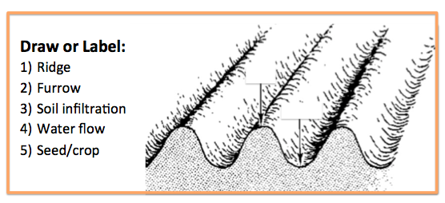
My Irrigation Design:
Circle and label the components of your irrigation system design that represent a 1) head ditch/gated pipe and 2) set size. Describe how these components work in furrow irrigation:

Label the type of furrow irrigation and describe how water is delivered to the crops:
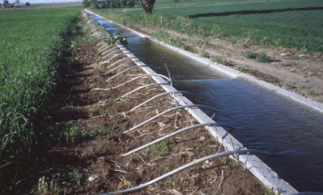

Factors that Influence Conventional Furrow Irrigation Efficiency:

Place a star where the head ditch or pipe is located. Draw a circle around the crops that are subject to excess water. Place a box around the portion of crops that are subject to water deficiency.

Conventional Furrow Irrigation:

Advantages Inefficiencies Solutions

