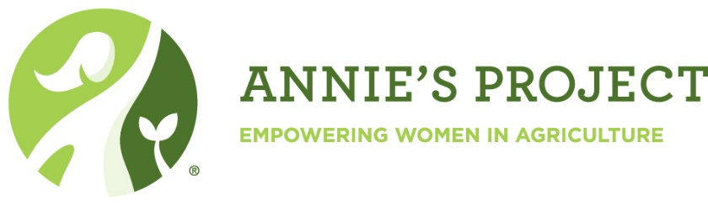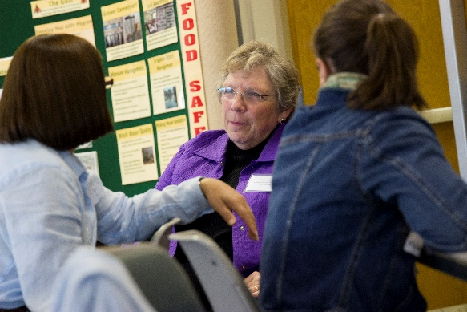

**Monday & Wednesday Evenings 5:30 – 9:00 pm (6 sessions) Jan. 28 – Feb. 13, 2019**

**Farm Credit Services of America**

**Sale Barn Conference Room**

**4101 N 6**th *(North Hwy 77)***,Beatrice NE**

**$75 for all six sessions! Materials, evening meal and snacks provided.**

For more information or to register call the Gage County Extension Office, 402.223.1384 or e-mail:

[gage-county@unl.edu](mailto:gage-county@unl.edu). Registration also available online at: <https://www.regonline.com/anniesproject-beatrice>

Empowering farm women to be better business partners through networks and by managing and organizing critical information.

financial management, human resources, marketing and the legal field. There's plenty of time for questions, sharing, reacting and connecting with your presenters and fellow participants.

It's a relaxed, fun and dynamic way to learn, grow and meet other women in agriculture.

*“I took the class to gain a better understanding about agribusiness and how financial decisions impact our farm operation. This class has improved communication with my spouse on concerns he works with on a daily basis.” – Linda*

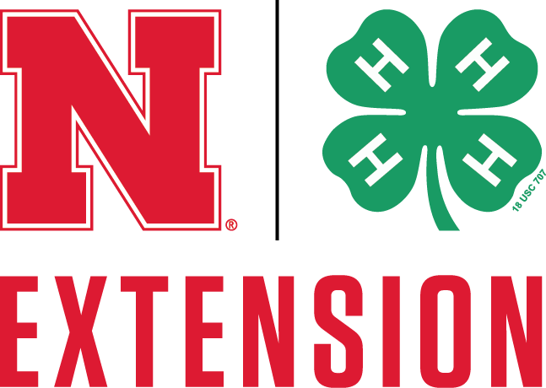

Follow Nebraska Women in Agriculture at [wia.unl.edu](https://wia.unl.edu/) or follow on

@NebraskaWIA and  @newomeninag

**Annie’s Project – Beatrice, NE**

**January 28**

* Human Resources Management
* Farm Labor Information
* Communications – Real Colors

**January 30**

* Insurance for Farms & Families
* Crop Insurance

**February 4**

* FSA and NRCS Government Programs
* Farm Bill – 2019 and beyond

**February 6**

* Interpretation of Financial Statements
* Farm Budgets and Finding Breakeven

**February 11**

* Land Leasing & Ownership
* Farm Succession Planning

**February 13**

Group’s Choice of Topics such as –

* Precision Agriculture and Production
* Ag Marketing
* Farm Accounting and Prep for Taxes
* Farm Health and Safety

***Why Annie's Project?***

This six-session course is a discussion-based workshop bringing women together to learn from experts in production,