Soil respiration is a measure of the carbon dioxide (CO₂) released from soil. It is released as a result of decomposition of soil organic matter (SOM) and plant litter by soil microbes and through plant roots and soil fauna. It is an important indicator of soil health because it measures the level of microbial activity and the content and decomposition of SOM. It also reflects the condition of the physical and chemical environment of a soil. In the short term, a high rate of soil respiration is not necessarily desirable; it may indicate an unstable soil system and loss of SOM from excessive tillage or other factors. Soil respiration can be measured by simple methods or more sophisticated laboratory methods. It is an indication of the conversion of nutrients in organic matter to forms available for plant use (e.g., phosphate as PO₄, nitrate nitrogen as NO₃, and sulfate as SO₄).
Figure 1.—Microbial activity and respiration and mineralization of organic matter in soil completes the lifecycle of earth-released water, oxidized minerals (NO₃ and PO₄, etc.), and CO₂ needed by photosynthetic green plants to use the sun’s energy to produce food (carbohydrates, etc.) and oxygen (J.W. Doran, M. Sarrantonio, and M.A. Liebig. 1996. Soil Health and Sustainability. In Advances in Agronomy. Volume 56:1-54. Academic Press).

Inherent Factors Affecting Soil Respiration
Inherent factors such as climate and soil texture impact soil respiration. Soils that have lower porosity also have a lower respiration rate. Soil respiration rates are also dependent on dynamic soil factors, including SOM content, temperature, moisture, salinity, pH, and aeration. Biological activity of soil organisms varies daily and seasonally. Microbial respiration more than doubles for every 10 °C (18 °F) that soil temperatures rise, to a maximum of 35 to 40 °C (95 to 104 °F). Soil temperatures higher than these limit plant growth, microbial activity, and respiration.
Soil respiration generally increases as soil moisture increases; however, oxygen is limited when the soil pores are filled with water, interfering with the ability of soil organisms to respire (fig. 2). Ideal soil moisture content is near field capacity, or when approximately
60 percent of the pore space is filled with water. Respiration is limited in dry soils because of the lack of moisture for microbial activity and other biological activity.
When water fills more than 80 percent of the pore space, soil respiration reduces to a minimum level and most aerobic
micro-organisms begin to use nitrate (NO₃) instead of oxygen, resulting in loss of nitrogen as gases (N₂ and nitrogen oxides), emission of potent greenhouse gases, reduction in yields, and an increased need for nitrogen (N) fertilizer, which increases cost.
Medium textured soils (silty and loamy soils) commonly have a favorable soil respiration rate because they have higher porosity, good aeration, and high available water capacity.
In clayey soils, much of the SOM is protected from decomposition by clay particles and other aggregates that limit soil respiration and associated mineralization (ammonification) of organic N. Sandy soils typically have a low content of SOM and low available water capacity, which limit soil respiration and mineralization of N.
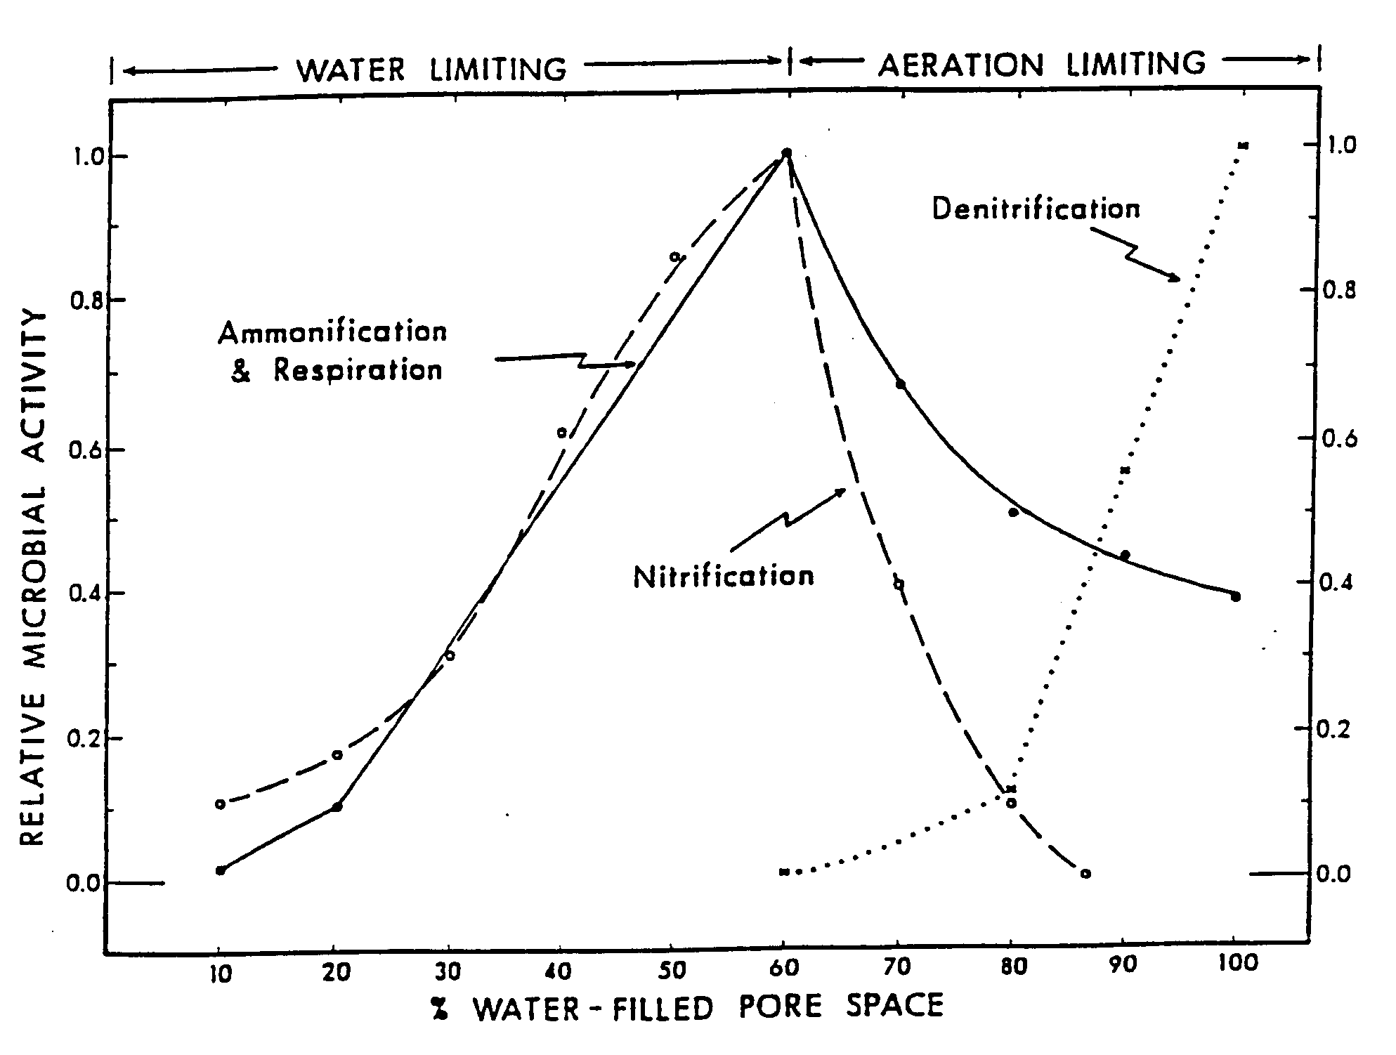
Figure 2.—Relative aerobic microbial activity (respiration, ammonification, and nitrification) and anaerobic microbial activity (denitrification) as related to water-filled pore space in soil (Linn and Doran, 1984; Parkin and others, 1996).

Soil Respiration Management

Management practices can increase or decrease the content of SOM and the potential for compaction. Soil biological activity increases with increased SOM and porosity. Increase respiration by leaving crop residue on the soil surface, using no-till cropping systems, growing cover crops and high-residue crops, and using other practices that add organic matter to the soil. Crop residue that has a low carbon-to-nitrogen (C:N) ratio (e.g., soybean residue) decomposes faster than residue that has a high C:N ratio (e.g., wheat straw). Using tillage methods that remove, bury, or burn crop residue or applying a high amount of N fertilizer stimulates microbial activity and can diminish SOM. Soil compaction can be managed by reducing soil disturbance and limiting equipment use.
Irrigating dry soils and draining wet soils can significantly increase soil respiration. Soil respiration tends to be higher in the rows than between the rows because of the presence of plant roots. Compacted areas, such as wheel tracks, tend to have lower respiration because of limited aeration and drainage and higher soil water content. Manage soils to minimize compaction and maintain high porosity.
Managing soil pH and EC (salinity) is important for crop growth and the availability and distribution of nutrients, and it impacts soil organisms that decompose SOM and provide for other processes that contribute to soil respiration. Fertilizers may stimulate respiration and root growth and nourish microbes; however, some fertilizers can be harmful to microbes if applied in high concentrations. In addition, sludge or other organic material that has a high concentration of heavy metals, certain pesticides or fungicides, or salts may be toxic to microbes.
To improve SOM content and limit compaction:
- Minimize soil disturbance and use of farm equipment when soils are wet.
- Use equipment only on designated roads or between rows.
- Limit the number of times equipment is used in a field.
- Subsoil to break up compacted layers before starting a continuous no-till system.
- Maintain living roots as long as practical by growing cover crops after harvesting.
- Apply solid manure or compost at a proper agronomic rate.
- Use diverse crop rotations that include
high-residue crops and perennial legumes or grasses.
- Maintain a cover on the soil and leave undisturbed residue on the soil surface rather than incorporating, burning, or removing it.
Soil biota respond favorably to management practices such as using plant residue, maintaining living roots, applying manure, tilling, and applying nitrogen (table 1). Certain management practices can induce a temporary increase in soil respiration and can have a negative impact on SOM content.

Table 1.—Interpreting management impacts on soil respiration and soil organic matter (SOM)
Management practice | Application | Short-term impacts | Long-term impacts
Application of solid manure or organic material | Apply at proper agronomic rate. Provides carbon and nitrogen to microbes, increasing their activity. | Increased respiration when manure begins to break down; increased biomass/forage production. | Improved soil structure; increased fertility and SOM content.
Use of high-residue crops or cover crops in rotation | Crops that have a high ratio of carbon to nitrogen (C:N) produce a high amount of biomass. Leave residue on soil surface to increase SOM. | Temporary fixation of nitrogen during residue breakdown; increased soil moisture; decreased erosion. | Improved soil quality; increased fertility and SOM content.
Tillage, such as annual disking or plowing | Mixes the soil, resulting in a temporary increase in oxygen and contact of residue to soil, allowing microbes to break down carbon sources. | Released nitrogen and other nutrients and CO_{2;} increased potential for erosion; increased rate of decomposition of residue and other carbon sources. | Decreased SOM content, soil quality, and soil fertility; reduced diversity of soil micro-organisms (increased bacteria); damaged soil structure.
Table 1.—Continued
Management practice | Application | Short-term impacts | Long-term impacts
Use of crop residue | Leave residue on the surface, increasing ground cover, to protect the soil. | Nitrogen temporarily tied up during breakdown of residue; increased soil moisture; decreased risk of erosion; lowered soil temperature. | Increased soil quality, fertility, and SOM.
Application of nitrogen fertilizer or manure | Provides nitrogen (energy), which allows microbes to break down residue with high C:N ratio more rapidly (e.g., corn stalks, wheat straw). | Temporary increased respiration due to increased rate of organic material breakdown. | If properly managed, increased SOM and soil quality; increased production and residue.
Use of farm equipment or other vehicles | Compacts soil, decreasing pore space, water movement, and oxygen and increasing nitrogen loss from denitrification. | Decreased respiration, yields, and water infiltration; increased runoff. | Decreased production; increased risk of erosion and runoff; decreased soil quality and microbial activity.
What management practices are used on the fields being evaluated, and what impact will these
practices have on respiration?
USDA is an equal opportunity provider and employer.

Will the management practices have a positive or negative impact on soil organic matter content
and porosity? Why or why not?

Problems Related to Soil Respiration and Relationship to Soil Function
Soil respiration reflects the capacity of soil to sustain plant growth and soil microbes. It is an indication of the level of microbial activity, SOM, plant litter, and decomposition. Soil respiration rates can be used to estimate nutrient cycling in the soil and the ability of the soil to sustain plant growth and biological activity.
Excessive respiration from decomposition of plant litter and SOM commonly occurs after tillage due to increased soil aeration.
A low soil respiration rate indicates limited availability of SOM or plant litter for soil microbes. It may also signify soil conditions (temperature, moisture, aeration, porosity, and available N) that limit biological activity and decomposition. Under these conditions, nutrients are not released from SOM or plant litter for use by plants and soil organisms. When the soils are flooded or saturated, soil respiration is reduced, nitrogen is lost through denitrification, and sulfur is lost through volatilization.

Measuring Soil Respiration
Materials needed to measure respiration:
____ Plastic container and probe for gathering and mixing soil samples.
____ Solvita® sample jar (fig. 3) or
3-inch-diameter aluminum cylinder and aluminum foil for use as a cover (fig. 4).
____ Solvita® foil pack containing gel paddle (fig. 3).
____ Solvita® color chart (fig. 5).
____ Solvita® interpretation guide for estimating differences in soil health, respiration, and potential N release.
____ Soil thermometer to verify soil temperature, or room with controlled temperature.
____ Resealable plastic bags for soil samples and permanent marker for labeling bags.
Considerations:
If the soil samples are mixed, respiration temporarily increases as a result of aeration (similar effect as tilling) by increasing the amount of oxygen available to break down organic matter more rapidly. The measurement of respiration does not include root respiration; however, it is very effective for comparing relative differences in soil quality, respiration, and N release from one site to another. An intact soil core taken from a 3-inch-diameter aluminum cylinder can be used instead of a mixed soil sample. An intact core better reflects respiration for no-till applications, and a mixed sample better reflects respiration immediately after tillage (period of flush) or longer after tillage (at least 1 day after mixing). To get an accurate comparison for different management systems, several soil samples can be measured.
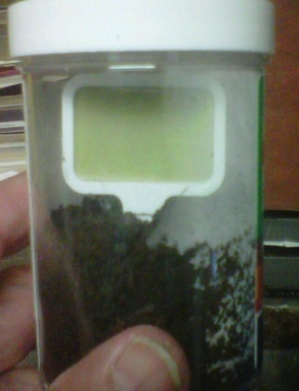
Figure 3.—Solvita®
jar and gel paddle.
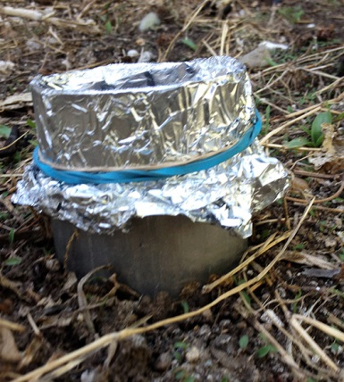
Figure 4.—Aluminum cylinder
with foil cover (gel paddle
inside).
Figure 5.—Solvita®
sample color chart.
Step-by-step procedure (mixed sample):
- Soil sampling (field)—Soil respiration is variable, both spatially and seasonally, and is strongly affected by organic matter content, manure applications, oxygen levels, soil moisture, salinity (EC), and soil temperature. The soil samples should be obtained just before the test is performed. Using a soil probe, gather at least 10 small samples randomly from an area that represents a particular soil type and management history. Extend the probe to a depth of 6 inches or less for each sample. Place the samples in the small plastic container. Repeat for each sampling area.
- Mixing (field)—Mix soil in the plastic container just well enough to be homogeneous. Remove roots, residue, and large stones. Place in a labeled, resealable plastic bag.
- Add water, if needed (in field or classroom). The sample should be at the ideal moisture content (near field capacity) for growing crops. If conditions are dry, it is best to add water to the field 24 hours prior to sampling. If necessary, water can be added before testing in the classroom.
- Shortly after sampling, add moist, mixed soil up to fill line in Solvita® jar. Tap the bottom of the jar on a hard surface occasionally during filling to eliminate
voids.
- Insert gel paddle into the soil with the gel facing the clear side of the jar. Be careful not to jostle or tip jar. Screw the lid on tightly, and record the time on the lid. Let stand for 24 hours. Keep the jar in a room with a controlled temperature of 68 to 75 °F, and keep away from sunlight.
- After 24 hours, compare the gel color on the paddle to the color chart. Record color in table 3. Note that the color on the paddle may not exactly match any of the colors on the chart. Select the best match. Be sure to use the correct side of the color chart; one is for reading in incandescent light and one in fluorescent light.
- Answer discussion questions, and complete interpretations section of table 3. Refer to Solvita® soil test instructions for additional information.
Mention of commercial products does not constitute an official endorsement by the
U.S. Department of Agriculture.

Interpretations
Record soil respiration rates, and complete table 3. The rate is impacted by soil health, soil moisture, and soil organic matter content.
It can be used to estimate the quantity of nitrogen released per year under normal climatic conditions (refer to table 2). The
rate of CO₂ released is expressed as CO₂-C pounds/acre-3 inches/day (3-inch depth
over an acre) or kilograms/hectare-7.6 centimeters/day.
A high soil respiration rate is indicative of high biological activity (refer to table 2). This can signify a healthy soil that readily breaks down organic residue and cycles nutrients needed for crop growth. Solvita® response ranges from inactive (0 to1; blue-gray) to very active (3.5 to 4.0; green-yellow) as soil respiration increases from use of desirable management practices, such as diverse crop rotations and no-till cropping systems. Some soils that are heavily manured or are high in content of organic matter can respond at an unusually high level (5; yellow). This can be detrimental to soil health if stable organic matter is decomposed. It generally is desirable for a soil to have a respiration rate of at least 3.
It typically takes several years for a soil to improve from a low biological status to a more active one. Managing residue, using diverse crop rotations, adding organic matter, and avoiding destructive tillage practices help to reduce the time needed to reach a more optimum biological condition.

Table 2.—Basic soil biological quality
Color and colorimetric number
Blue-gray  (0 to 1.0) | Gray-green  (1.0 to 2.5) | Green  (2.5 to 3.5) | Green-yellow  (3.5 to 4.0) | Yellow  (4 to 5)
Soil respiration activity*
Very low | Moderately low | Medium | Ideal | Unusually high
Dry, sandy soils that have little or no organic matter | Soils with marginal biological activity and organic matter | Soils that have a moderately balanced condition and to which organic matter has been added | Soils with sufficient organic matter content and populations of active micro-organisms | Soils with excessive organic matter content
**Approximate level of CO₂ – respiration
<300 mg CO₂-C/kg soil/week | 300 to 500 mg  CO₂-C/kg soil/week | 500 to 1000 mg  CO₂-C/kg soil/week | 1,000 to 2,000 mg CO₂-C/kg soil/week | >2,000 mg  CO₂-C/kg soil/week
<9.5 lbs  CO₂-C/acre-  3 in/day | 9.5 to 16 lbs CO₂-C/acre-3 in/day | 16 to 32 lbs CO₂-C/acre-3 in/day | 32 to 64 lbs CO₂-C/acre-3 in/day | >64 lbs CO₂-C/acre-3 in/day
Approximate quantity of nitrogen (N) release per year (normal climatic conditions)
<10 lbs/acre | 10 to 20 lbs/acre | 20 to 40 lbs/acre | 40 to 80 lbs/acre | 80 to >160 lbs/acre
* Under optimum soil temperature and moisture conditions.
** Doran, J., and W. Brinton. 2001. Soil quality correlation of basal respiration and N mineralization over time using intact 3-inch field soil cores under optimal temperature and moisture in the lab. U.S. Department of Agriculture, Agricultural Research Service. More accurate estimates of yearly potential mineralizable nitrogen (PMN) release with optimal re-wetting of air-dry soils can be made using the Solvita® soil CO₂ burst test and calculator.

Table 3.—Soil respiration levels and interpretations
Sample site | Median 24-hour soil and room temper-ature | Dates | Start time | End time | Gel color and colorimetric number | Soil activity rating (table 1) | *Average respiration level (lbs CO₂-C/acre-  3 in/day) | Nitrogen release (lbs/ac/yr)
Ex. 1 | 77 °F  (25 °C) | 4/30-5/1/12 | 8:00 AM | 8:15 AM | Gray-green (2.5) | Moderately low to medium | 16 | 20
*Pounds of CO₂-C/acre-3 in/day based on 3-inch soil sample. Values are doubled for a 6-inch
sample, tripled for a 9-inch sample, etc.
Are the soil respiration levels what were expected? Why or why not?

Is the SOM content expected to decline, improve, or stay the same? Why?

Glossary

Ammonification.—Production of ammonium (NH₄) from the decomposition of SOM.
Denitrification.—Anaerobic conversion and loss of nitrate nitrogen to nitrite and NO, N₂O, and N₂ gases.
Mineralization.—Decomposition of organic matter that releases nutrients in a form available for plant use (e.g., phosphorus, nitrogen, and sulfur); occurs as a result of respiration.
Nitrification.—Aerobic microbial process that converts soil ammonium N to nitrate that is available for plant use, or to nitrite, NO, and N₂O if pH, EC, or oxygen levels impair aerobic activity.
Porosity.—Ratio of pore volume to total soil volume. Porosity is affected by soil texture, compaction, and pore distribution. Higher
porosity means that there is more pore space, allowing for higher available water capacity of the soil and more soil biological activity. Compaction decreases porosity.
USDA is an equal opportunity provider and employer.
Respiration.—Release of carbon dioxide (CO₂) from a soil as a result of decomposition of SOM by soil microbes and from plant roots and soil fauna. It can be measured by simple methods or more sophisticated laboratory methods.
Soil microbes.—Soil organisms, such as bacteria, fungi, protozoa, and algae, which are responsible for soil respiration and many other important soil processes, such as nutrient cycling. The number of soil organisms in a heaping tablespoon of fertile soil can be more than 9 billion, or 1.5 times the human population on earth.

