(P) commonly is one of the most limiting nutrients for crops and forage. The primary role of P in plants is storage and transfer of energy produced by photosynthesis for growth and reproductive processes. Phosphorus cycles in soil through various processes and in various forms. Some forms are readily available for plant use, and some are not (fig. 1). Adequate P levels promote fruit, flower, and seed production; increase crop yields; promote root growth and hardiness of plants in winter; stimulate tillering; and hasten crop maturity. Phosphate soil tests assist in determining the P cycling in soils, production potential, appropriate P levels for soil microbial processes, and potential crop response to P fertilizer. Moderate levels of P typically are adequate for productivity and soil microbial processes. High levels indicate excessive application of P fertilizer; a potential for loss of soluble P in surface runoff, drainage tile, and groundwater at a shallow depth; and a potential for leaching of P in sandy and organic soils.
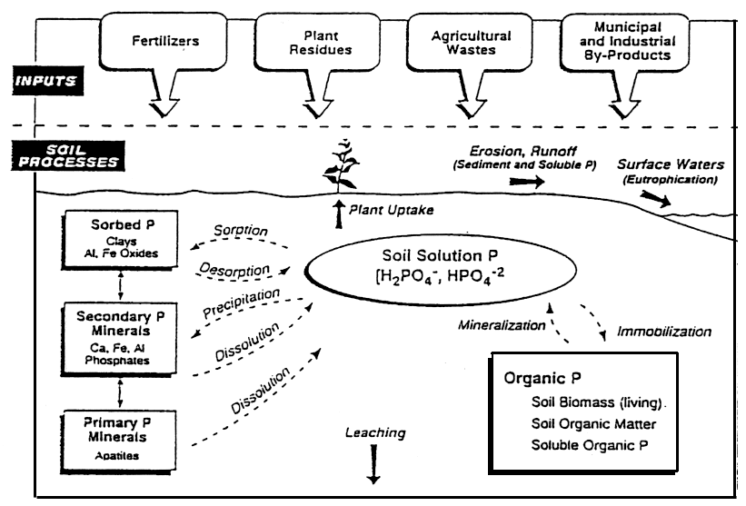
Figure 1.—Soil phosphorus cycle (Pierzinski and others, 1994).

Inherent Factors Affecting Soil Phosphorus

Inherent soil properties and climate affect the growth of crops and their response to applied P fertilizer and regulate the processes that can restrict the availability of P. Climatic conditions, such as rainfall and air temperature, and site conditions, such as soil moisture and aeration (oxygen level) and salinity (salt content/electrical conductivity) affect the rate of mineralization of P as a result of decomposition of organic matter. Organic matter decomposes, releasing P, more quickly in warm, humid climates than in cool, dry climates. Phosphorus is released faster from well-aerated soils (higher oxygen level) than from saturated soils (lower oxygen level).
Soil pH of 6 to 7.5 is ideal for the availability of P for plant use. Values of less than 5.5 and 7.5 to 8.5 limit availability of P as a result of fixation by aluminum, iron, or calcium (fig. 2), which commonly are associated with soil parent material.
Moderate levels of P do not readily leach out of the root zone in most soils. Potential for loss of P in these soils is associated mainly with erosion and runoff. Soils that have a high level of P are prone to loss of soluble P in surface runoff, drainage tile, and groundwater at a shallow depth, and sandy and organic soils are prone to loss of P through leaching. To minimize sedimentation and loss of soluble P, closely manage soils that have a high or very
high level of P, are subject to erosion and runoff, or are in close proximity to streams, lakes, and other bodies of water.
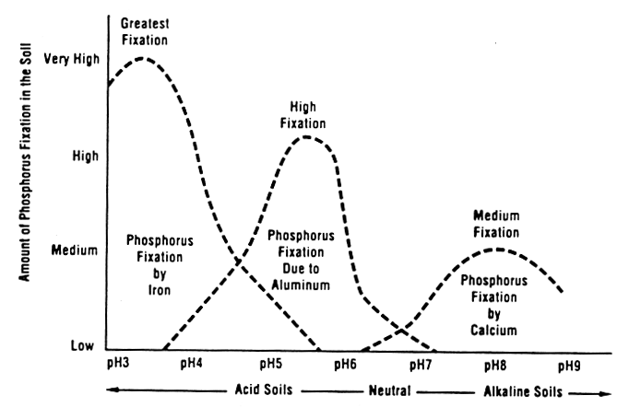
Figure 2.—Phosphorus availability across pH ranges (California Fertilizer Association, 1995).

Phosphorus Management
The availability of P can be increased by applying lime to acid soils, using practices that increase organic matter, and properly placing
P fertilizer, which affects the efficiency of use by crops. Loss of P can be minimized by limiting erosion and runoff, injecting or incorporating P, and limiting or eliminating applications of P fertilizer if the level of P in the soil is high or very high.
Adequate P is essential for crop and forage production. It encourages vigorous root and shoot growth, promotes early maturity, promotes efficient use of water by plants, and increases grain yields. Phosphorus deficiency reduces yields by delaying maturity, stunting growth, and restricting energy use by plants.
Soil P is relatively stable; it moves very little as compared to nitrogen, unless it is present in excessive amounts. The lack of mobility and low solubility limit the availability of P applied in fertilizer because it is fixed by P compounds in the soil. Fixed P slowly becomes available to crops over several years, depending on the type of soil and P compounds (fig. 1). Phosphorus in eroded sediment in bodies of water is also released over several years.
Purple leaf tissue is symptomatic of P deficiency (fig. 3). It appears first on the tips of leaves and progresses until the entire leaf exhibits a purple color. Lower leaves die when phosphorus deficiency is severe, especially if hot, dry, windy conditions persist. Emerging leaves commonly are green because plants mobilize available P to the youngest leaves first.
Symptoms of P deficiency commonly occur as young plants are exposed to cool, wet conditions. Under these conditions, plant growth exceeds the ability of the roots to supply P. Young plants are especially vulnerable because their root systems are limited and P is immobile in the soil. Cultural or environmental factors that limit root growth contribute to the symptoms of P deficiency. These factors include cool temperatures, wet or dry conditions, compaction of the soil, damage from herbicide use, damage from insects, salinity, and root pruning from side-dressing knives or cultivators. Once growing conditions become favorable again and further root growth occurs, leaves normally regain their green color.
Figure 3.—Phosphorus-deficient corn characterized by purple color on lower leaves.
The availability of P is controlled by three primary factors—soil pH and mineralogy, content of organic matter, and placement of
P fertilizer.
Lime should be applied to acid soils to achieve an ideal pH level (pH of 6 to 7). Low soil pH severely limits the availability of P for plant use. Soil pH of less than 5.5 typically limits the availability of P by 30 percent or more. Acidity also reduces root growth, which is critical for the uptake of P. High amounts of iron oxides, available aluminum, or calcium carbonates or sulfates in soil fix P, limiting its availability.
Maintaining the content of organic matter in
the soil is important for controlling the availability of P. Mineralization of organic matter provides a significant portion of the P available for crop use.
Phosphorus fertilizer and manure or other organic amendments can be applied to remedy P deficiency, but careful management is needed to provide a form of P that is available for plant use. Roots must come in contact with available P for uptake to occur. It commonly is recommended to apply P in the rows as a starter fertilizer to increase early growth, even if the amount of P in the soil is sufficient for grain. Phosphorus can also be injected 2 inches below the seeds of row crops, which provides a ready source of P for young seedlings. Producers should carefully evaluate the value of applying P fertilizer early in the growing season. Seedlings may look better if starter P fertilizer is applied, but yields may not be increased.
Primary P management strategies:
- Apply lime to acid soils to increase pH to between 6.5 and 7.0 (fig. 2).
- Apply small amounts of P fertilizer frequently rather than large amounts all at one time.
- Minimize the tie-up of P by banding or injecting P fertilizer or liquid manure.
- Place P fertilizer near rows or in furrows, where roots are most active.

Measuring Soil Phosphate (PO₄)
Materials needed to measure phosphate:
____ Plastic container and probe for gathering and mixing soil samples
____ Phosphate test strips
____ 1/8-cup (29.5 mL) measuring scoop
____ Calibrated 120-mL vial with lid for shaking
____ Squirt bottle
____ Distilled water or rainwater
____ Pen, field notebook, permanent marker, and resealable plastic bags
Considerations:
Electrical conductivity (EC) should always be measured on a sample before measuring phosphate. Soil nitrate/nitrite and soil pH can also be measured on the sample using the steps in the following paragraphs.
Soil P tests, which help in determining potential crop growth and recommendations for fertilizer, are of value only if correlated and calibrated to the response of crops to applied P. Thus, soil P test results are an “index” of relative availability.
Quick in-field hand test:
- Soil P levels in a field vary depending on location, past management, and time of year. Examples of variables include placement of P fertilizer (broadcast or banded; in rows or between rows), soil texture, organic matter content, and application of manure or other fertilizer. Using a soil probe, gather at least 10 small samples to a depth of 8 inches or less randomly from an area that represents a
particular soil type and management history. Place samples in the small plastic container and mix. Samples gathered for no-till cropping, forage establishment, and environmental purposes can be taken to a shallower depth. Do not include large stones and plant residue. Repeat this step for each sampling area.
- Neutralize hands by rubbing moist soil across palms. Discard soil. Place a scoop of the mixed soil in palm of hand and saturate with “clean” water (distilled water or rainwater).
- Squeeze hand gently until a soil and water slurry forms.
- Touch tip of phosphate test strip to the soil and water slurry. Leave until the liquid is drawn up at least 1/8 to 3/16 inch beyond the area covered by the soil (fig. 4).
- After 1 to 2 minutes, compare color of wet test strip to color chart on the test strip container (fig. 5). The color on the chart that most closely matches the color on the test strip indicates the amount of phosphate in the saturated soil. Record value in table 1.
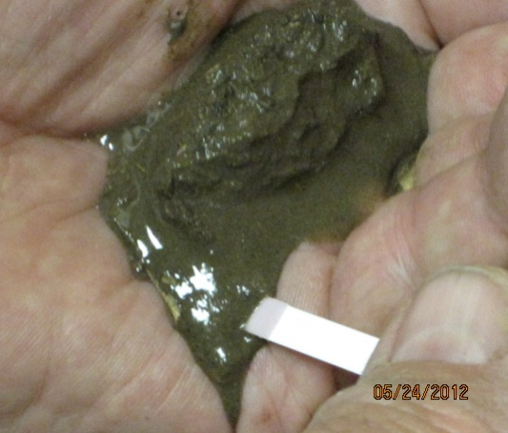
Figure 4.—Quick in-field hand
test.
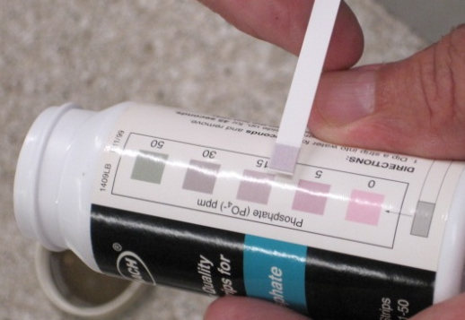
Figure 5.—Phosphate
color chart.
1:1 soil to water phosphate test for classroom:
- Soil sampling should be completed as instructed in step 1 under “Quick in-field hand test.”
- Fill scoop (29.5 ml) with the mixed soil, tamping down during filling by carefully striking the scoop on a hard, level surface. Put soil in vial. Add one scoopful (29.5 ml) of water to the vial, resulting in a 1:1 ratio of soil to water, on a volume basis.
- Tightly cap the vial and shake 25 times. Let settle for 1 minute. Remove cap, and carefully decant 1/16 inch of soil and water slurry into cap.
- Allow to settle for 2 to 3 minutes. Touch end of phosphate test strip to soil and water slurry. Leave until the liquid is drawn up at least 1/8 to 3/16 inch beyond the area covered by the soil (fig. 6).
- After 1 to 2 minutes, compare color of wet test strip to color chart on test strip container (fig. 5). The color on the chart that most closely matches the color on the test strip indicates the index value of phosphate in the water-saturated soil. Record value in table 1.
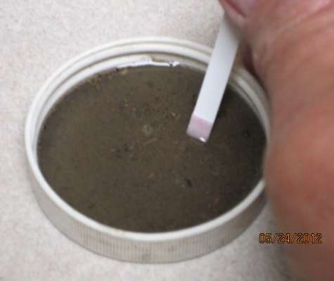
Figure 6.—1:1 soil to water test.

Interpretations
Compare water-soluble phosphate (PO₄) test results to other P test method results, PO₄ categories, and recommended fertilizer rates in table 1. Answer discussion questions. Recommendations for fertilizer and PO₄ categories will vary with the type of crop grown and Land Grant University recommendations.

Table 1.—Phosphorus test results and agronomic recommendations for corn grown in Nebraska*
(Based on standard P tests and water-soluble PO₄ test for a 1:1 soil to water mixture.)
Site | Water-soluble PO₄ in 1:1 soil to water mixture |  | Soil P relational values by P test method (ppm) |  |  | Relative PO₄ level**** | Recommended fertilizer for corn (lbs P₂O₅/acre and [P/ac**])
 | PO₄ (ppm) | Relative PO₄ level | Water-soluble PO₄*** | Olsen P**** | Bray  1-P**** |  | Broadcast**** | Band****
Ex.1 | 16 | High | 0-5 | 0-3 | 0-5 | Very low | 80 [35] | 40 [17]
 |  |  | 5-10 | 4-10 | 6-15 | Low | 40 [17] | 20 [9]
 |  |  | 10-15 | 11-16 | 16-24 | Medium | --- | 20 [9]
 |  |  | 15-20 | 17-20 | 25-30 | High | --- | ---
 |  |  | >20 | >20 | >30 | Very high | --- | ---
*If animal manure or compost has been applied, most soils generally have a medium to very high level of phosphorus and do not need supplemental fertilization. Land Grant University recommendations should be followed. Further guidance is provided in the NRCS Nutrient Management Standard 590 (http://www.nrcs.usda.gov/Internet/FSE_DOCUMENTS/stelprdb1046896.pdf)
**Recommendations are based on use of synthetic P fertilizer, but they can also be used for organic sources of P such as rock phosphate or soft phosphate that can supply equivalent levels of available P over time.
***Water-soluble P (PO₄) test (Hach trademark) for 1:1 soil to water mixture based on comparison with Bray 1-P and Olsen P tests for nineteen benchmark soils (Bray 1-P test for soils with pH <7.2;
Olsen P test for soils with pH >7.2). Water-soluble Aquachek-based P recommendations agreed for twelve soils (63 percent) and were borderline for another three soils, for a total of 79 percent. Four 1:1 soil to water mixture/water-soluble PO₄ tests indicated higher available P than results of standard Bray 1-P and Olsen P tests.
****Based on “Fertilizer Suggestions for Corn,” University of Nebraska NebGuide G74-174-A, revised September, 2001. For soils that have a medium level of phosphorus, applying 10 to 20 pounds per acre of P₂O₅ may increase early growth and application is optional.
Are soil phosphate levels adequate? What are the relative P levels and recommended rate of
application of P₂O₅ fertilizer according to table 1?

Do current management practices limit phosphorus losses from erosion and sedimentation? Do
they prevent soluble P in runoff or drainage tiles from reaching streams or lakes?
USDA is an equal opportunity provider and employer.

Are proper management practices being used to maintain soil health (compaction, pH, salinity, and
organic matter content)? Do they properly manage the placement and application rate of P fertilizer
or manure? Why or why not?

Glossary

Immobilization.—Temporary “tying up” of water-soluble P as a result of soil
micro-organisms decomposing plant residue. Immobilized P will eventually become available for plant use as decomposition progresses.
Mineralization.—Conversion of nutrients in soil organic matter (e.g., phosphorus, nitrogen, and sulfur) to inorganic forms that are available for crop use; occurs during respiration.
Orthophosphate.—Form of phosphorus absorbed by plants, generally H₂PO₄- or HPO₄²⁻.
Phosphorus cycle.—Circulation of many different forms of P in soil. Some forms are available for plant use, and some are not, such as those fixed to iron, aluminum, and calcium minerals (fig. 1).
USDA is an equal opportunity provider and employer.
Phosphorus fixation.—Phosphate that is bound to iron, aluminum, and calcium minerals and sorbed on clay minerals. Fixation and availability of P vary with soil pH (fig. 2).
Soil phosphate.—Form of P that is available for plant use, expressed as PO_{4.}

