Soil pH: What affects it, what it affects, managing it and testing it
Approximately 135 minutes
***Content and lab derived from the USDA-NRCS Guides for Educators. Please see the Guides for additional helpful pictures and diagrams.***
Objectives
By the end of the lesson, students will know or be able to:
- Define: acidity, alkalinity, buffering capacity, soil pH
- List and describe inherent factors that affect soil pH
- Describe how to manage soil pH
- Describe how soil pH affects soil function
- Measure and interpret soil pH

Materials
- Guided notes (one per student)
- 8 ½ x 11 paper that says “Climate”
- 8 ½ x 11 paper that says “Mineral Content”
- 8 ½ x 11 paper that says “Soil Texture”
- Land to take soil samples
- All laboratory supplies (See Lab Guided Notes)
- Post-It notes
Preparatory Work
- Print all necessary copies
- Secure permission to collect soil samples from the land owner

Enroll the Participants – Approximately 4 minutes

Show students the supplies that will be used during the lab portion of this lesson: soil probe, plastic bucket, pH test strips, measuring scoop, shaking vial, squirt bottle, distilled water, notebook.
Ask students which of the tools they can identify and facilitate a brief class discussion about the tools.
Share with students that this multi-day lesson focuses on soil pH and that after learning about key definitions and management practices, the class will apply the information in a laboratory experience to test soil pH.

Provide the Experience – Defining key terms – Approximately 3 minutes

Direct students to their guided notes and instruct them to match each of the terms with one of the provided definitions.

Label the Information – Approximately 4 minutes

Review the terms and definitions using the accompanying PowerPoint or the information found here:
Acidity: having a pH of less than 7
Alkalinity: having a pH of greater than 7
Buffering Capacity: a soil’s ability to maintain its pH when changes are being made to the soil
Soil pH: a measure of the soil’s acidity or alkalinity

Demonstrate the Relevance – Approximately 4 minutes

Instruct students to construct one sentence that includes and demonstrates the definitions of each of the four terms addressed in this lesson. Students may share the sentences with the class or with other students.
Instruct students to add the following points to their notes:
- Soil pH is an indicator of soil health.
- Soil pH affects crop yields, crop suitability, plant nutrient availability and soil microorganism.
- Soil pH can be managed by applying nitrogen and lime, and by using cropping practices that increase soil organic matter and overall soil health.

Provide the Experience – Inherent Factors Affecting Soil pH – Approximately 5 minutes

Divide the class into three small groups. Provide each group one of the 8 ½ x 11 papers with one of the following words on it:
Climate
Mineral Content
Soil Texture
Instruct the small groups to write on the papers how they believe each of the factors affect soil pH.
After a short amount of time, ask groups to rotate to a new factor and add their thoughts to that paper.
Rotate a second time so all groups discuss all three factors.
Ask the groups that started at each factor to review for the class all of the ideas that were added to the paper.
Label the Information – Approximately 7 minutes

Inform students that the three factors they discussed are known as “inherent factors” that affect soil pH; these are factors that cannot be changed.
Direct students to their guided notes and add the following information about each inherent factor:
- Climate
  - Increased temperature and rainfall cause increased leaching rates and increased soil mineral erosion rates
  - Increased leaching yields lower pH
  - Decreased leaching and rain cause pH to either increase or remain steady
- Mineral Content
  - High organic matter content yields a higher buffering capacity
  - Organic matter amount can be changed through management practices
- Soil Texture
  - High clay content yields a higher buffering capacity due to slower leaching rates
  - Clay content amount cannot be changed
  - High sand content yields a lower buffering capacity due to large pore spaces and fast leaching rates
  - High sand content means the organic matter content is low, which means the buffering capacity is low, percolation rate is high and the pH is low

Demonstrate the Relevance – Approximately 5 minutes

Facilitate a discussion with students about the soil in your area. Here are a few guiding questions to use during the discussion:
What are the pH characteristics of the soil in our area?
How does that affect our farms, yards and gardens?
How does the pH correction affect our environment and maintenance costs?

Provide the Experience – Managing Soil pH – Approximately 3 minutes
Show students the PowerPoint slide with the pictures of the forest, grassland and crop field.
Instruct students to use what they know about soil pH and inherent factors to determine how the pH might vary between each of the three types of lands.
Elicit student responses.

Label the Information – Approximately 12 minutes
Share the following information with the students and encourage them to add it to their guided notes:
- Soil pH is affected by land use, management and vegetation
  - Forests have a high level of organic matter
  - Grasslands have a medium level of organic matter
  - Croplands have the lowest level or organic matter of these three types of land
- As land moves from forest to grassland and from grassland to cropland:
  - Organic matter is lost
  - Soil minerals are removed (during harvest)
  - Erosion increases
  - Nitrogen and sulfur are added to the soil
  - pH decreases
- Acidification can be limited or corrected by:
  - Adding lime yields an increased pH
  - Applying nitrogen and sulfur in the correct amounts and at the times when plants are using them
  - Diversifying crop rotations
  - Applying organic matter
  - Using no-till practices and cover crops
Demonstrate the Relevance – approximately 3 minutes

Direct students to the chart in their guided notes. Fill in the following pH preference data for the crops listed in the chart.
Corn: 6.8
Wheat: 6.8
Soybeans: 6.8
Oats: 7.5
Barley: 7.5
Alfalfa: 6.8-7.5
Timothy: 6.8
Carrots: 6.0
Tomatoes: 7.5
Cucumbers: 7.5

Provide the Experience – Soil Functionality and pH – Approximately 3 minutes

Inform students that a soil’s pH indicates its suitability for plant growth.
Direct students to discuss with a partner how pH might affect key needs of plants in their growth process.

Label the Information – Approximately 7 minutes

Encourage students to capture the following information in their guided notes:
- A pH level that is too low or too high can cause
  - Nutrient deficiencies because of leaching
  - A decline in microbial activity because of improper environment for the microbes
  - A decrease in crop yields
  - A deterioration of overall soil health
  - An inhibition of the nitrogen cycle (low pH)
  - Limited effectiveness of herbicide and insecticide degradation
  - Limited solubility of heavy metals
  - A lack of effectiveness and carry-over of herbicides

Demonstrate the Relevance – approximately 4 minutes

Instruct students to form pairs and discuss what current practices they think affect soil pH and how each of these soil problems affects farms and gardens.

Provide the Experience – Measuring and Interpreting Soil pH – Approximately 3 minutes

Review the laboratory scenario with students. Students can find the scenario in their guided notes.
Marge and Jim are planning to have a garden during the next spring and summer growing season. They recently moved to a new home in a new town and do not know much about the soil in the area. Marge and Jim taken their gardening seriously, both for consumption of the food as well as for entering their crops competitively at county and state fairs. It’s really important that the garden is successful. To help guarantee success, Marge and Jim plan to conduct tests to measure their soil’s pH levels.

Label the Information – Approximately 15 minutes

Review and identify each of the supplies from the soil testing kit that will be used during the lab activity.
- Soil probe for gathering soil samples
- Plastic bucket for mixing soil samples
- Roll of pH test strips
- 1/8-cup (29.5-mL) measuring scoop
- Calibrated 120-mL shaking vial with lid
- Squirt bottle
- Distilled water or rainwater
- Pen, field notebook, sharpie and zip-lock bags
Review the steps of the laboratory activity and provide any instructions specific to your classroom expectations and time.

Demonstrate the Relevance – approximately 125 minutes

See the attached laboratory guided notes for the steps to complete the laboratory. Review the results and analysis steps of the lab
Review the Content – Approximately 4 minutes

Provide each student with two Post-It notes. Instruct students to write down what they know about soil pH on one note and to write down what they wonder or are curious about in regards to soil pH. Ensure student names are on the Post-It notes and collect them to continue the class discussion and guide students in their capstone project.

Celebrate Student Success – Approximately 2 minutes

Congratulate students on their discovery of pH level results for their tested soil. Encourage students to continue being curious during each of the laboratory activities of the soil science unit.

Guided Notes: Soil pH
Vocabulary Matching
Soil pH Soil pH is less than 7
Alkalinity A measure of soil acidy or alkalinity
Acidity Soil’s ability to resist pH change
Buffering Capacity Soil pH is greater than 7

Soil pH is an indicator of _______________ _______________________.

Soil pH affects ______________________, ____________________________, ___________________________________________ and ________________________.

Soil pH can be managed by applying __________________ and _____________, and by using _____________________ ____________________ that increase soil ___________________ __________________ and overall soil health.

Management of Acidity Notes

Plant | Ideal pH
Corn, Wheat, Soybeans, Timothy | 6.8
Oats, Barley, Tomatoes, Cucumbers | 7.5
Alfalfa | 6.8-7.5
Carrots | 6

Guided Notes: Soil pH Laboratory
Soil pH Scenario
Marge and Jim are planning to have a garden during the next spring and summer growing season. They recently moved to a new home in a new town and do not know much about the soil in the area. Marge and Jim taken their gardening seriously, both for consumption of the food as well as for entering their crops competitively at county and state fairs. It’s really important that the garden is successful. To help guarantee success, Marge and Jim plan to conduct tests to measure their soil’s pH levels.

Laboratory Supplies
- Soil probe for gathering soil samples
- Plastic bucket for mixing soil samples
- Roll of pH test strips
- 1/8-cup (29.5-mL) measuring scoop
- Calibrated 120-mL shaking vial with lid
- Squirt bottle
- Distilled water or rainwater
- Pen, field notebook, sharpie and zip-lock bags
Laboratory Steps
Soil pH level is highly variable, depending on field location and time of year, as well as what is growing. It is affected by fertilizer placement in rows or between rows, soil texture, organic matter content and applications of manure or fertilizer.

In-Field Quick Hand Test
- Using a soil probe, gather at least 10 small samples randomly from the area that represents the soil type and management history to be tested. Ensure that each sample is taken at a depth of eight inches.
- Place each sample into the plastic bucket provided.
- Remove large stones and plant residue from the sample.
- Mix the soil together.
- Rub wet soil across your palms to neutralize your hands. Discard this soil.
- Place a scoop of mixed soil in your palm and saturate the soil with distilled water or rainwater.
- Squeeze the wet soil gently until the water runs out of the cup of the hand and onto the side of the soil sample.
- Touch the end of a 1-inch-long piece of pH test strip directly to the water so that the tip is barely wet and the solution can be drawn up the strip at least ¼ inch to ½ inch beyond the area masked by soil.
- Compare the color of the pH test strip approximately 1/3 of the way up the colored portion of the strip to the color chart on the dispenser of the test strips.
- Record the soil pH and interpretations in Table 1. Use Figures 1 and 2 to complete the chart.

1:1 Soil-Water Soil pH Test in Classroom
- Complete Step 1 from the In-Field Quick Hand Test.
- Tamp down one sampling scoop (29.5 mL) of mixed soil by striking the scoop carefully on a hard, level surface. Place the sample in the plastic mixing vial.
- Add one scoop (29.5 mL) of water to the same vial. The vial will contain a 1:1 ratio of soil to water, on a volume basis.
- Place the cap on the vial tightly and shake the vial 25 times.
- Let the sample settle for one minute.
- Remove the vial cap and gently pour 1/16 inch of soil-water solution carefully into the lid.
- Let the sample sit in the lid for two or three minutes.
- Take the end of a 1-inch-long piece of pH paper and immerse it 1/16 inch into the solution until the liquid is drawn up at least ¼ to ½ inch beyond area covered by soil.
- Compare the color approximately 1/3 of the way up the colored portion of the strip to the color chart on the dispenser.
- Record the soil pH and interpretations in Table 1. Use Figures 1 and 2 to complete the chart.

Table 1. Soil pH and Interpretations
Site | Soil pH | Soil pH Category (i.e. very acid) | Nutrients Impacted by Soil pH | Crops Impacted by Soil pH Level | Notes

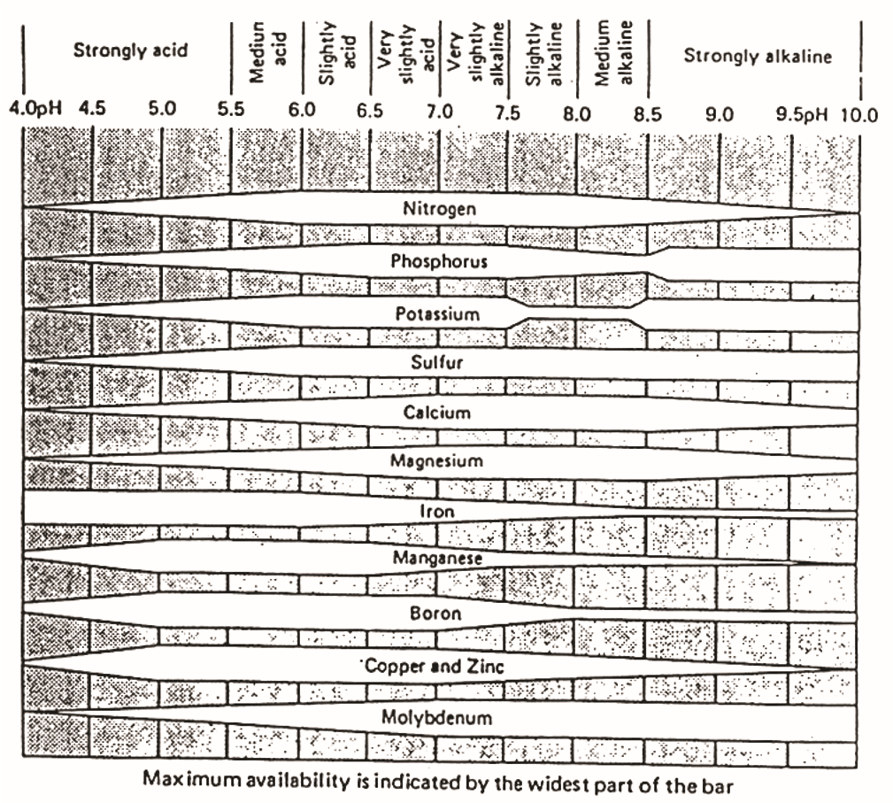
Figure 1. Soil pH Category

Figure 2. Plant pH Preferences
Plant | Ideal pH
Corn, Wheat, Soybeans, Timothy | 6.8
Oats, Barley, Tomatoes, Cucumbers | 7.5
Alfalfa | 6.8-7.5
Carrots | 6

Notes completed by ___________________________

Climate

Soil Texture

Mineral Content

